Required Capstone Project   
Executing an End-to-End Analytics Process - Template

**Rathina Grace Monica Abraham Geoffrey**

|  |  |
| --- | --- |
|  |  |

**Scenario:**

You are assisting a credit analyst who wants to gather, organise and analyse data on credit card transactions and customers in order to identify fraudulent information. Execute an end-to-end analytics process to accomplish this task.

The tasks below outline the requirements and the step-by-step guide on how to successfully complete this capstone activity.

**Tools:**

To complete this project, you need the following database and software:

* Credit_Database.db
* capstone workbook.xlsx
* Task 5.1 Model Data for Clustering
* Task 5.2 Model Data for Classification
* DB Browser (SQLite)
* Power Pivot in Microsoft Excel
* Power BI
* Orange

**Note:** Click the software to proceed to their official download links.

**Assignment Instructions**

**Task 1: Extract relevant information from a database**

**Task 1:** Using the '**Credit_Database.db'**file, find the total number of customers with multiple cards using a SQL query.

**Note:** Reviewing **Module 2 – Database: Data Source** will help you accomplish this task

**Estimated Time: 15 minutes**

**Tools:** DB Browser (SQLite)

**Submission:** Take a screenshot of your work and paste in the space provided below.

**Step 1:**

Open a fresh DB SQlite worksheet, click “Open Database”.

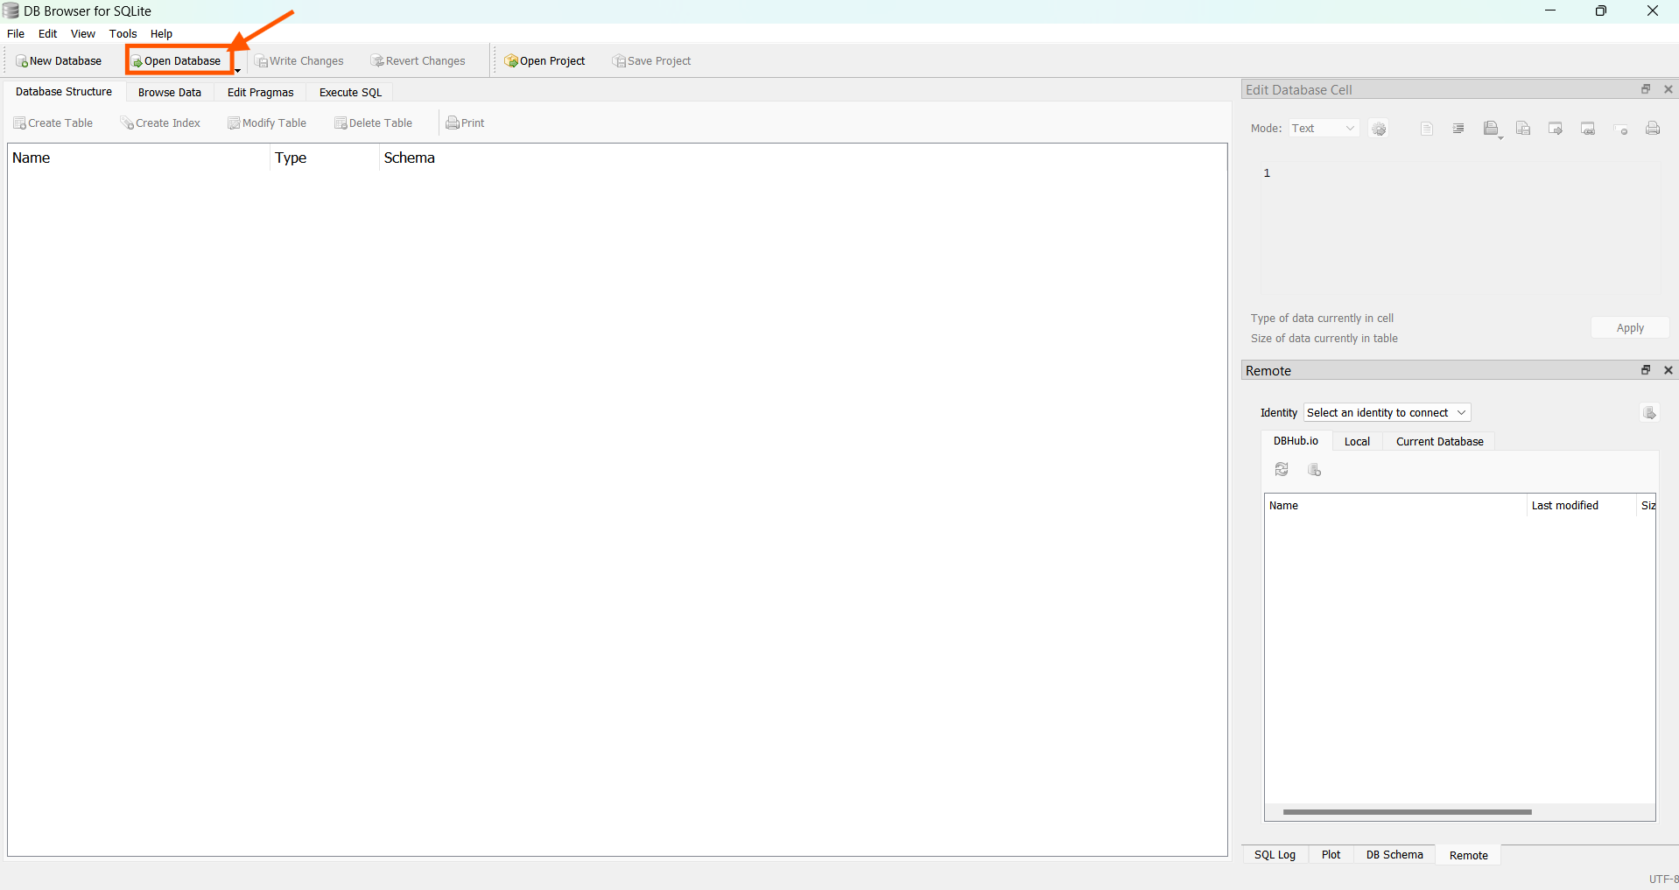

**Step 2:**

Navigate and open the “Credit_Database.db” file.

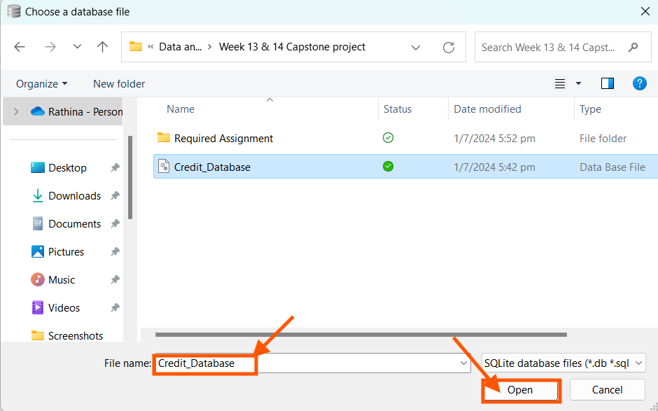

**Step 3:**

We find there are 4 different tables Card Base, customer Base, Fraud, Transaction Base loaded to the Database Structure window.

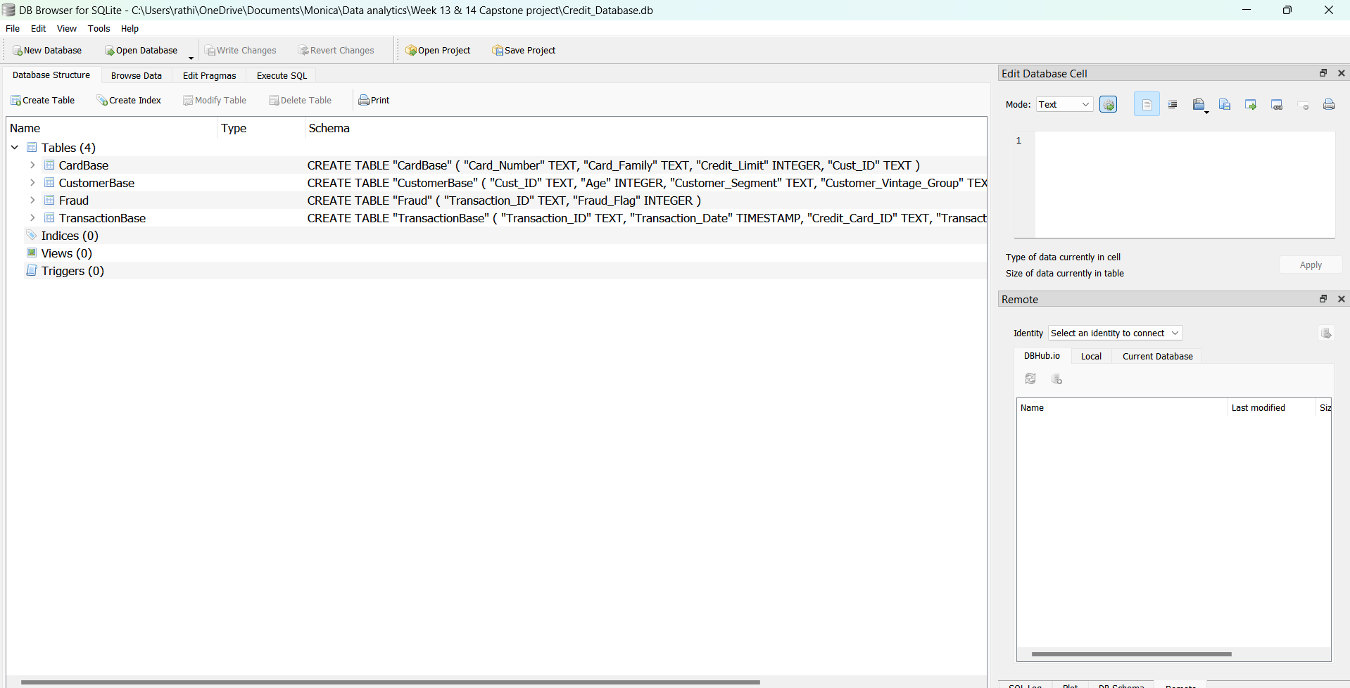

In the Execute SQL window, writing the code.

We find that there are total of 18 customer ID with more than one credit card of the same type. Validating the code by displaying the different card number and card family for a particular customer with more than one credit card.

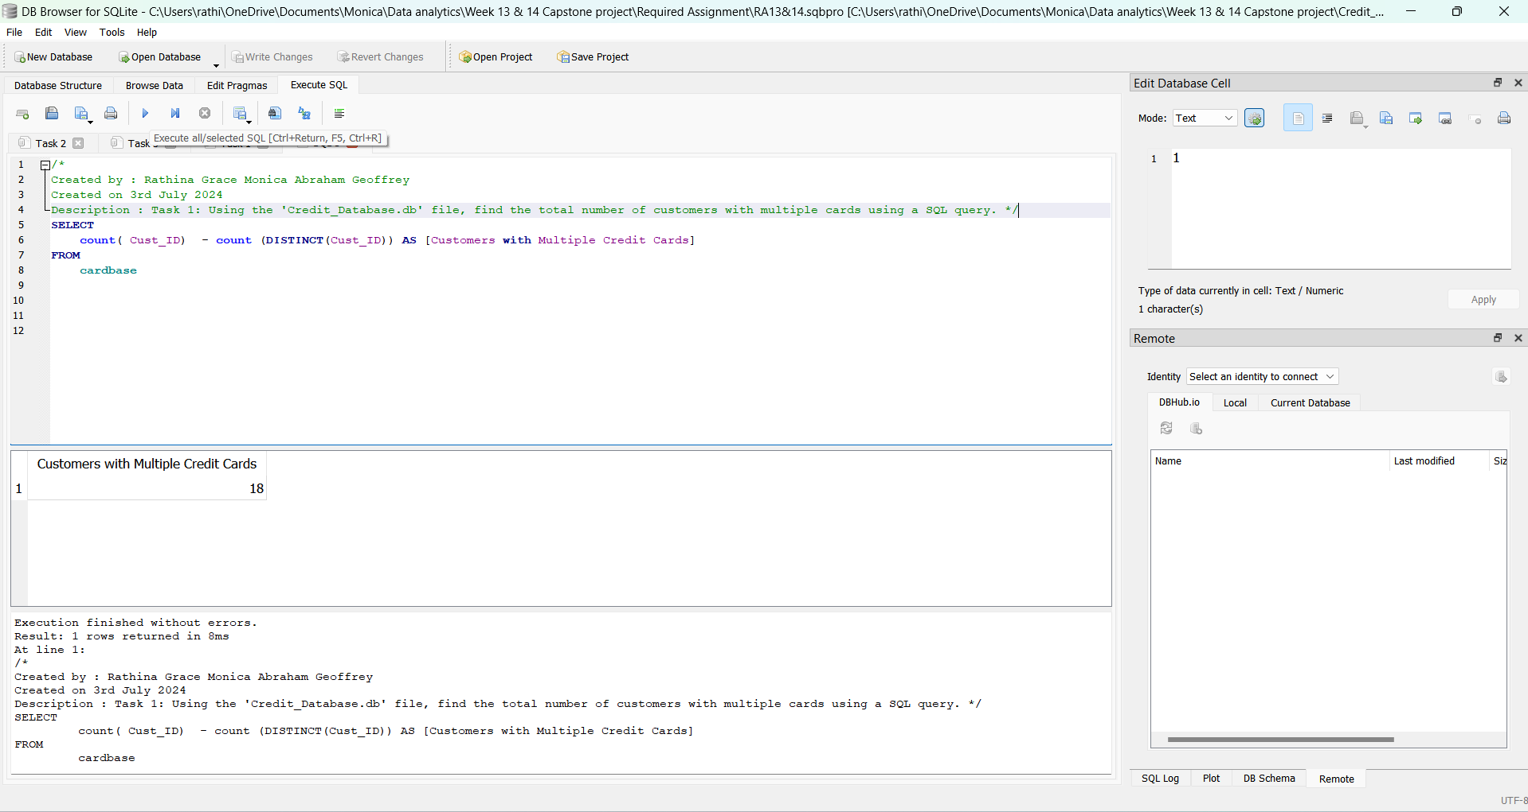

Hence completing the given task 1.

**Task 2: Organise and shape data by writing SQL queries**

**Task 2.1:**  Using the '**Credit_Database.db'**file, find the average sales for each customer segment using a SQL query

**Note:** Reviewing **Module 3 – Database: Data Queries** will help you accomplish this task

**Estimated Time: 15 minutes**

**Tools:** DB Browser (SQLite)

**Submission:** Take a screenshot of your work and paste in the space provided below.

**Step 1:**

The question connects the three tables i.e. Cardbase table, Customer base table and transaction base table. Hence, two inner joins are performed to find the final table customer segment and average sales.

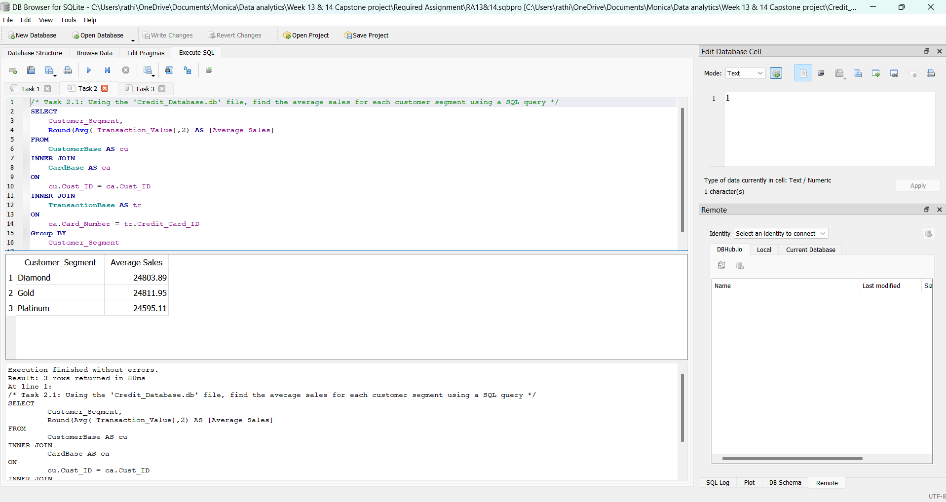

Thus, Completing the given task 2.1.

**Task 2.2:**  Find the total number of fraudulent transactions and the total fraudulent amount using a SQL query

**Note:** Reviewing **Module 3 – Database: Data Queries** will help you accomplish this task

**Estimated Time: 15 minutes**

**Tools:** DB Browser (SQLite)

**Submission:** Take a screenshot of your work and paste in the space provided below.

**Step 1:**

On executing the below SQL Query, we find a total of 109 records of fraudulent transactions with the total transaction amount of 2922168.

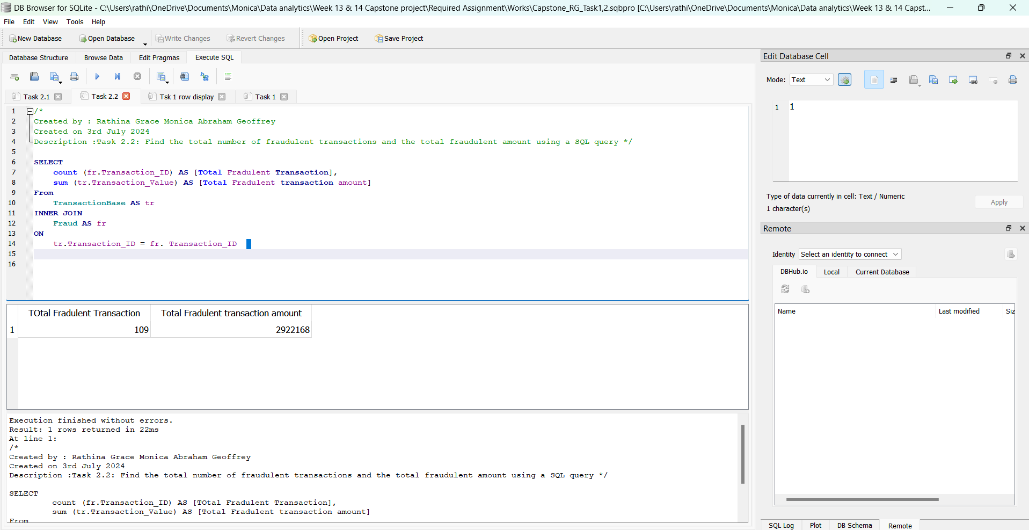

Thus, Completing the given task 2.2.

**Link to my dB SQLite work**

https://drive.google.com/file/d/155fSwkPX3ikGn1CGev96hM9thpFRqLqf/view?usp=sharing

**Task 3: Creating a data model in Power Pivot**

**Task 3.1:** Using '**capstone workbook.xlsx**',create a data model with the four tables in Excel Power Pivot and a calendar table. Show the relationships between these tables.

Add Cust_ID in the TransactionBase table by looking it up from the CustomerBase table.

**Note:** Reviewing **Module 5 – Date Warehouse: Data Model** will help you accomplish this task

**Estimated Time: 60 minutes**

**Tools:** Power Pivot in MS Excel

**Submission:** Take a screenshot of your work and paste in the space provided below.

**Step 1:**

Open a fresh Excel worksheet and save it as “Task 3.xlsx”

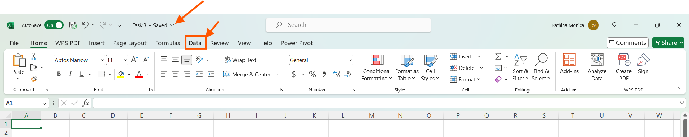

**Step 2:**

To import the data, click “Data”, Select “Get Data”, Select “From File” , choose "From Excel workbook”.

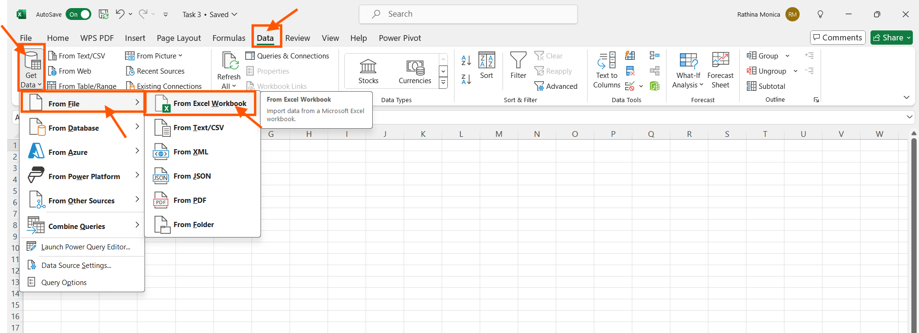

**Step 3:**

Navigate and import the “capstoneworkbook.xlsx” file

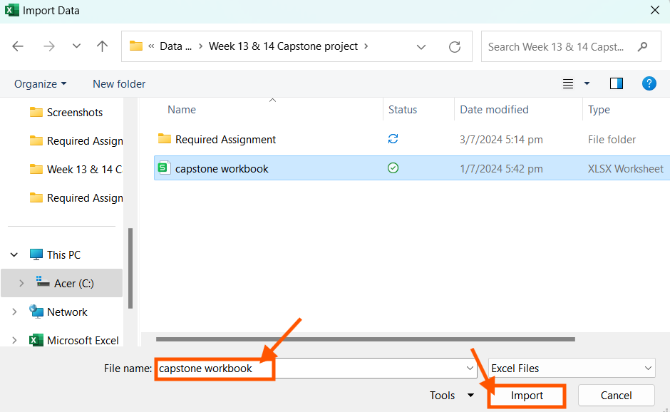

**Step 4:**

It leads to the navigator window, mark “Select multiple items”, choose all the 4 different tables, click “Load”.

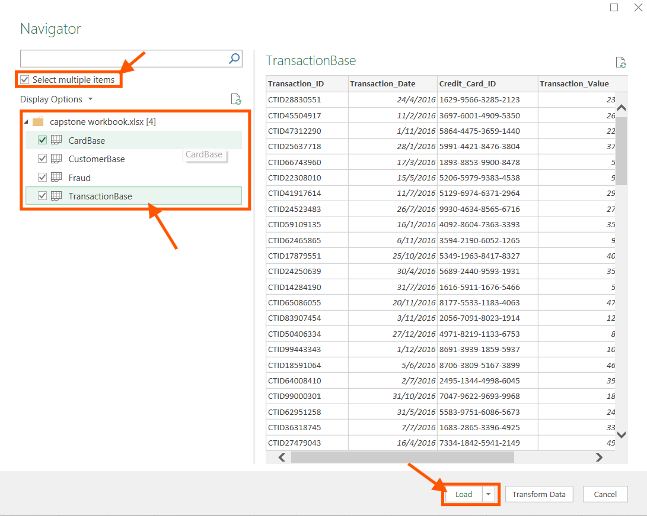

**Step 5:**

We find all 4 tables loaded in the Excel worksheet. Now select “Power Pivot”.

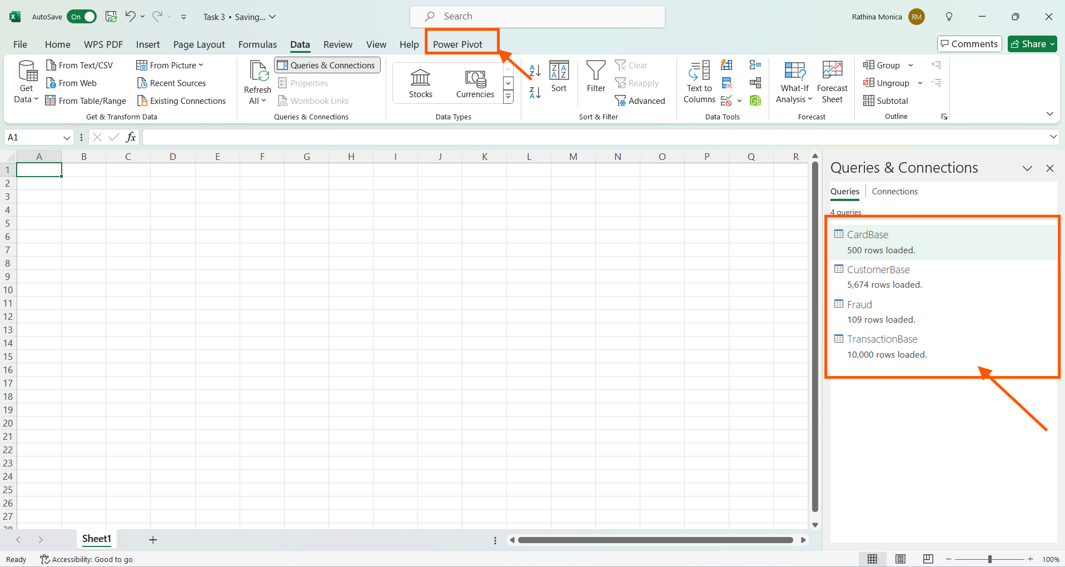

**Step 6:**

Select “Manage Data Model”

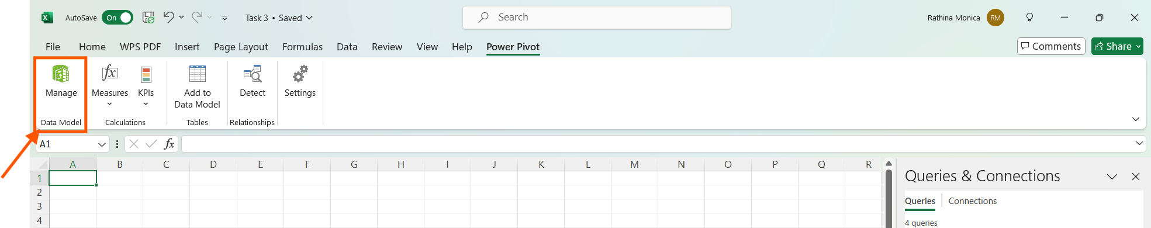

**Step 7:**

We find all the 4 tables. Properly loaded in the data model.

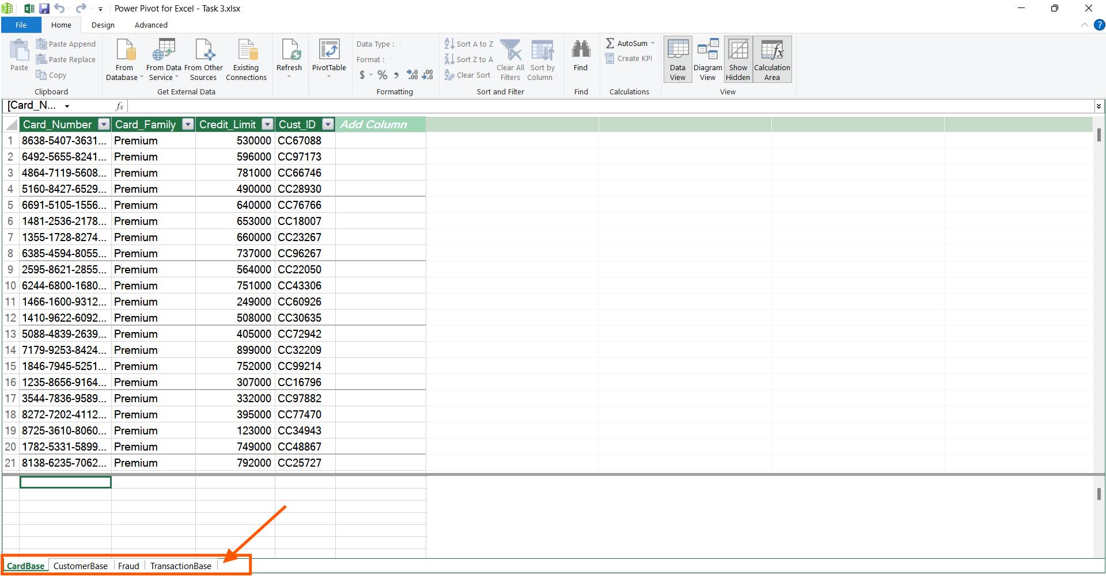

**Step 8:**

Choose “Diagram View”.

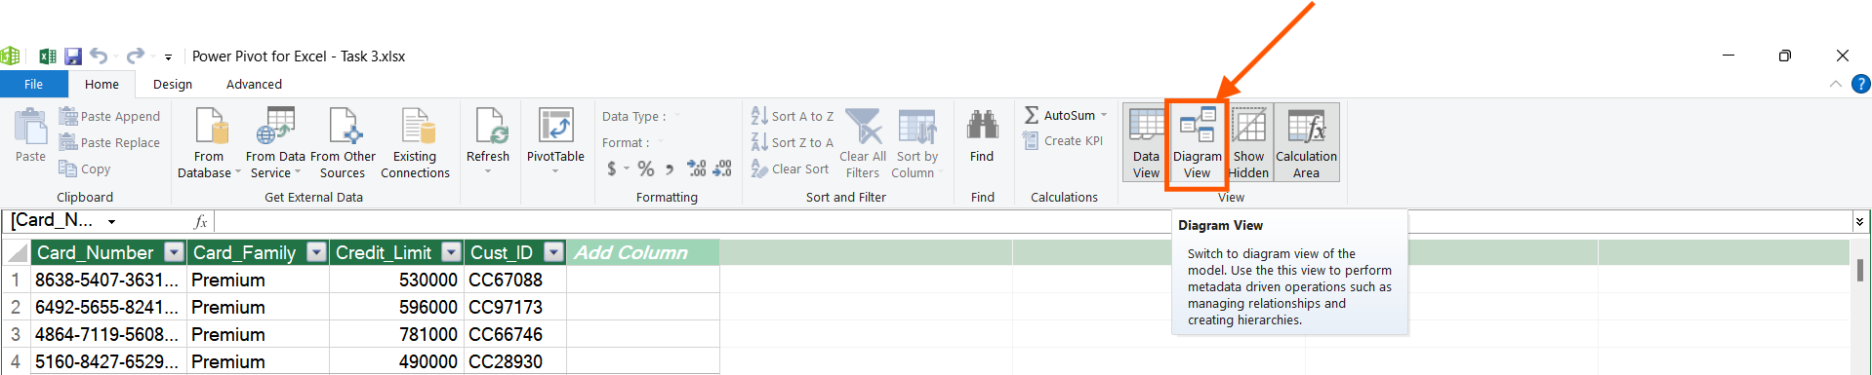

**Step 9:**

We find all the four tables neatly arranged in the diagram view. Now, click “Design” menu, select “Date Table”, Click “New”. We find that the date table is created for the year 2016, starting from 01st January 2016 till 31st December 2016. As we have transaction history only for 1-year 2016 in the transaction base table. Having transaction table as reference the start and end date of the date table is decided.

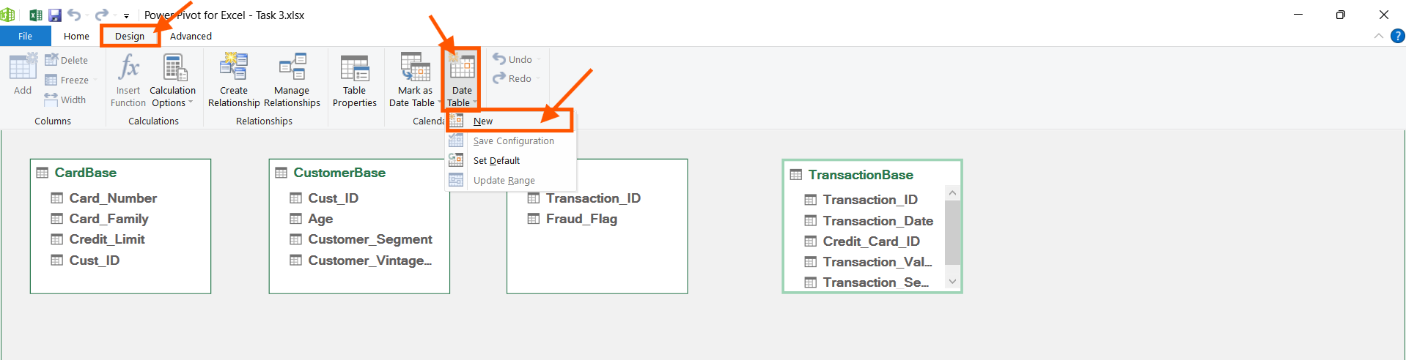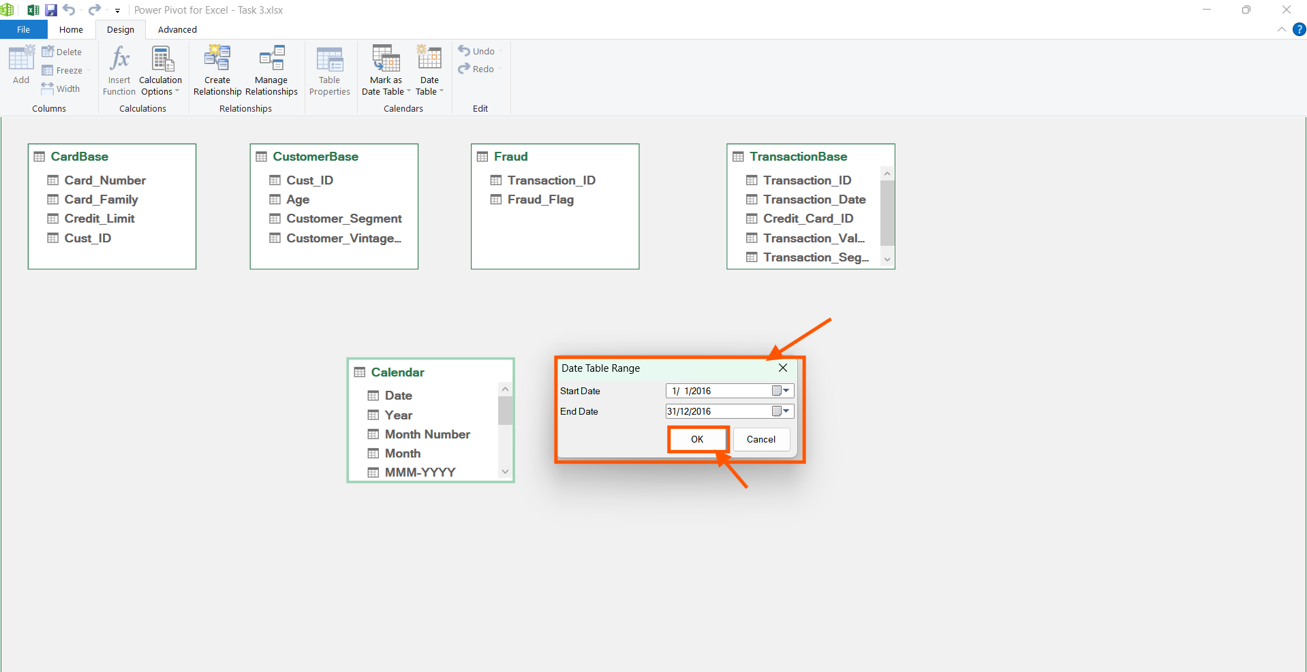

**Step 10:**

Now Creating Relationship between these tables.

Create an active relationship between “Card_Number” column from “Cardbase” table and “Credit_Card_ID” column from “Transactionbase” table. Click “Close” button.

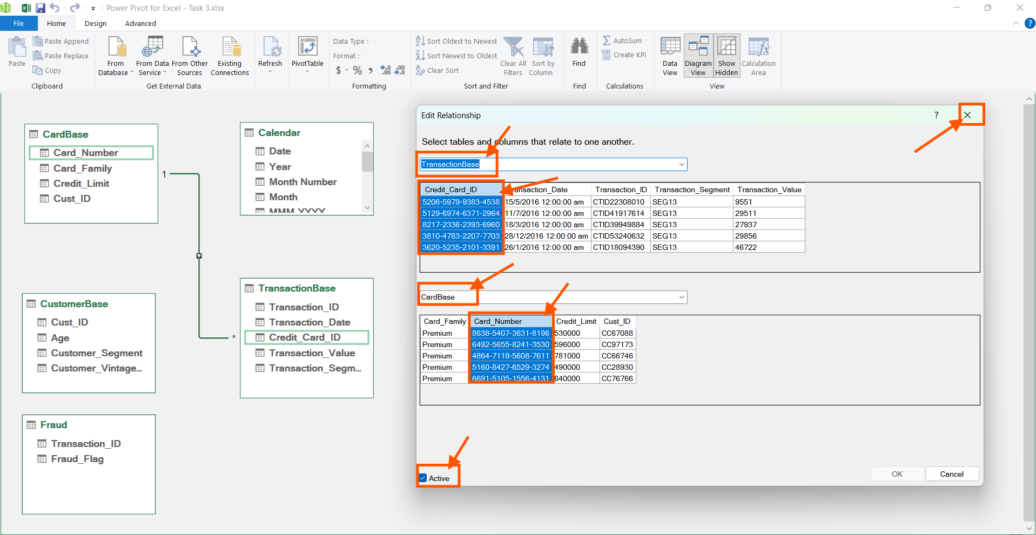

Create an active relationship between “Transaction_ID” column from “Fraud” table and “Transaction_ID” column from “Transactionbase” table. Click “Close” button.

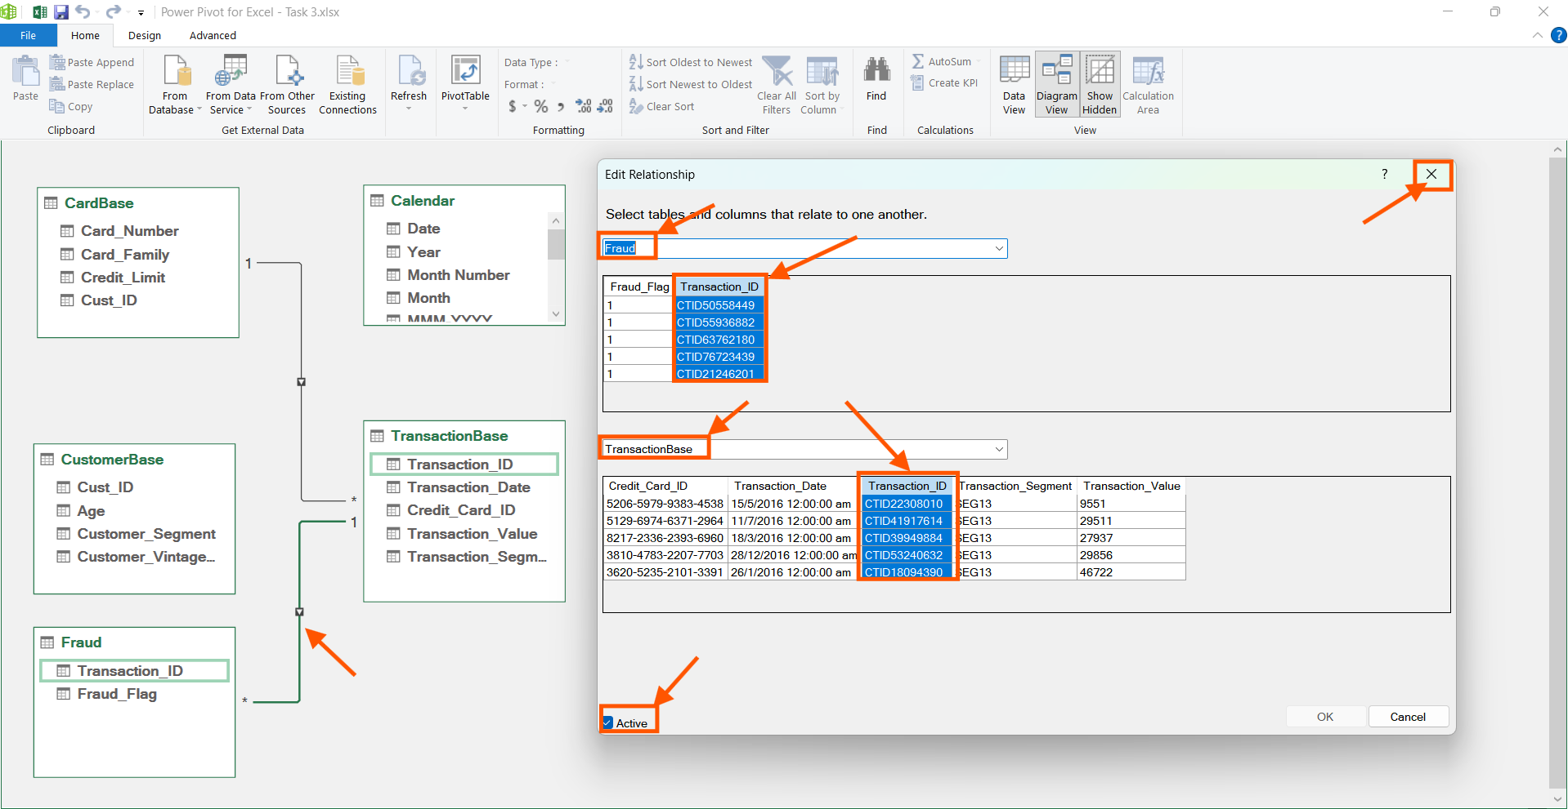

Create an active relationship between “Transaction_Date” column from “TransactionBase” table and “Date” column from “Calendar” table. Click “Close” button.

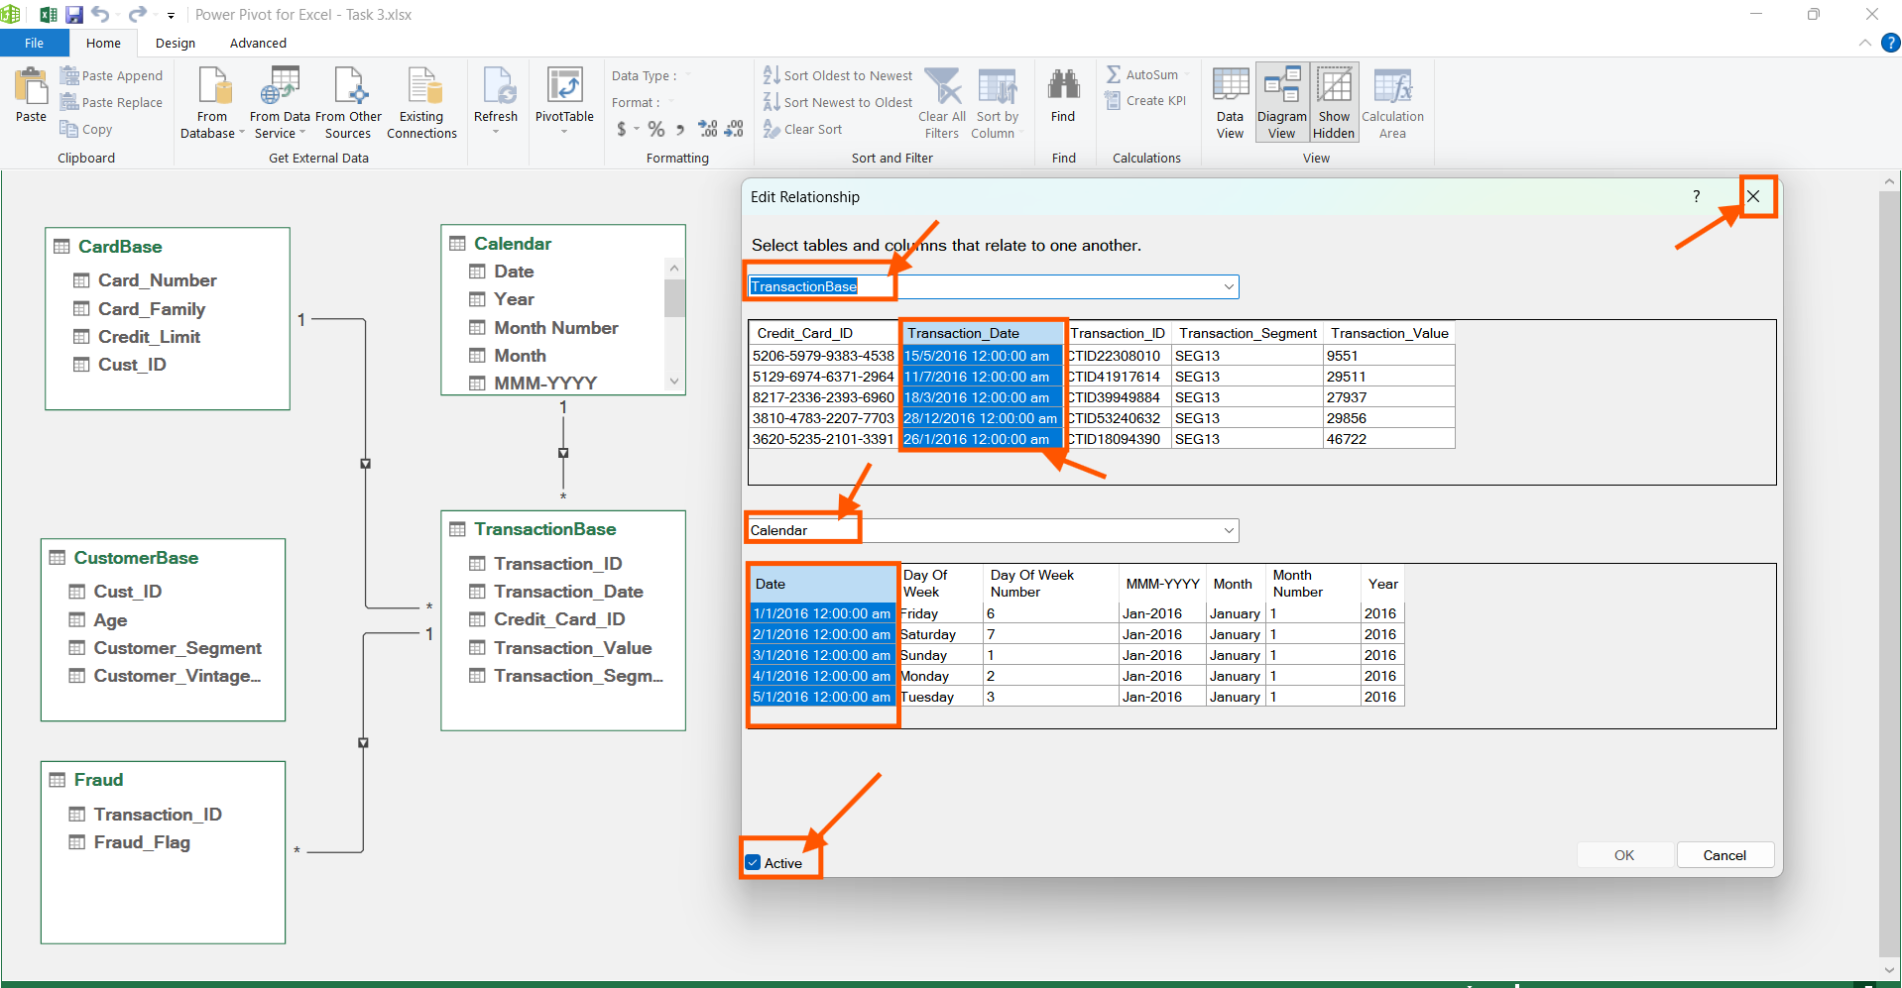

Create an active relationship between “Cust_ID” column from “CardBase” table and “Cust_ID” column from “CustomerBase” table. Click “Close” button.

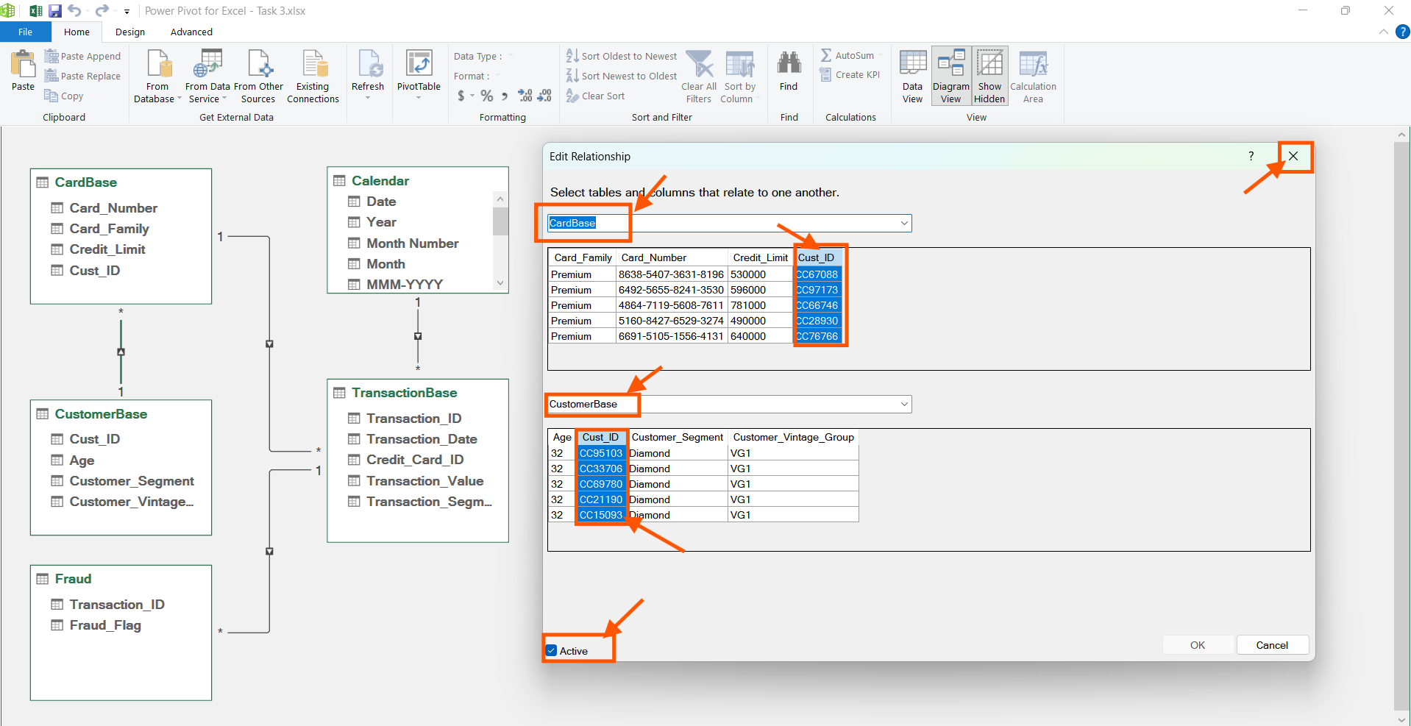

There by “Transactionbase” table serves as the fact table and the other tables as dimensions table. The “customerbase” table is connected to the transaction table through “CardBase” table.

The final diagram view after relating all the tables.

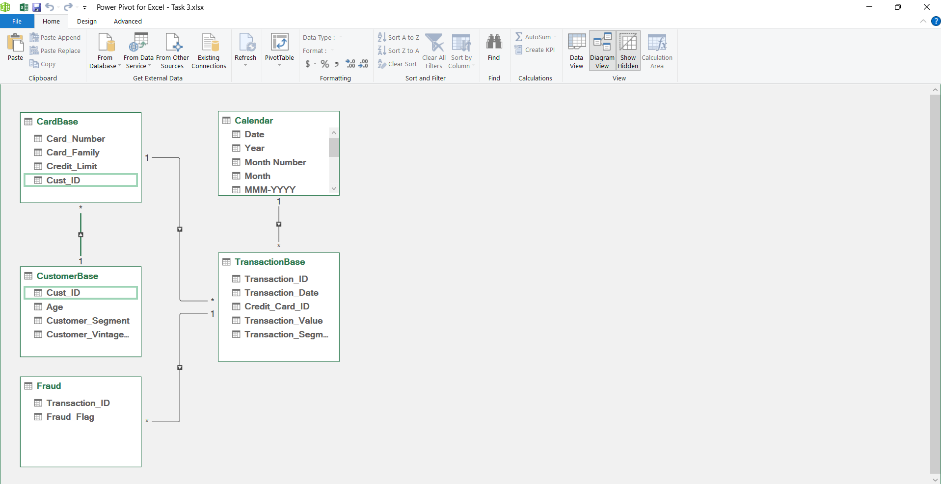

Going back to data view, “Transactionbase” table. Click “Add Column”. Using the DAX function below add the “Cust_ID” from the “Customerbase” table.

=RELATED(CustomerBase[Cust_ID])

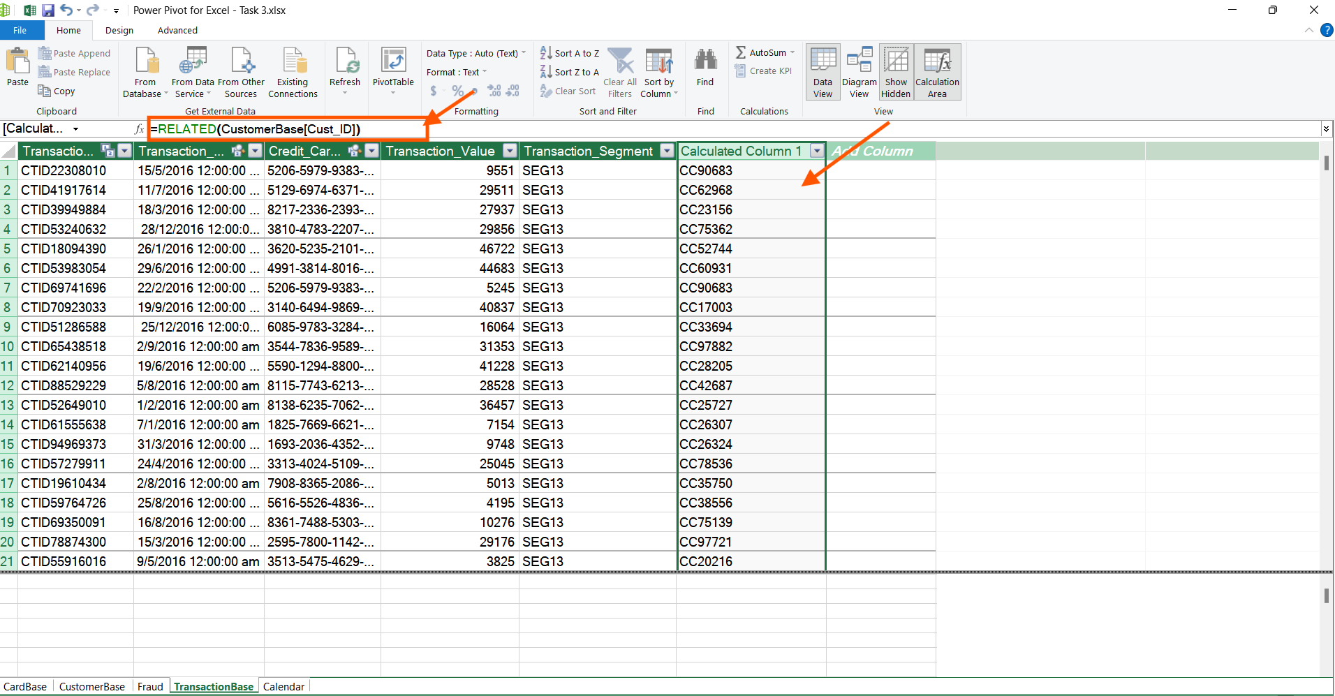

Thus, completing the given task 3.1.

**Task 3.2:** Create a Pivot table with a monthly percentage (MoM %) change in sales. Then, create a combo chart with sales per month, previous month sales and %MoM spend. Add slicers to customer segment and customer vintage groups. The chart and the records in the Pivot table should change as your selection in the slicer values change.

**Note:**  Reviewing Module 8 – Data Visualisation: Pivot Tables and Charts will help you accomplish this task

**Estimated Time: 60 minutes**

**Tools:** Power Pivot in MS Excel

**Submission:** Save your output in .xlsx or .csv format with the file name [Capstone_Initial of first name + last name_Task 3.2]. Upload the Excel file together with this template filled with your answers.

**Step 1:**

Calculate the Total sales in the transaction table using the DAX measure below.

Total Spend:=SUM([Transaction_Value])

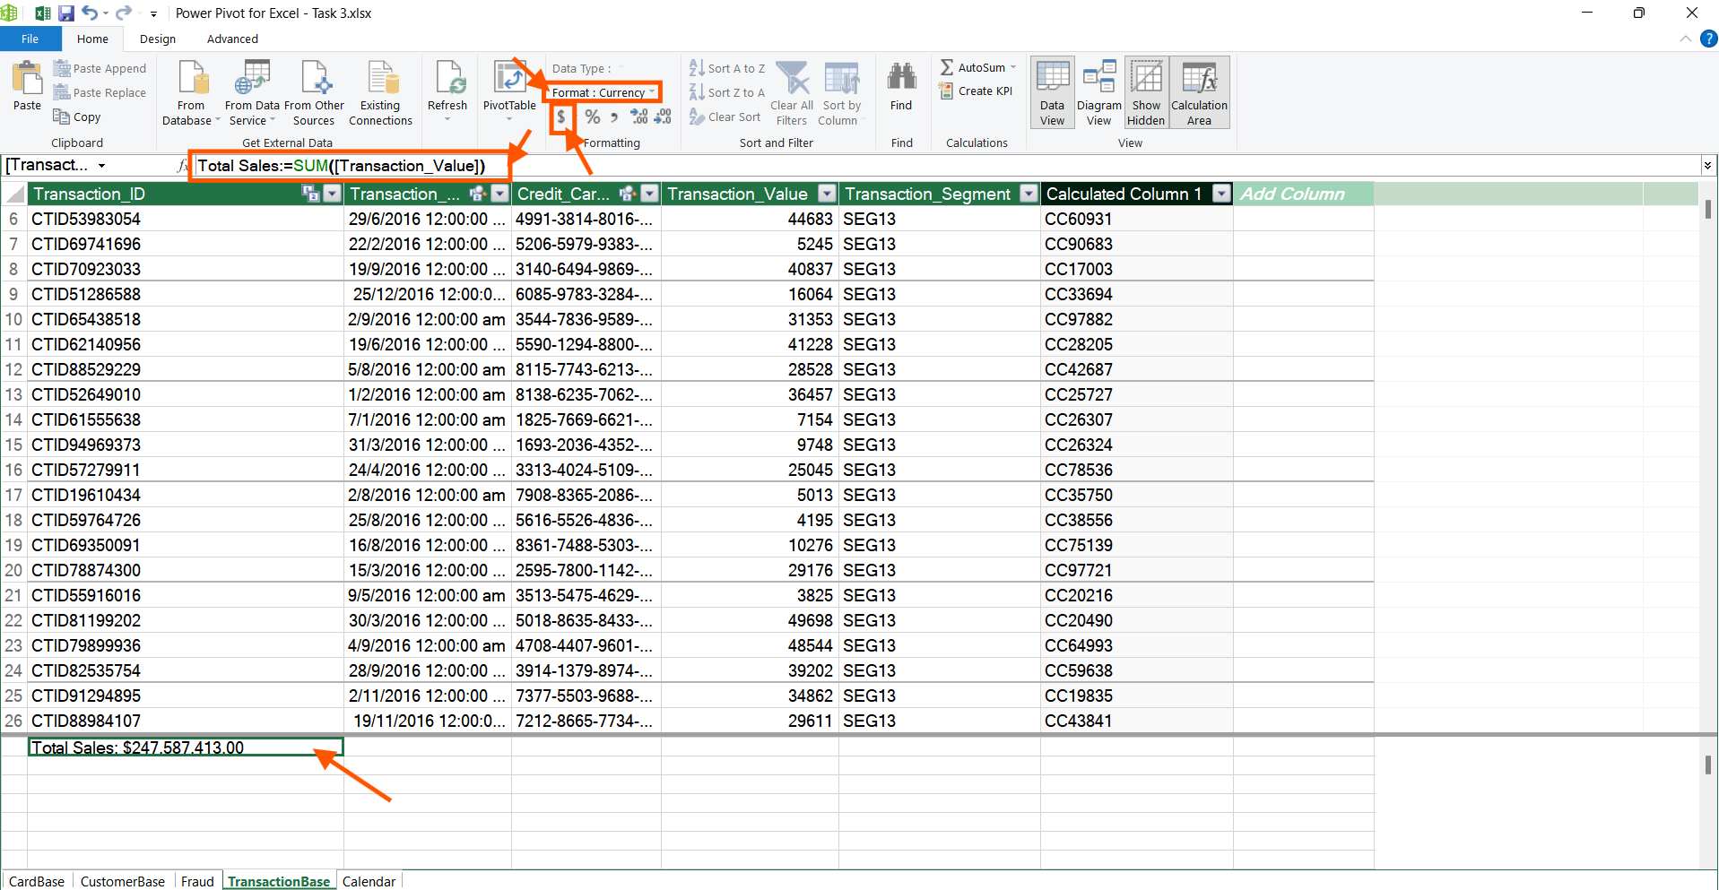

**Step 2:**

Calculate the previous month spend using the DAX function below

Prev Month Sales:=CALCULATE(SUM([Transaction_Value]),PARALLELPERIOD('Calendar'[Date],-1,MONTH))

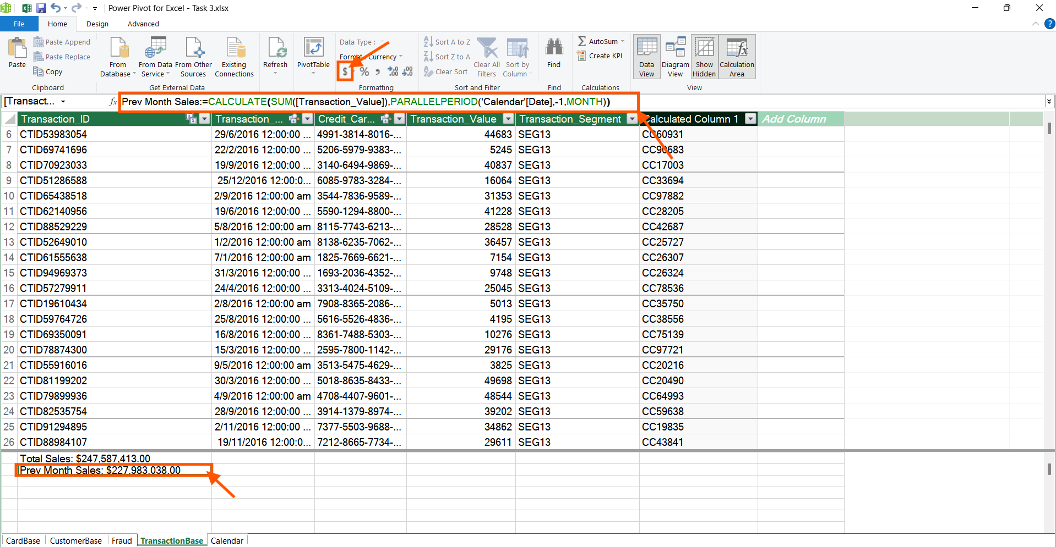

**Step 3:**

The %MOM spend is calculated using the following DAX measure below.

%MOM spend:=DIVIDE(([Total Spend] - [Prev Month Spend]),[Prev Month Spend],0)

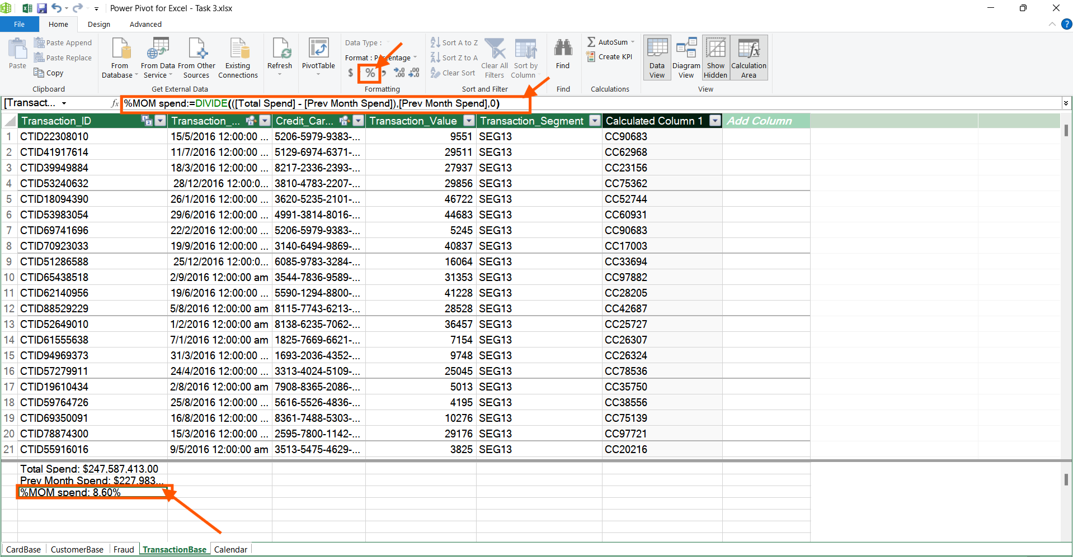

Now going back to the Excel Worksheet , Click “Insert”, Select “Pivot table”, Select from the “From Data Model”

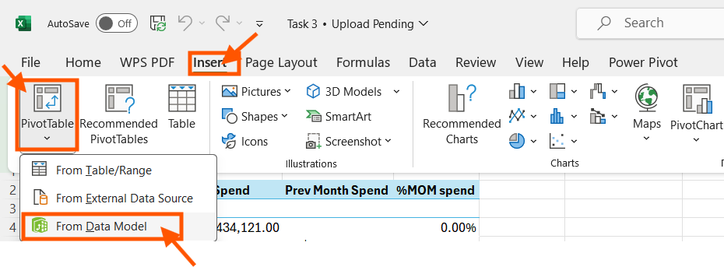

Select the location of pivot table.

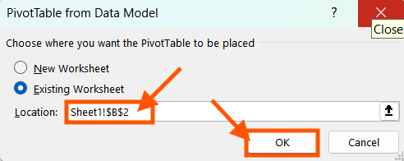

In the pivot table fields, select the following values.

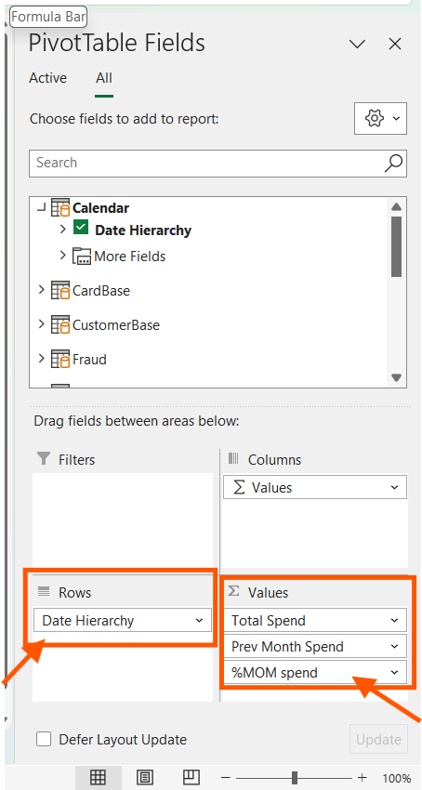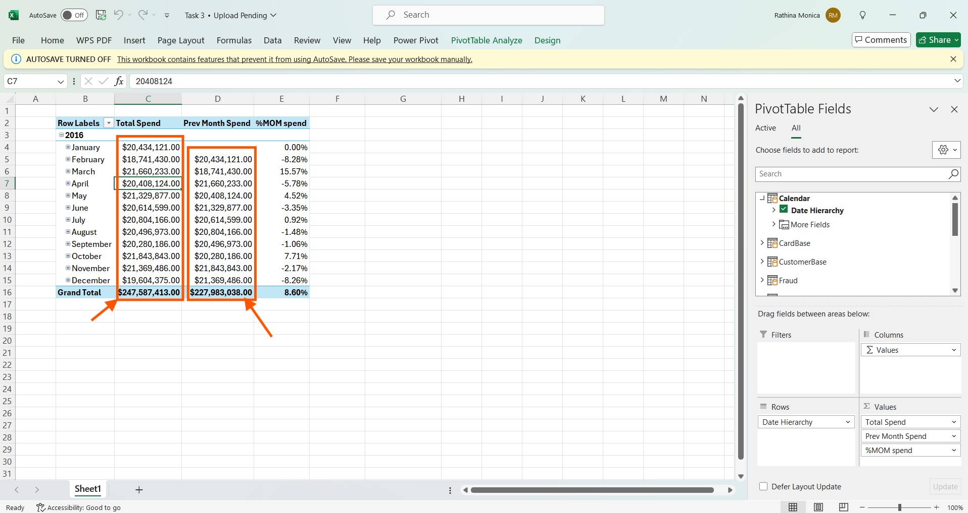

We find that in the pivot table , the previous month value and current month value matches every month.

Select “Insert” option, select “Pivot Chart”, Choose “Pivot Chart”.

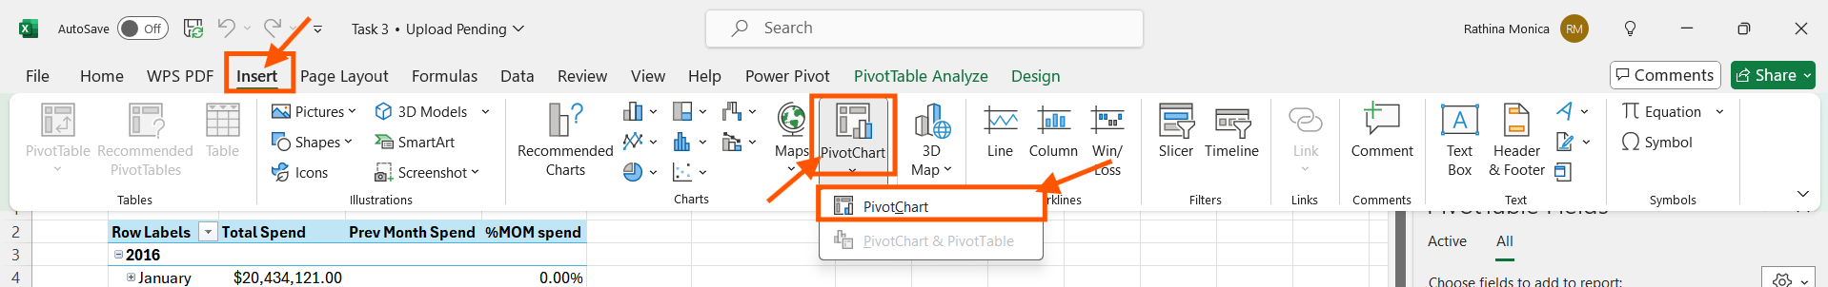

Select Combo chart and choose secondary axis for %MOM spend

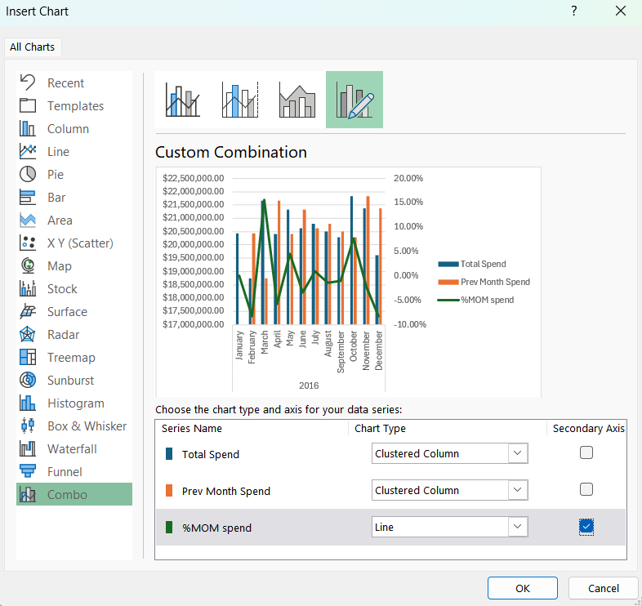

Press “OK”. Adjust the position of the chart, Double click the Y axis, under Format Axis, change the display values to Millions, under numbers, change the categories to currency with 2 decimals. We get this basic graph.

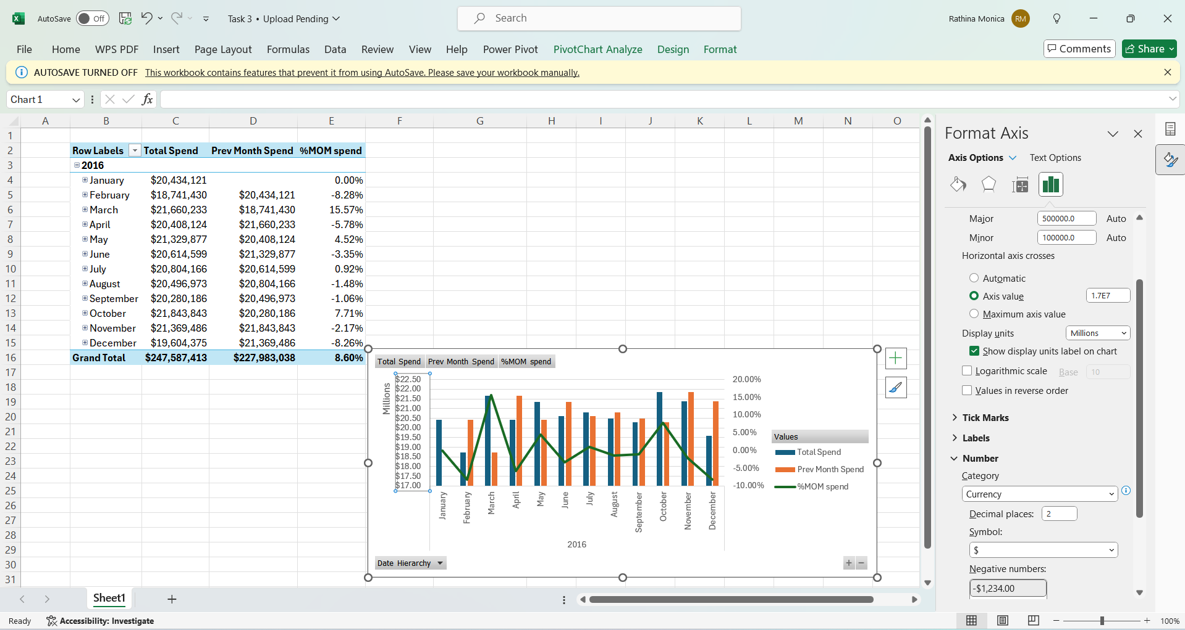

Now adding the two slicers to the worksheet by selecting “Pivotchart Analyzer”, choose “Insert Slicer”.

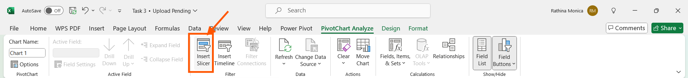

Select “All”, Under “Customerbase” table, choose "Customer_segment”, “Customer_Vintage”, Press “OK”

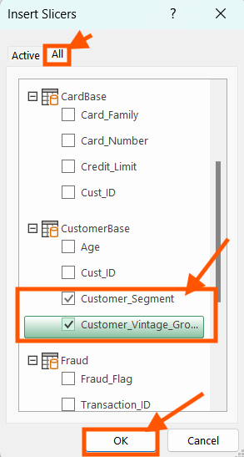

Click the “Customer Segment” slicer, choose “Slicer” menu, Select “Report Connections”. Link both the pivot table as well as pivot chart through report connections to the slicer.

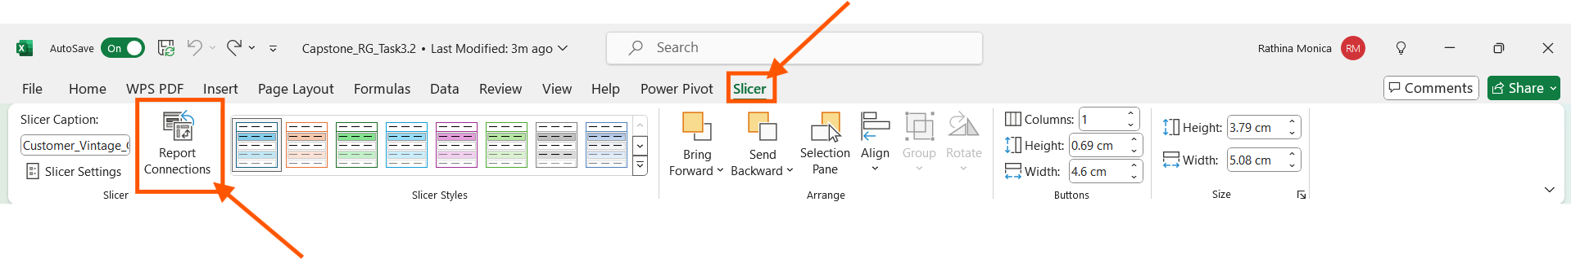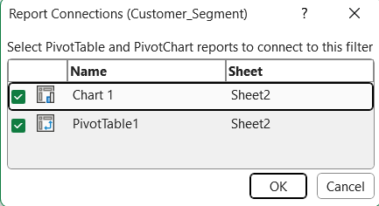

Repeat the same process for the “Customer_Vintage” Slicer.

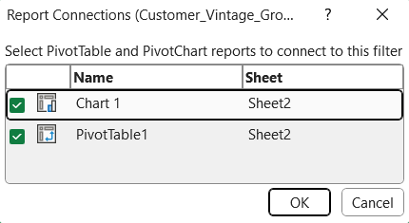

Finally, we get this output.

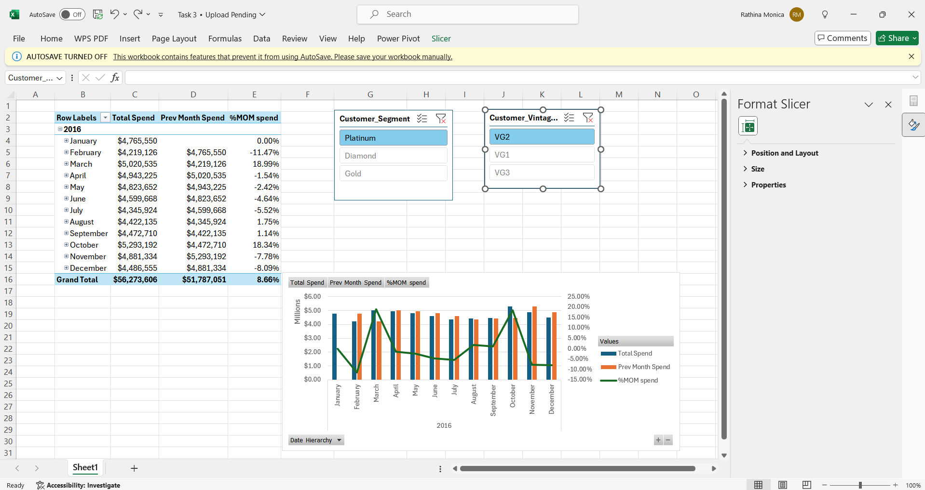

The Pivot chart is corrected by correcting the Previous month sales value.

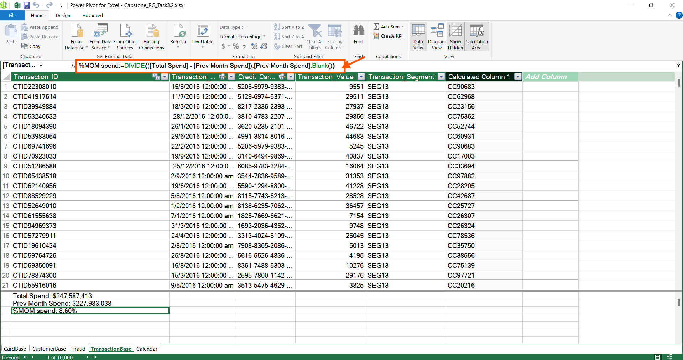

Now checking the values of Pivot chart and Pivot table.

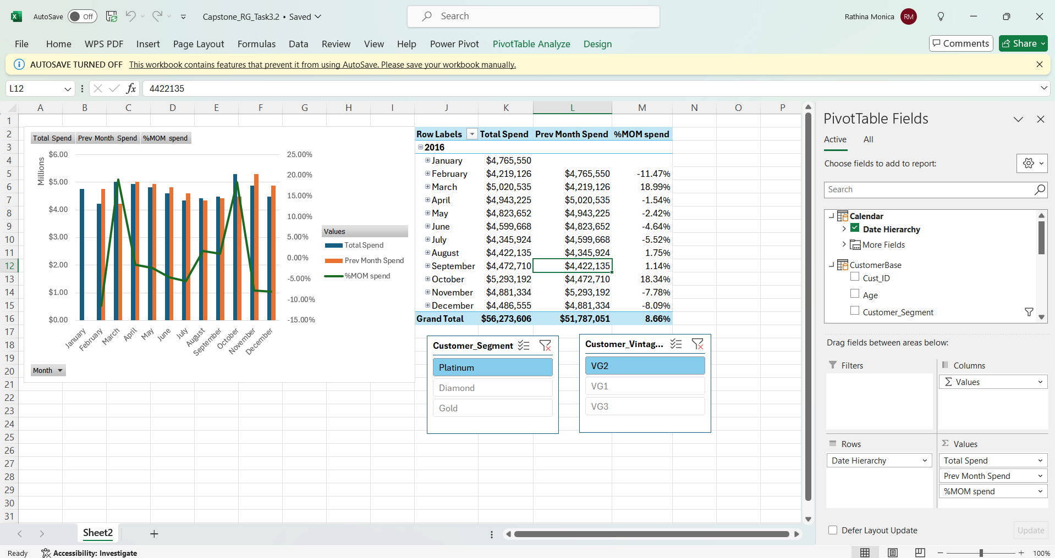

Now right clicking the grand total value of “%MOM Spend”, Choose “Format Cells”.

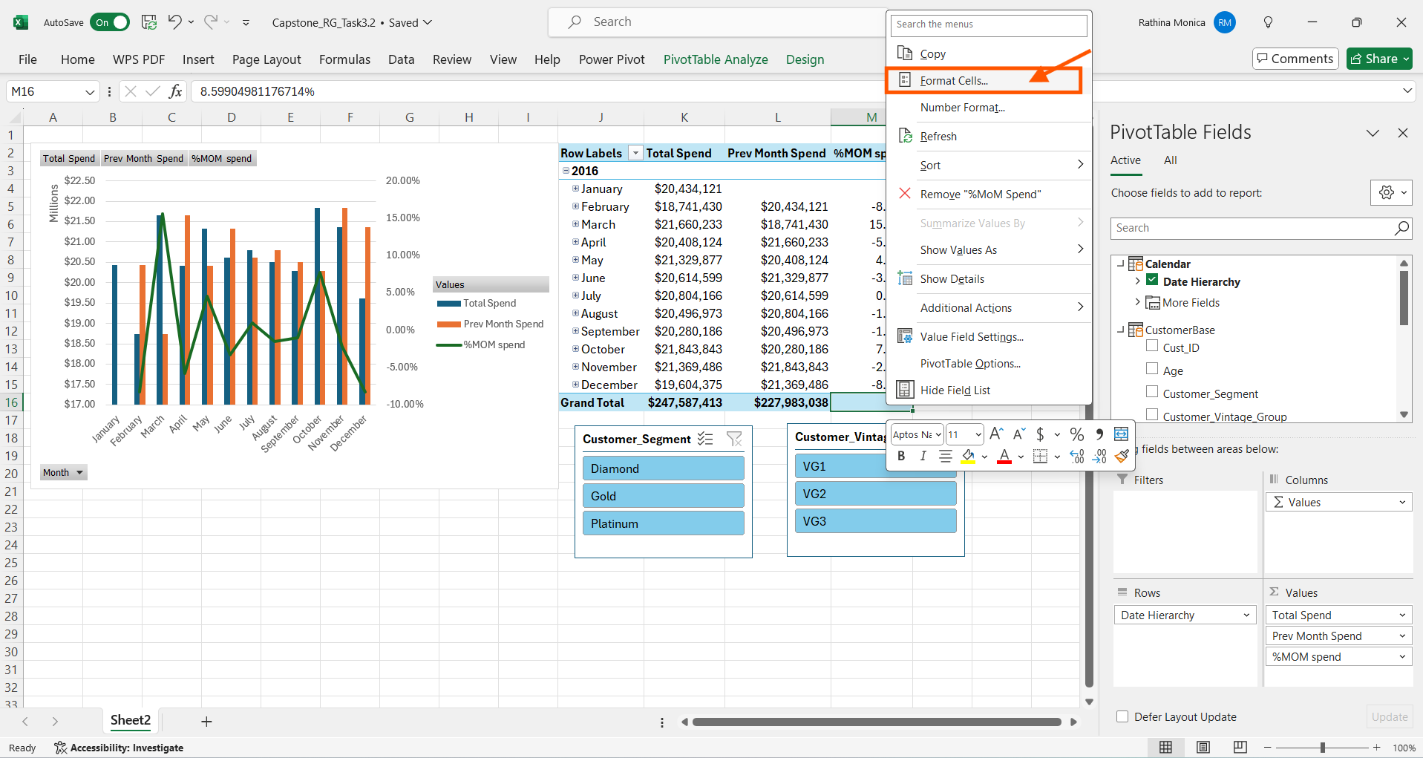

Select “Font” option, under “Color” try to match the color of the font equal to background colour.

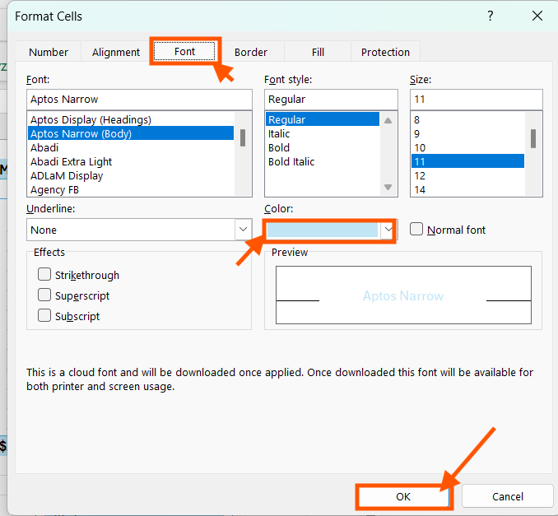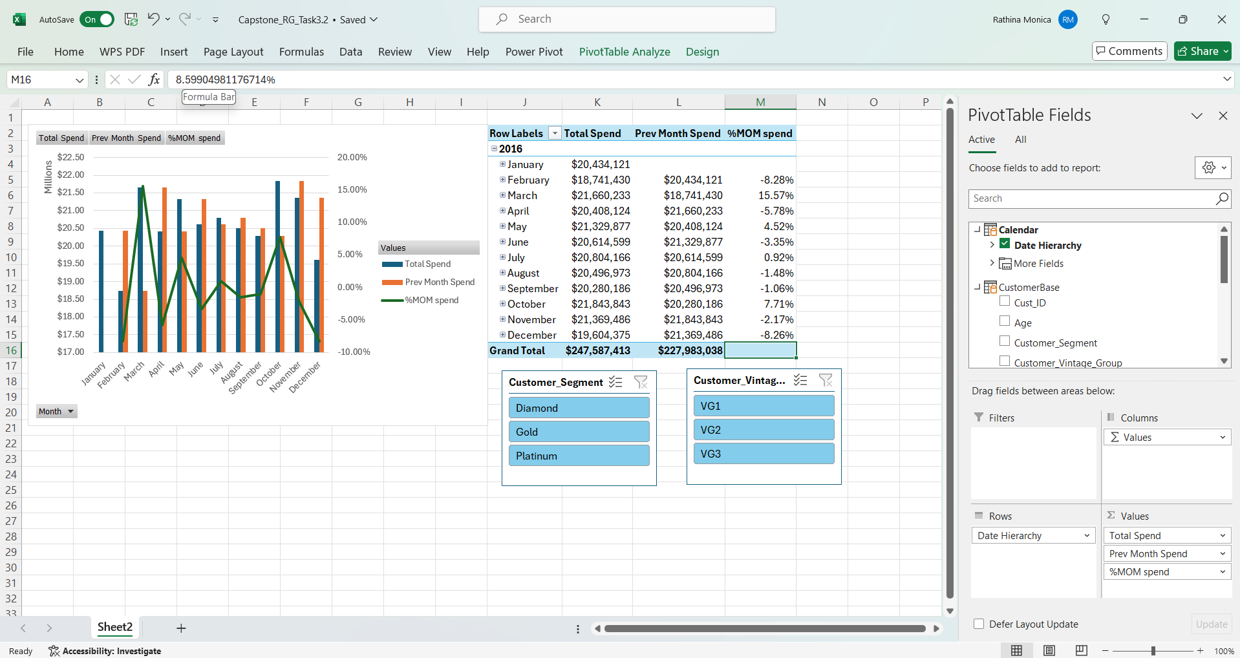

**Method 2:**

Creating a DAX for %MOM using HASONEVALUE and naming it as MOM% using the DAX below.

MOM%:=IF(HASONEVALUE('Calendar'[Month]),IF(ISBLANK([Prev Month Spend]),BLANK(),DIVIDE(([Total Spend]-[Prev Month Spend]),[Prev Month Spend])))

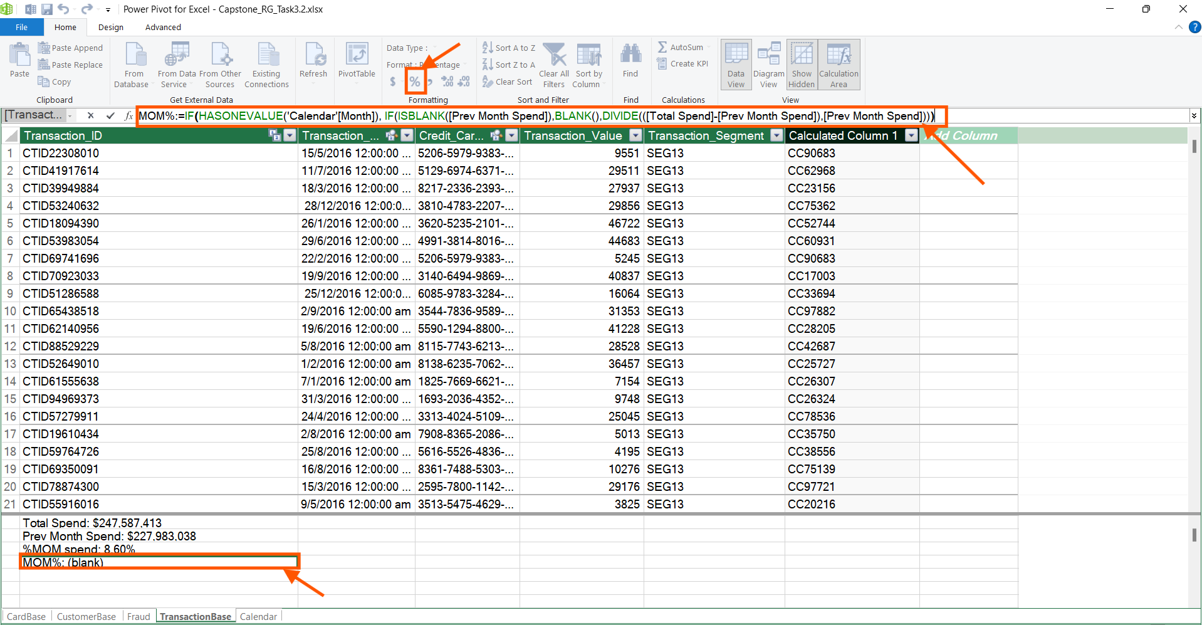

We find that the MOM% in the data model is populated. Creating a Pivot Table and Pivot chart together from the data model in a new worksheet and renaming the worksheet as Method 2.

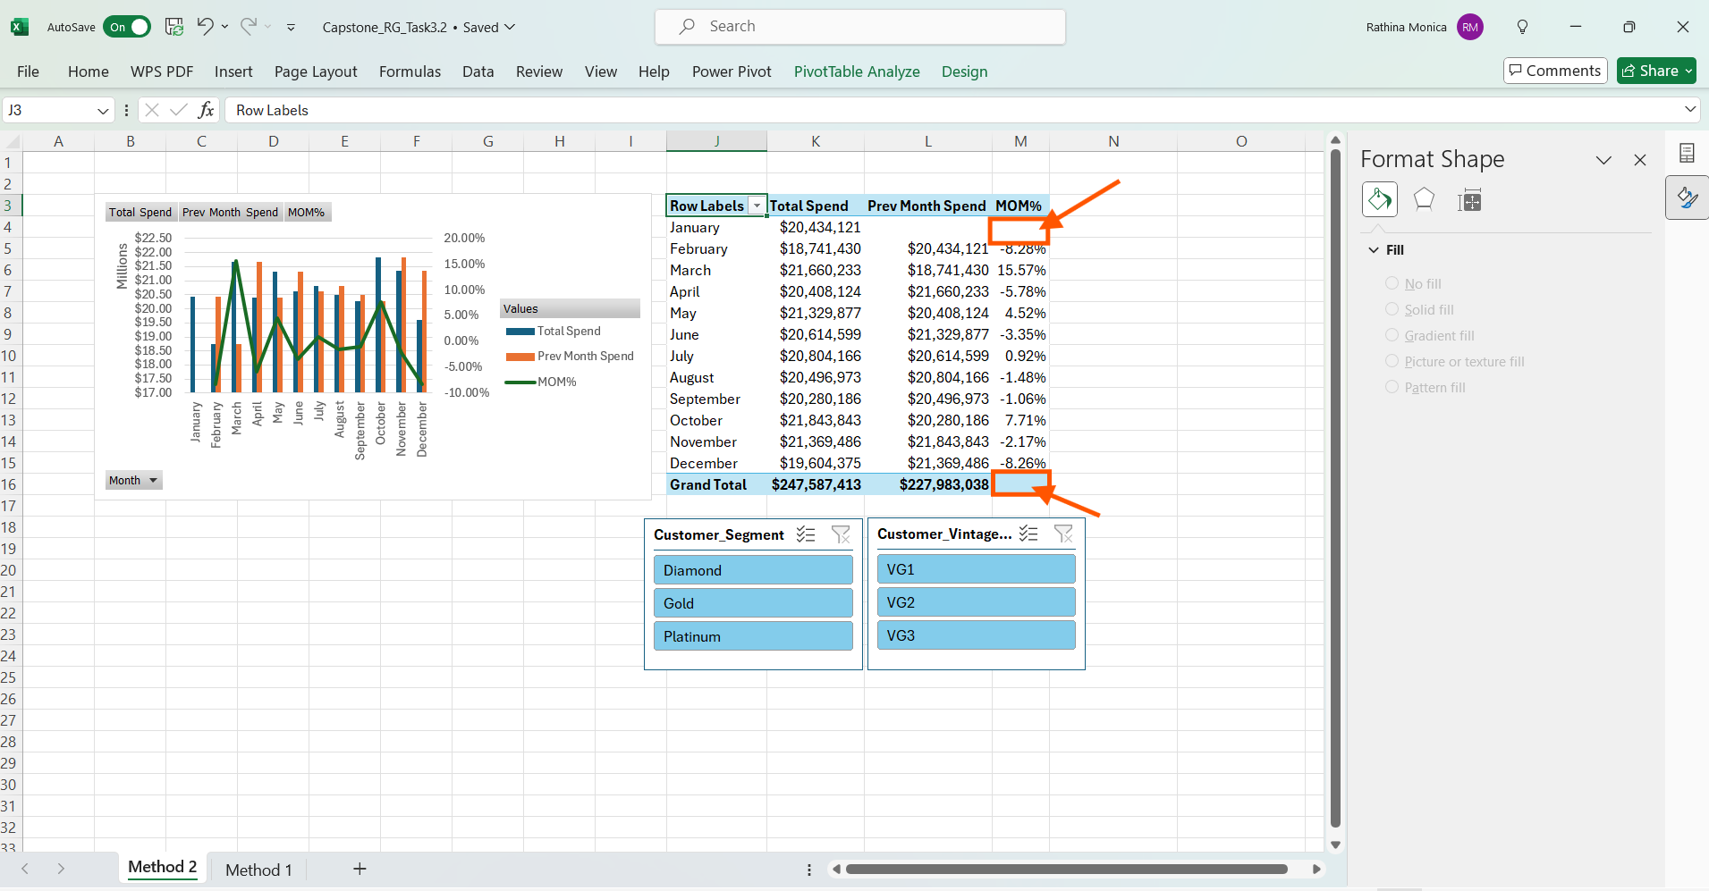

In the above worksheet named as Method 2, we find that the grand total value for MOM% is not there. Now connecting the two slicers and linking them to both pivot chart and table using report connections, we get this final output.

Thus, completing the given Task 3.2. Save the .xlsx file as “capstone_RG_Task3.2.xlsx”.

**Link to Excel work**

https://sg.docworkspace.com/d/sIJKc8bKDAoyBuLQG

**Task 4: Create data visualisations using tables, charts, and interactive dashboards in Power BI**

**Task 4:** Using‘**capstone workbook.xlsx**’,create a dashboard in Power BI as follows –

1. Create 4 cards showing the following metrics-
   1. Total number of credit cards
   2. Total number of Customers
   3. Total number of Transactions
   4. Current Monthly Sales
2. Create a line chart showing Avg Transaction Value by Month.
3. Create a bar chart with the average age for each customer vintage group.
4. Create a matrix/table with rows displaying the ~~quarters,~~ total sales, total number of transactions, total number of fraud transactions, %age of fraudulent transactions and average transaction value for each quarter.
5. Link the charts with the customer segment slicer and month dropdown.

The line chart showing average monthly transaction should not change when you select a month in the month dropdown.

**Note:** Reviewing **Module 9 – Data Visualisation: Power BI I** and **Module 10 – Data Visualisation: Power BI II** will help you accomplish this task

**Estimated Time: 60 minutes**

**Tools:** Power BI

**Submission:** Save your output in .pbix format with the file name [Capstone_Initial of first name + last name_Task 4.1]. Upload the Power BI file together with this template filled with your answers.

**Step 1:**

Open a Power BI blank report

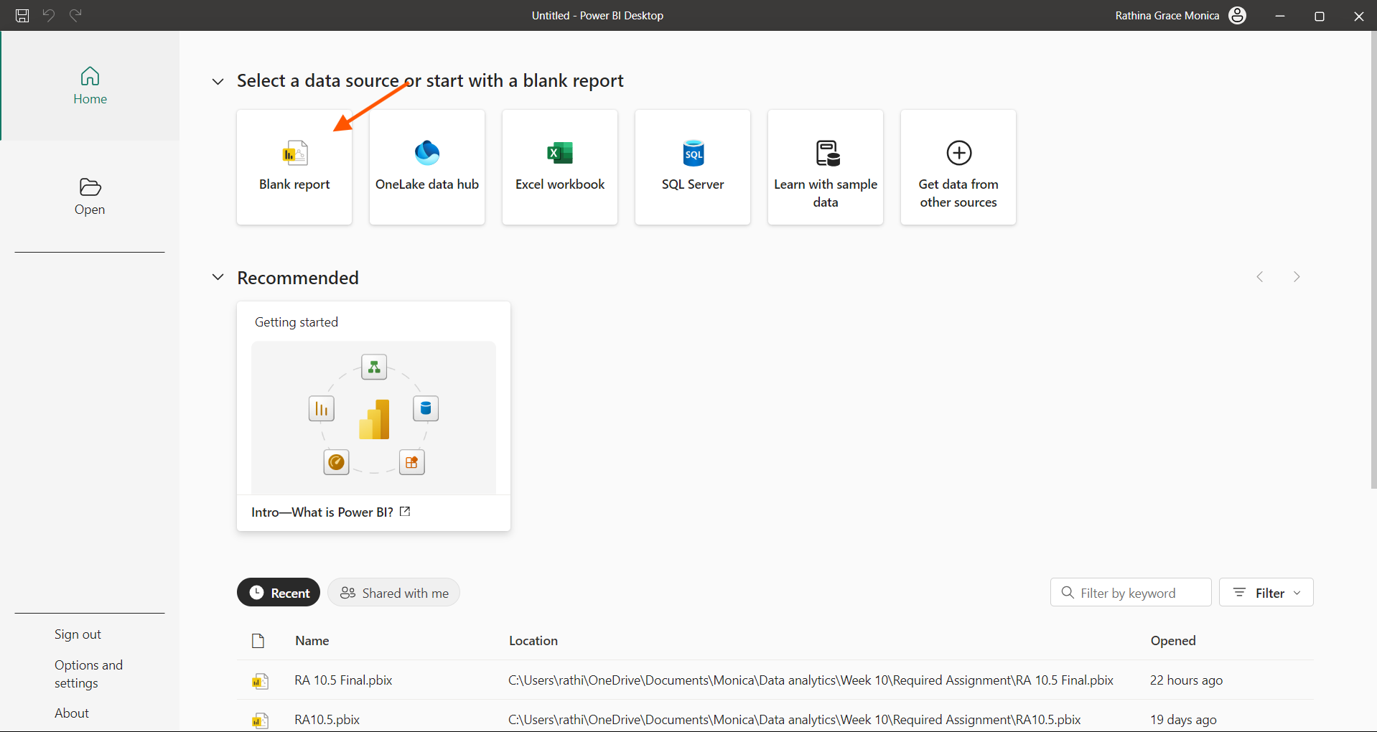

**Step 2:**

Click “Excel Workbook”, Navigate and load the “Capstone workbook.xlsx file”, Click “Open”.

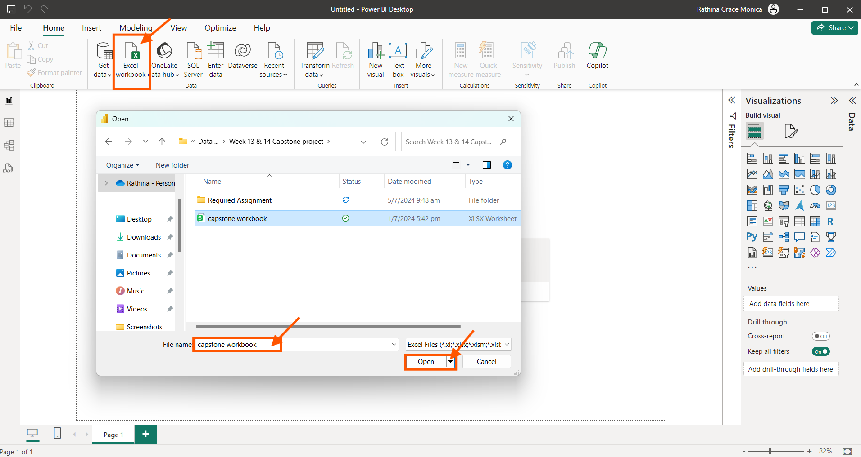

**Step 3:**

Select all the four tables and click “Load”.

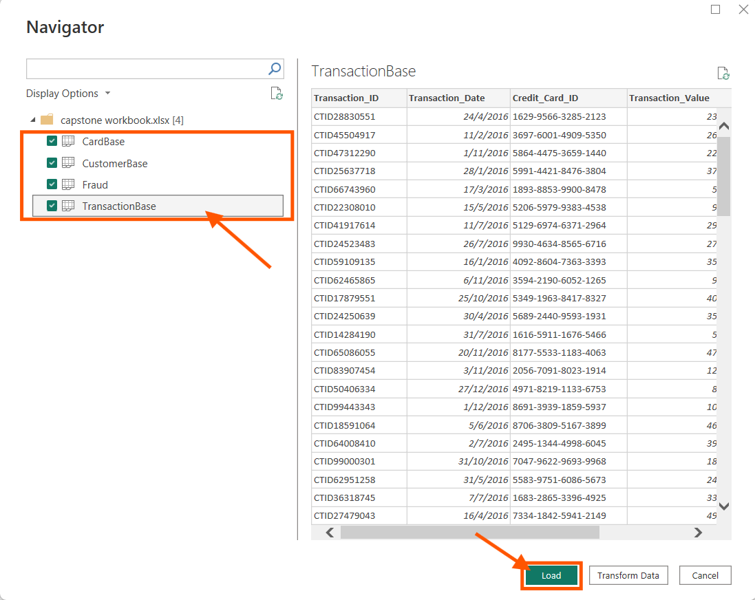

**Step 4:**

We find all the tables are loaded properly, Now click the “Table view” to do the necessary DAX functions

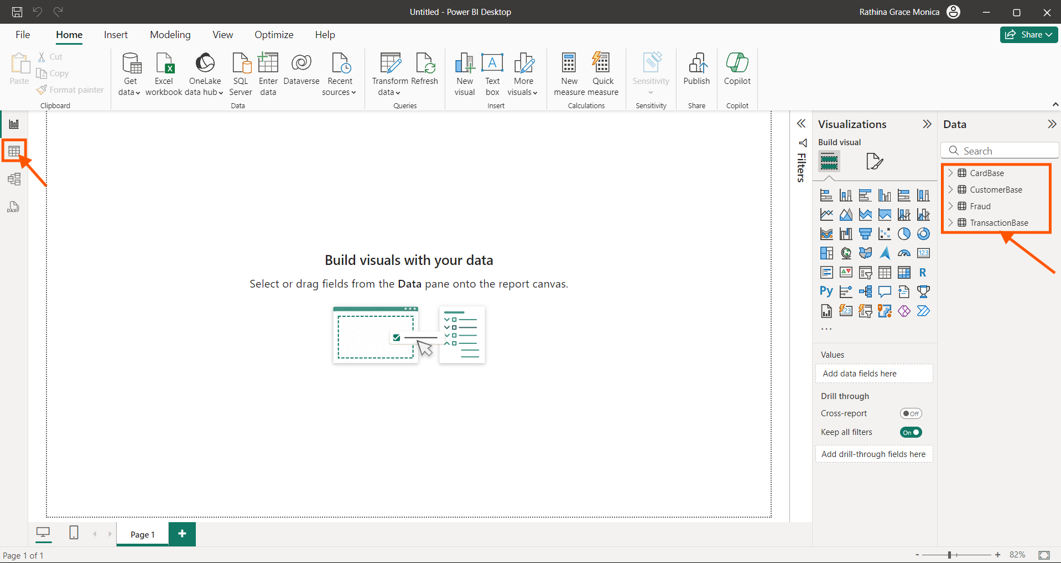

**Step 5:**

To Create new measure, select “New Measure”

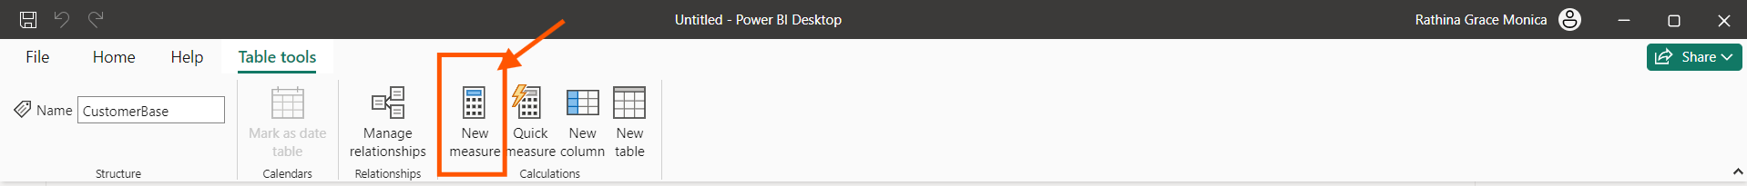

The total number of Credit cards are calculated in the “Cardbase” table using the DAX formulae below

Total Number of Credit Cards = DISTINCTCOUNT(CardBase[Card_Number])

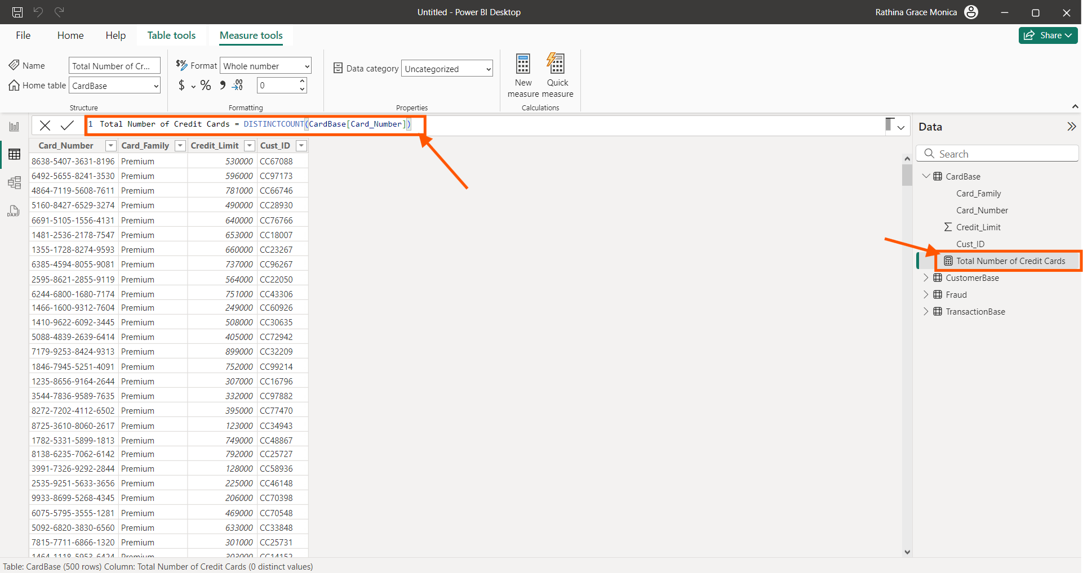

**Step 6:**

The total number of customers are calculated in the “Customerbase” table using the DAX formulae below.

Tota Number of Customers = DISTINCTCOUNT(CustomerBase[Cust_ID])

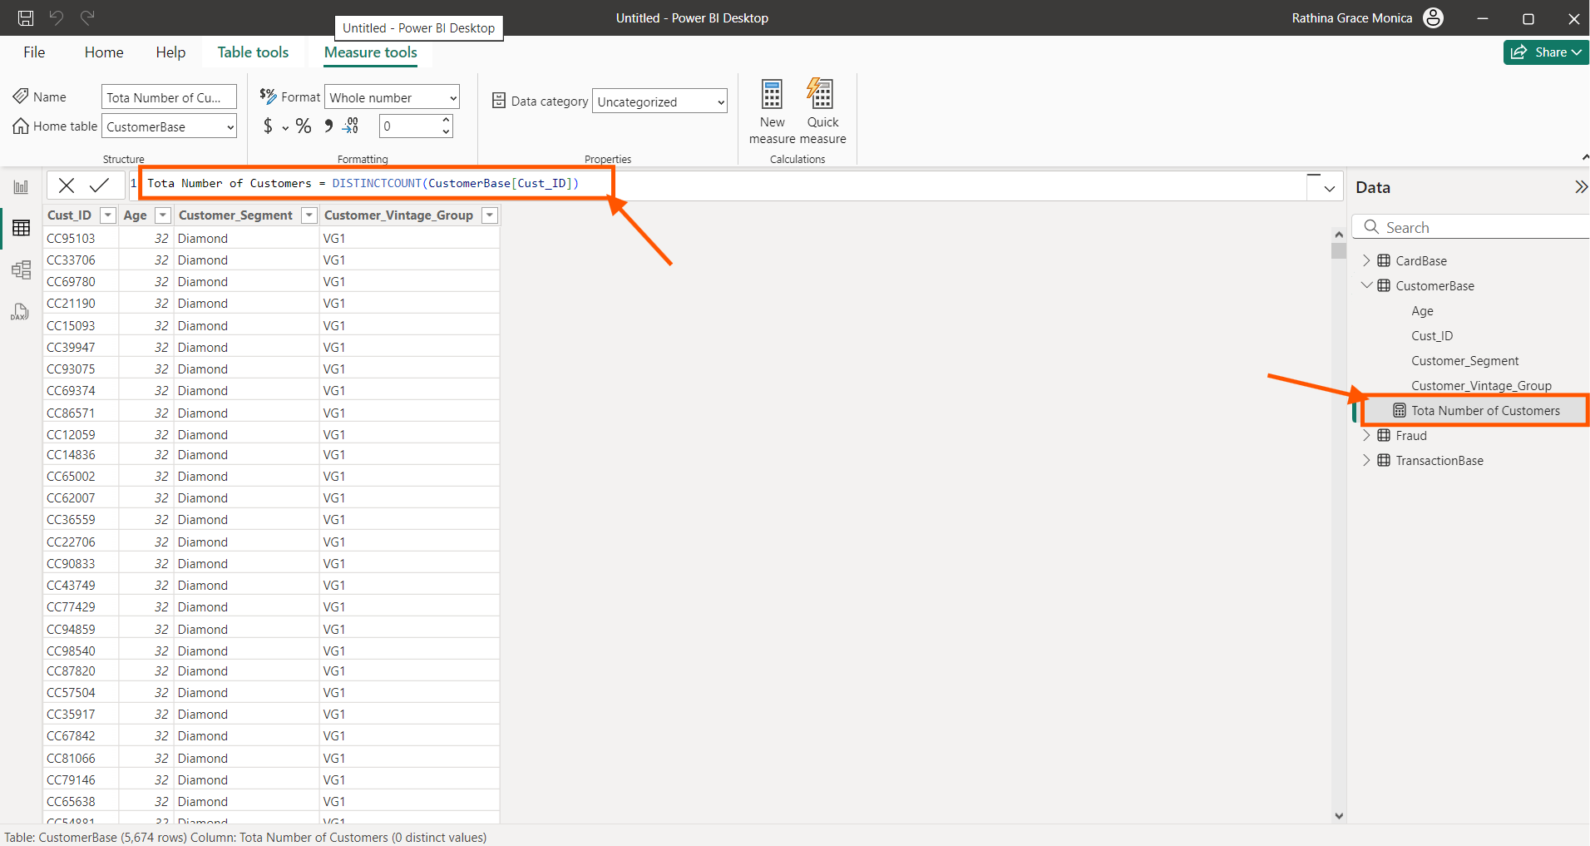

The total number of Transactions are calculated in the “Transactionbase” table using the DAX formulae below.

Total number of Transactions = DISTINCTCOUNT(TransactionBase[Transaction_ID])

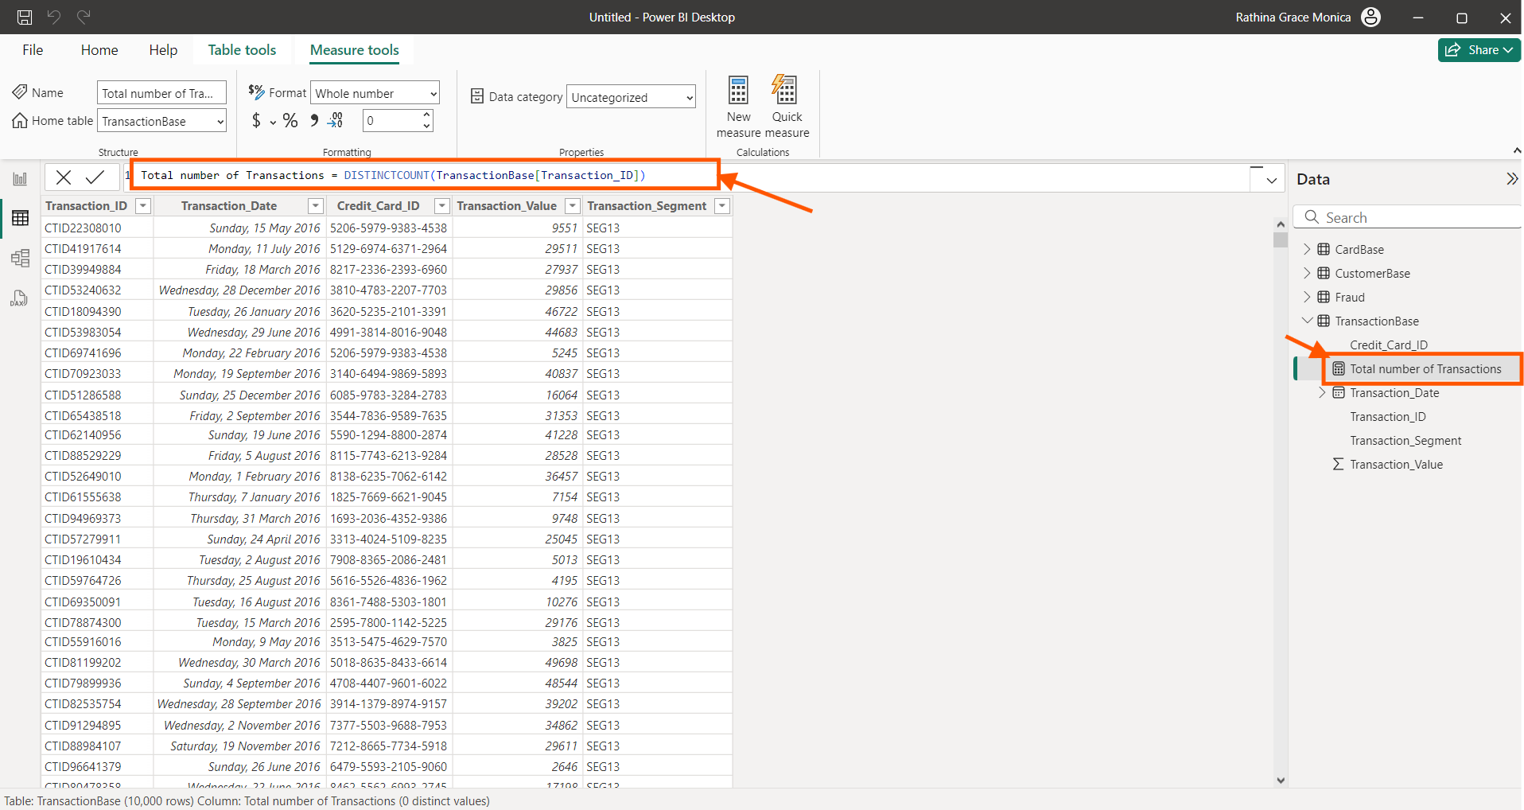

**Step 7:**

Create the date table with start date 01-01-2016 and end date 31-12-2016

Select “New Table” and using the following DAX function create the date table.

Date Table = CALENDAR(DATE(2016,01,01),DATE(2016,12,31))

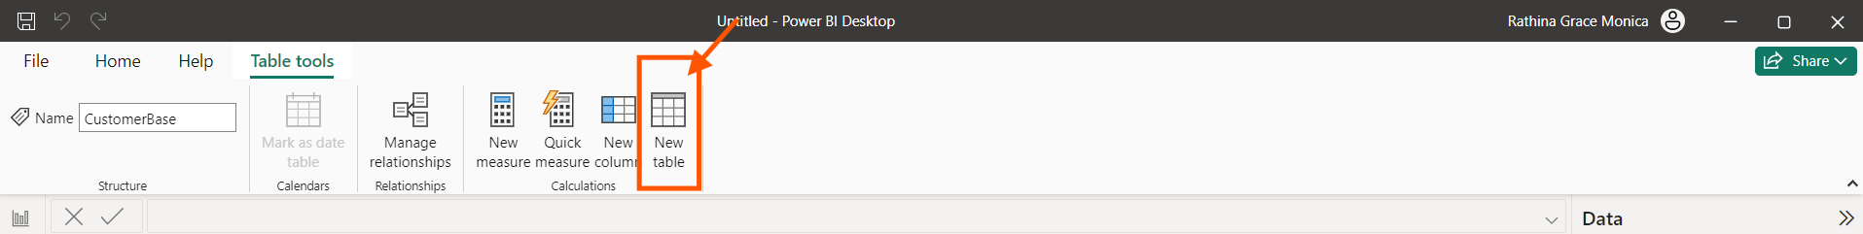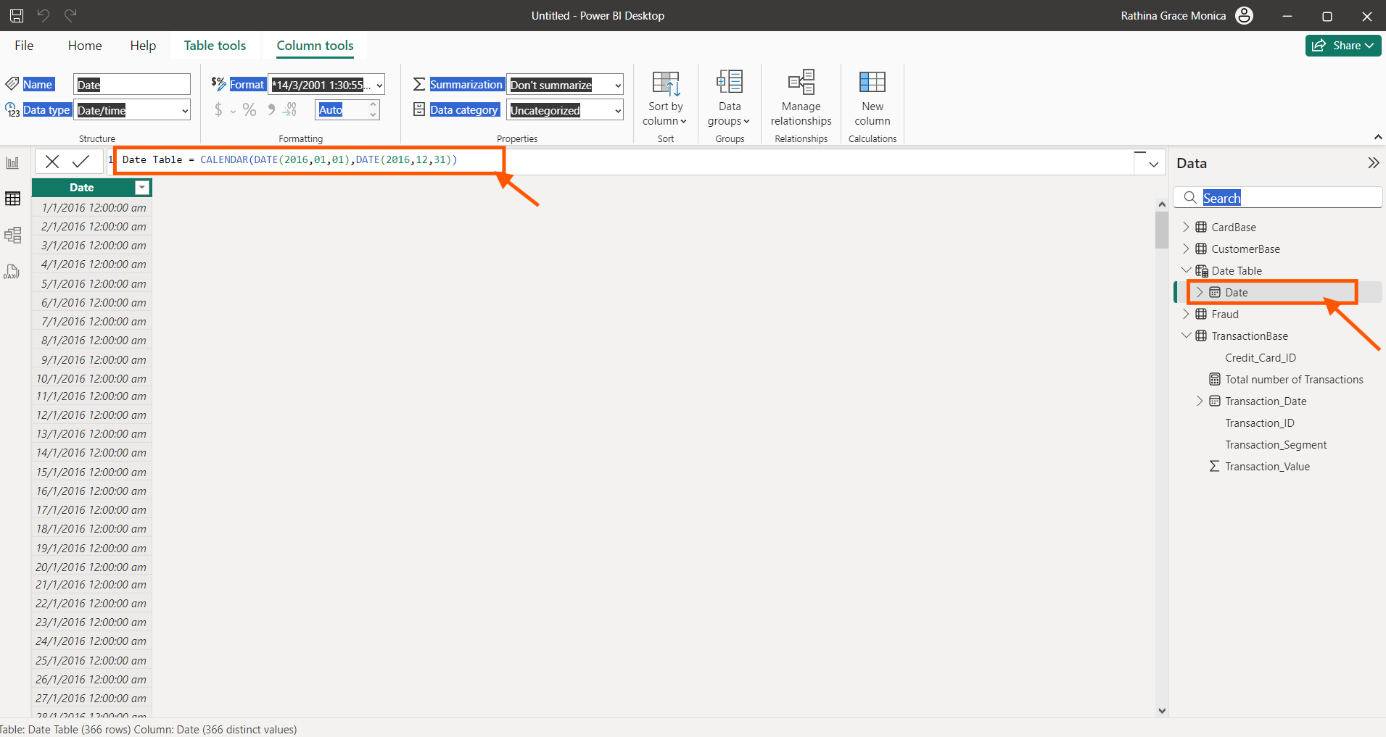

**Step 8:**

To create few more columns in the Date table. Click “New Columns”. Using the DAX function create the new column year.

Year = [Date].[Year]

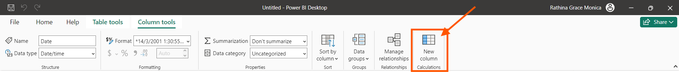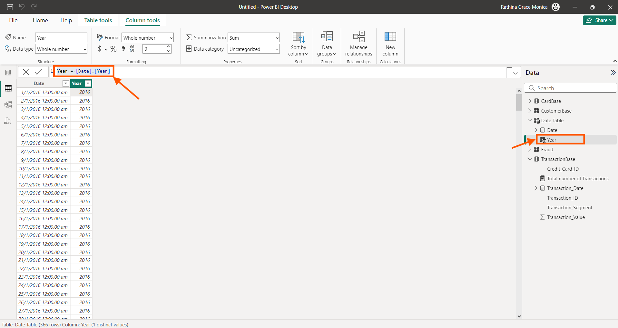

Month = [Date].[Month]

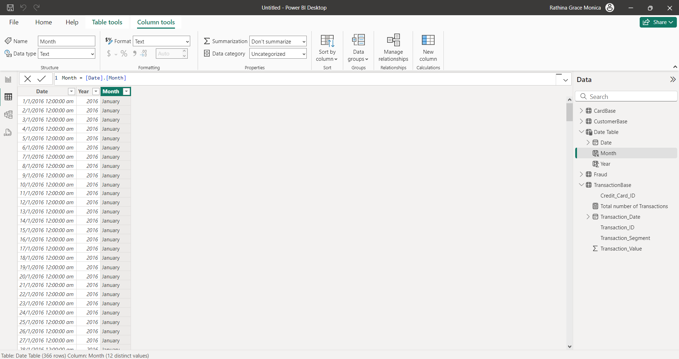

Qtr = [Date].[Quarter]

Select “Diagram View” to manage the relationship among the tables.

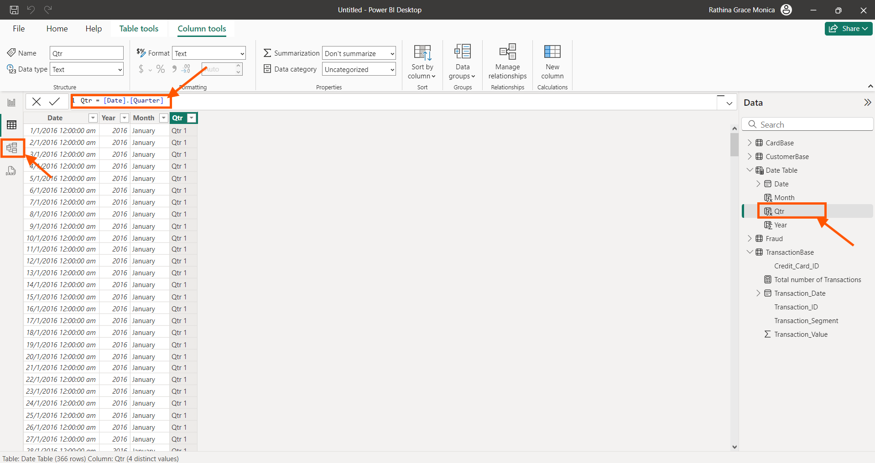

We find all the files are properly related and a Year Hierarchy is also created.

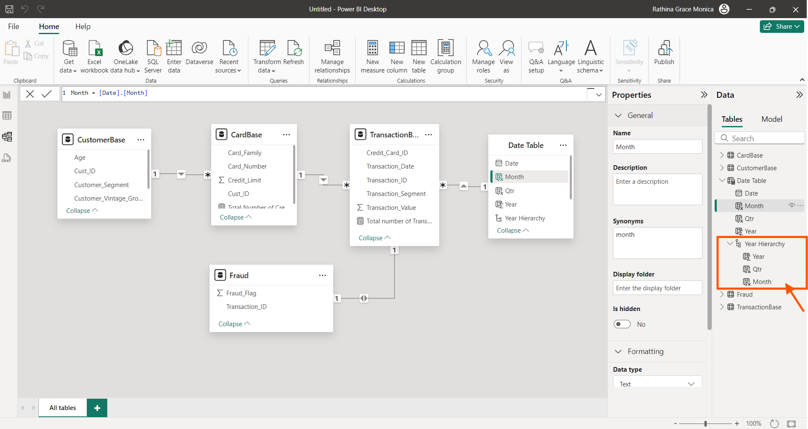

Date Table is renamed as “Calendar” table for convenience.

Sort the Months in the Calendar table according to Months number. By creating a new column months number using the below DAX

Month No = [Date].[MonthNo]

Select the “Months” column, select “Sort column by”, Choose “Months No.”

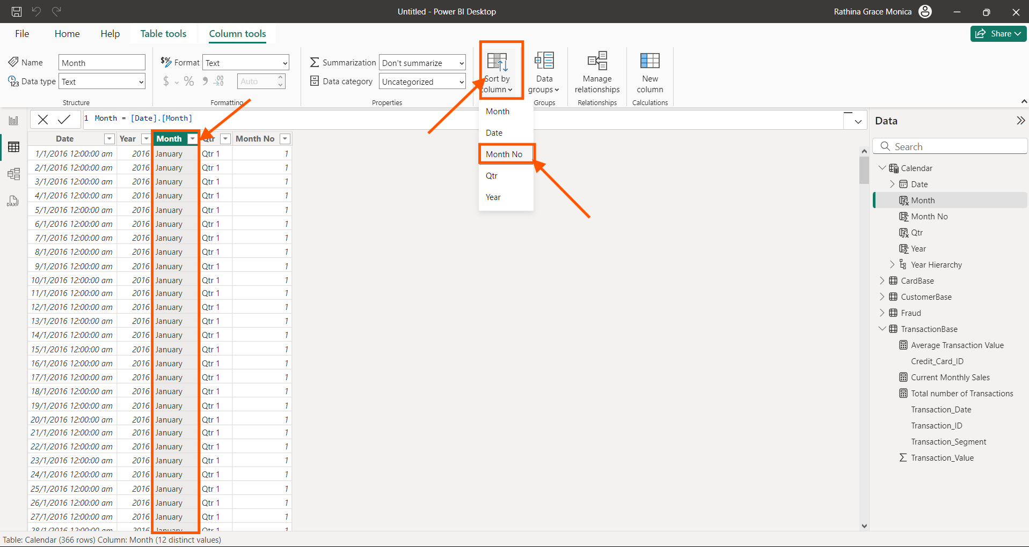

**Step 9:**

Now creating the last measure Current Monthly sales. Using the following DAX function.

Current Monthly Sales = TOTALMTD(SUM(TransactionBase[Transaction_Value]),'Calendar'[Date] = MAX('Calendar'[Date]))

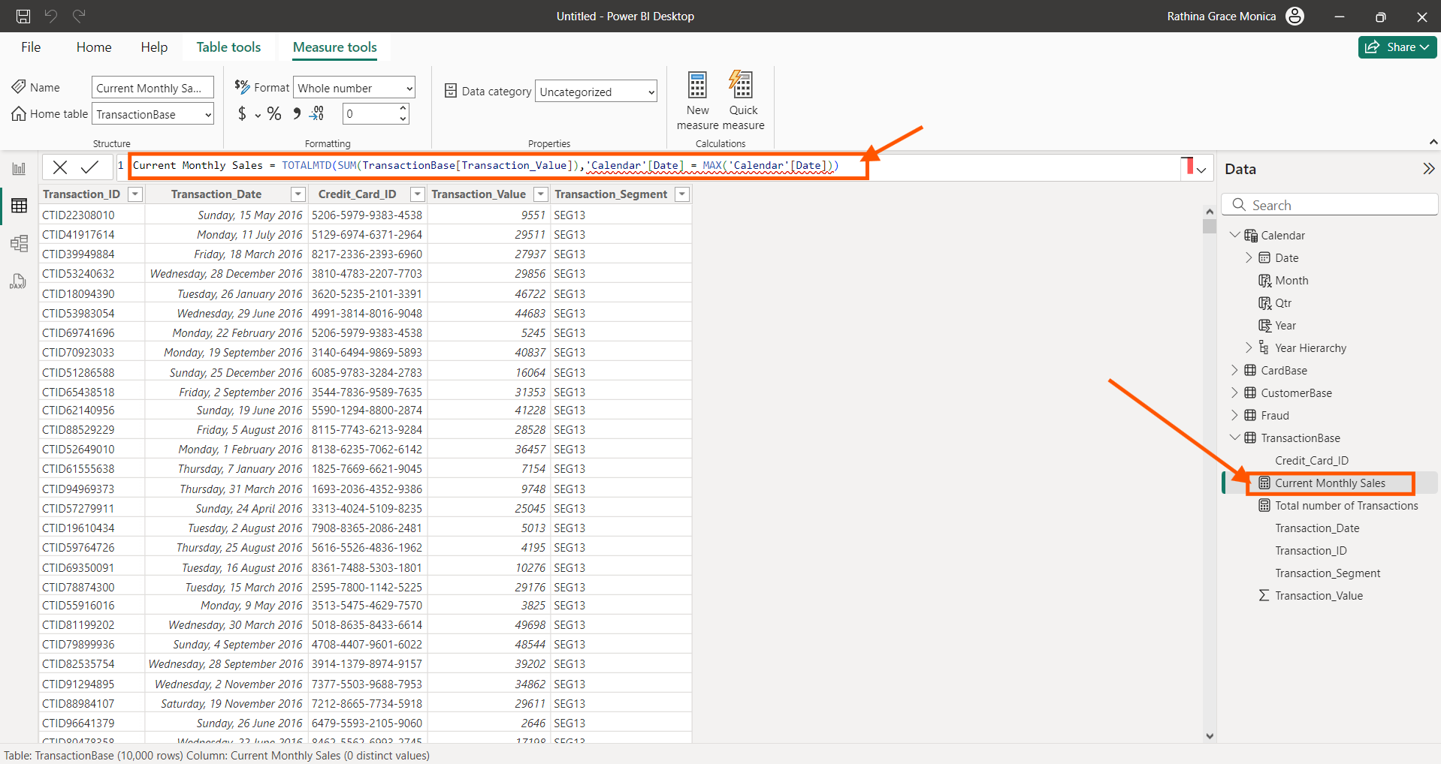

**Step 10:**

In the “Report View”, Select “Cards” from the “Build Visuals”, Choosing “Total number of credit cards” measure from “Cardbase” table.

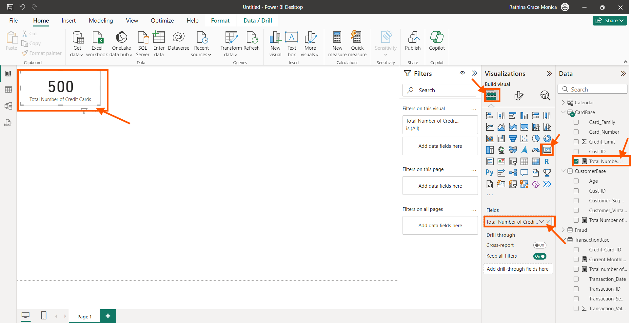

**Step 11:**

Now changing the background, font style, font size and colour options of the card in the format menu.

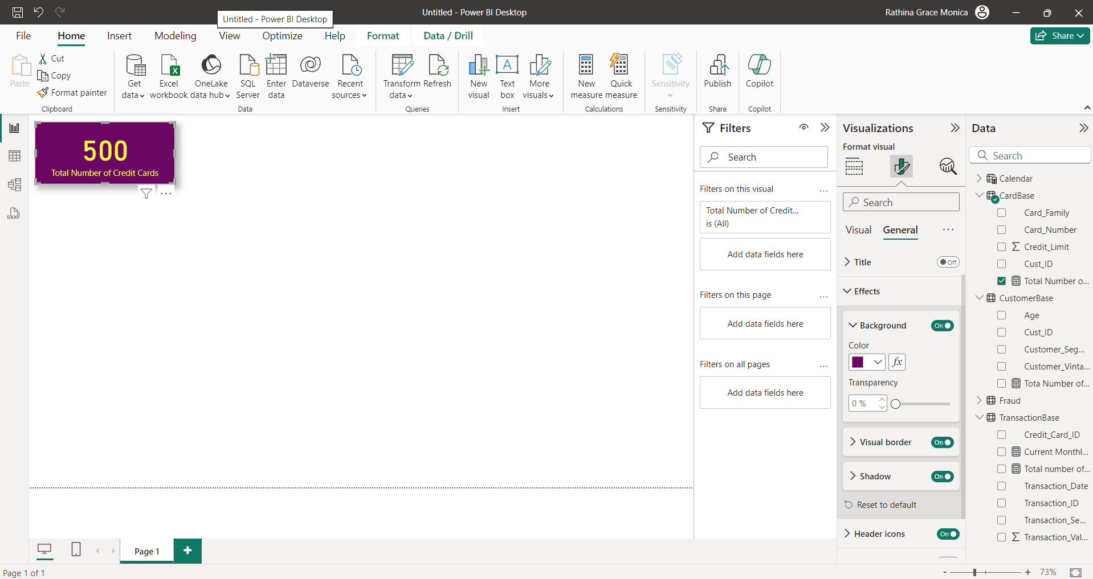

**Step 12:**

Repeat Step 10 and Step 11 and generate the other 3 cards.

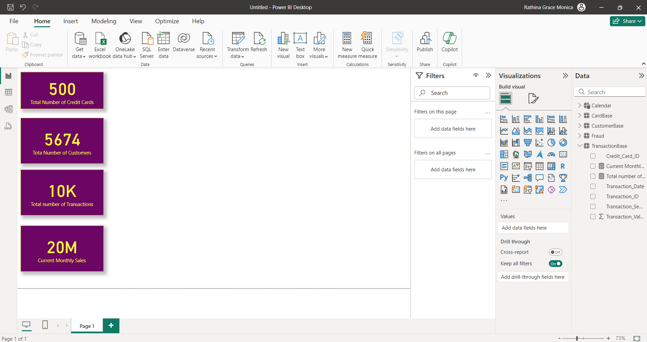

**Step 13:**

Create a new measure “Average Transaction Value” under the “Transaction” table using the following DAX function.

Average Transaction Value = AVERAGE(TransactionBase[Transaction_Value])

Select the “Report View”, to create a line chart.

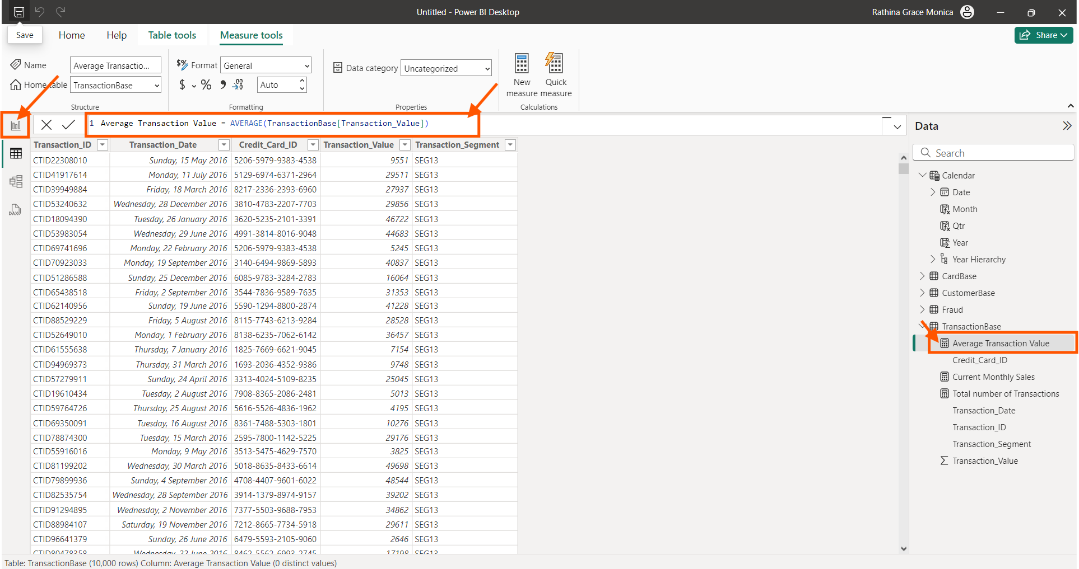

**Step 14:**

Select “Line Chart” from “Build Visuals”, Choose “Months” from “Calendar” table along X axis and “Average Transaction Value” from the “Transaction Table” along the Y axis.

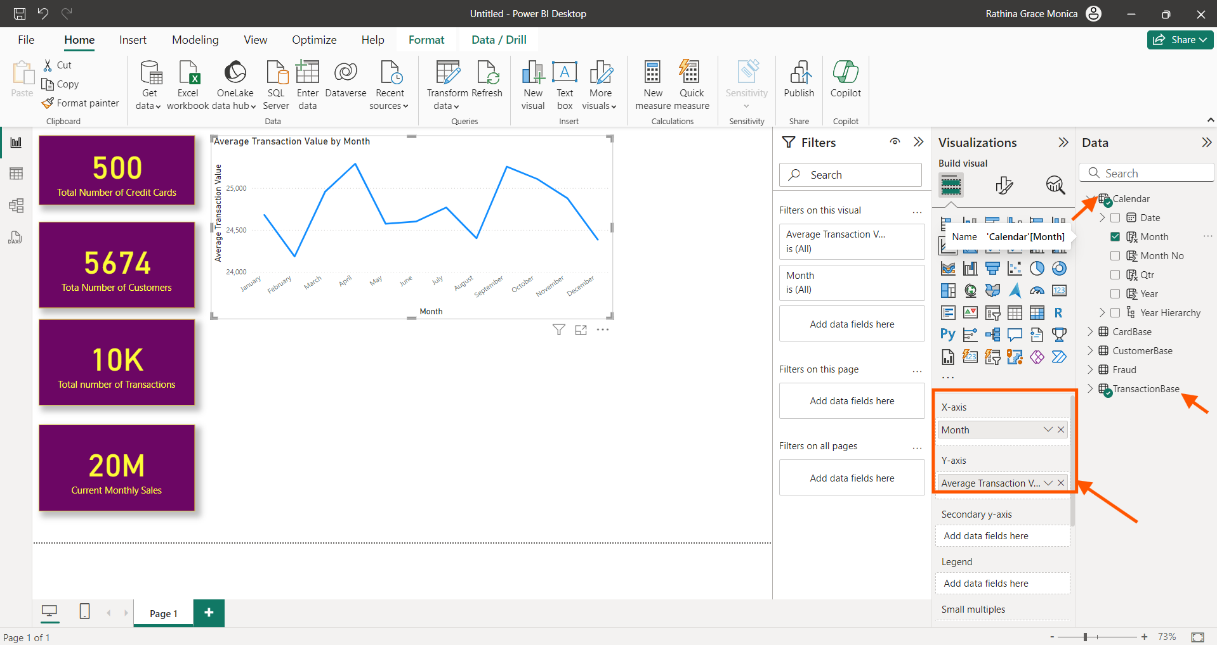

**Step 15:**

Changing the font size, colour and background of the title in the format option

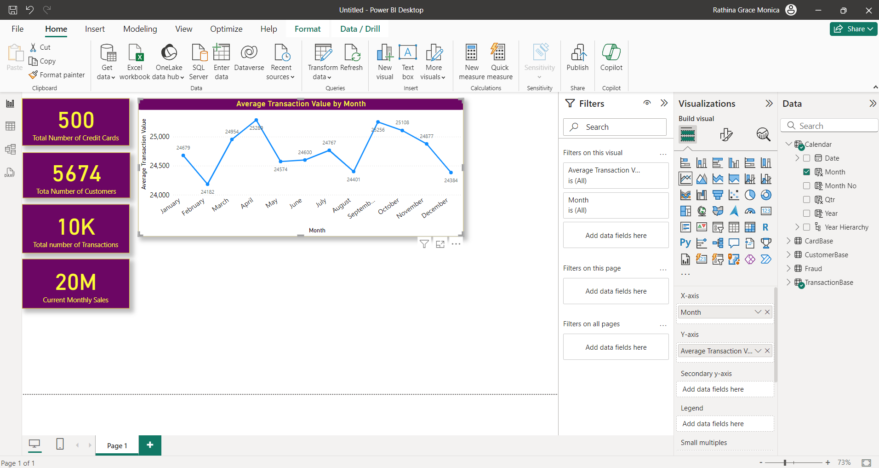

**Step 16:**

Calculate a new measure “Average Age of Customers” in the “Customerbase” table using the following measure below.

Average Age of customer = AVERAGE(CustomerBase[Age])

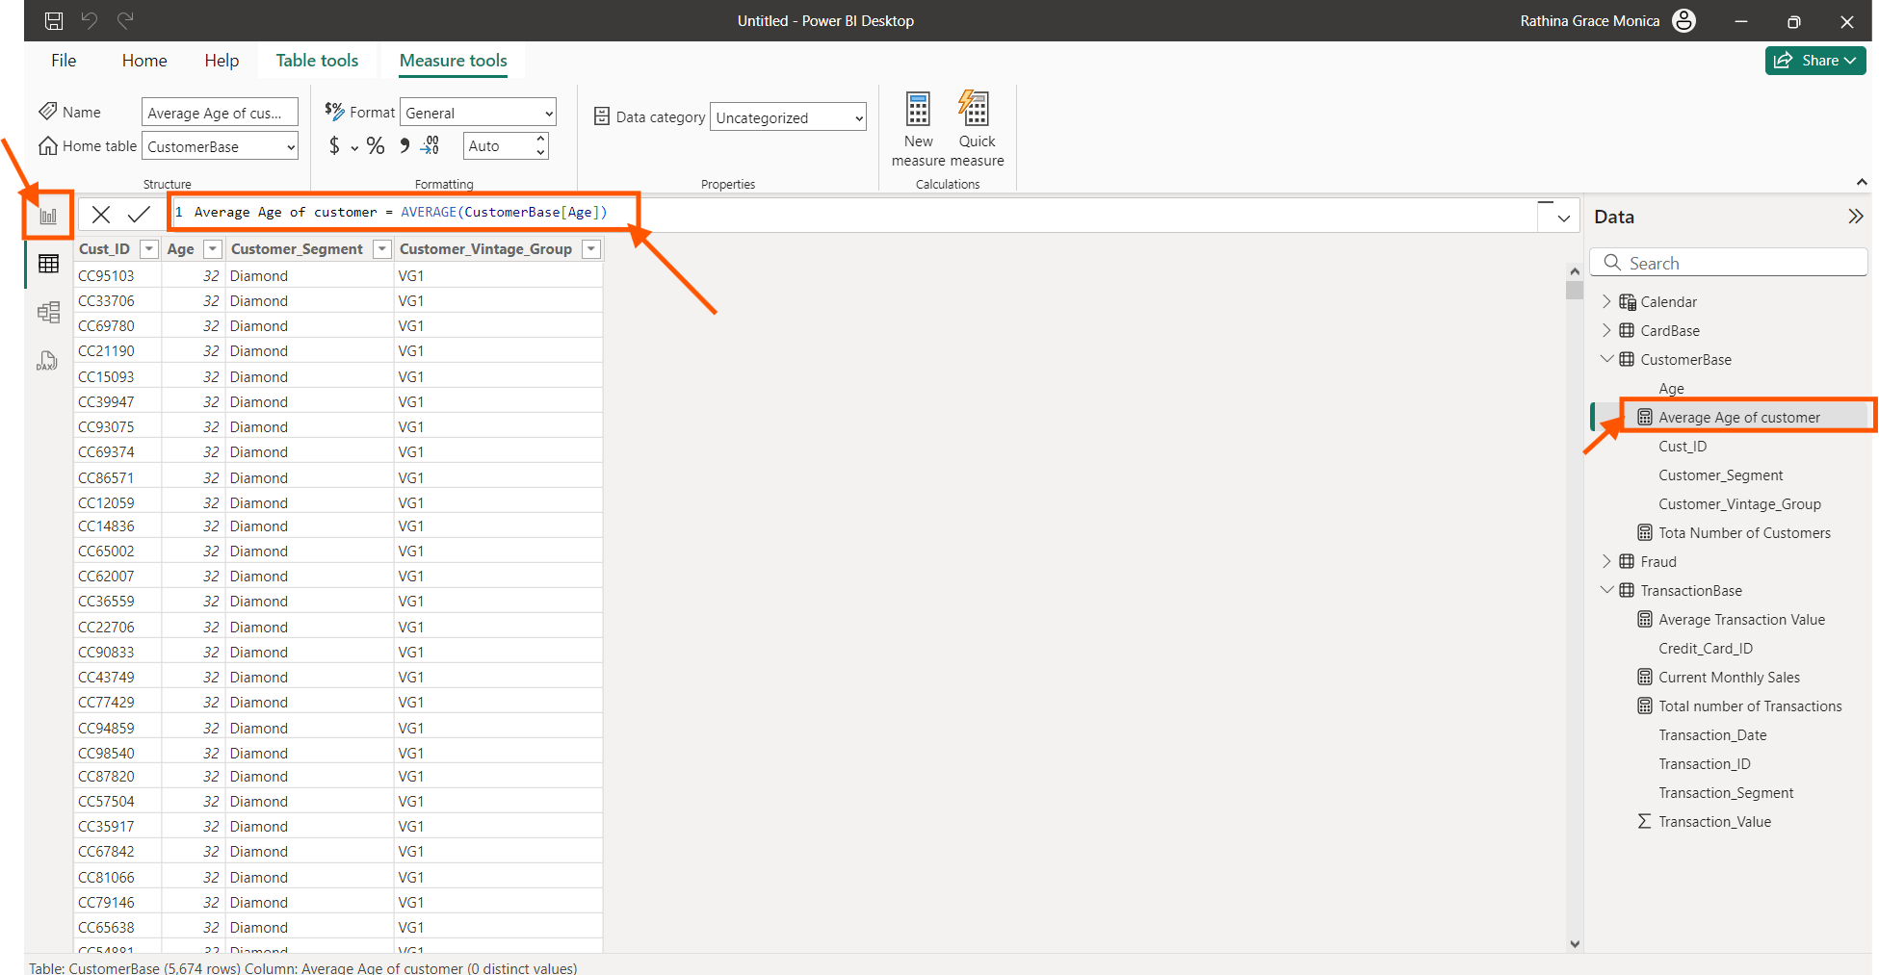

**Step 17:**

In the report view, select “Stacked column Chart” under “Build Visuals”, choose “Customer Vintage group” along the X axis and choose "Average Age of customer” along Y axis.

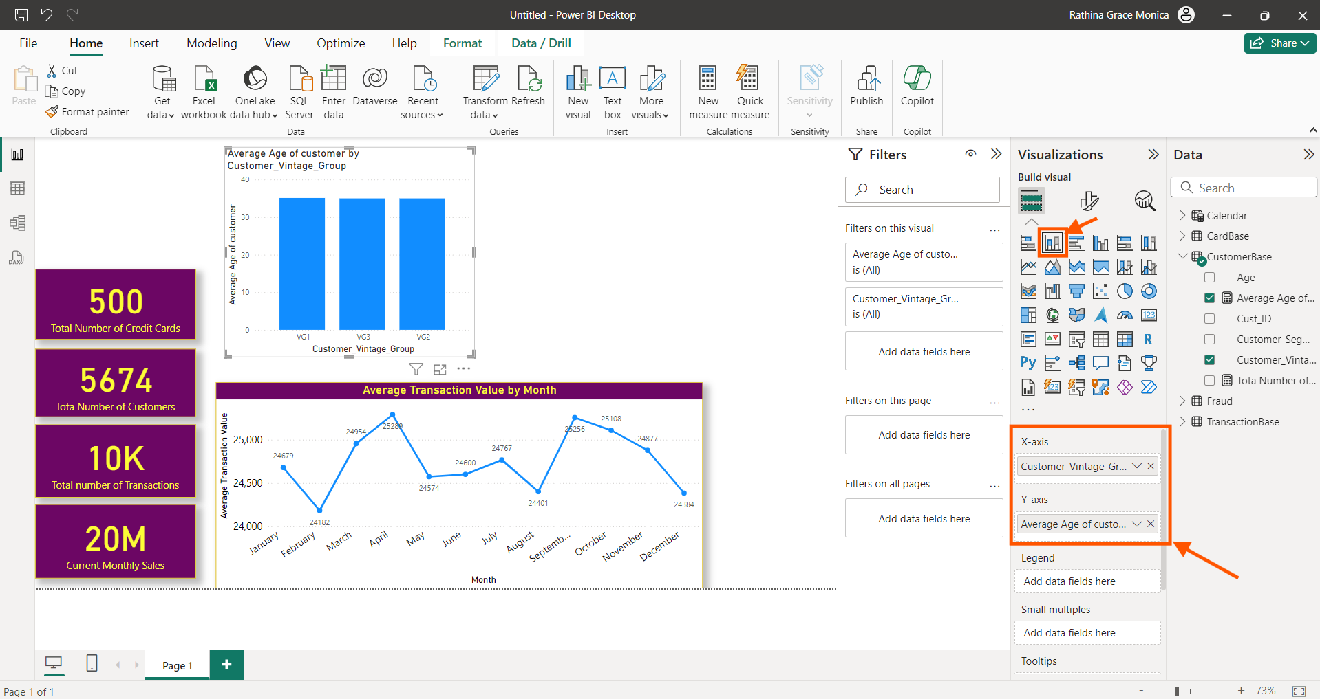

**Step 18:**

Now changing the visual effects of the graph in the format option.

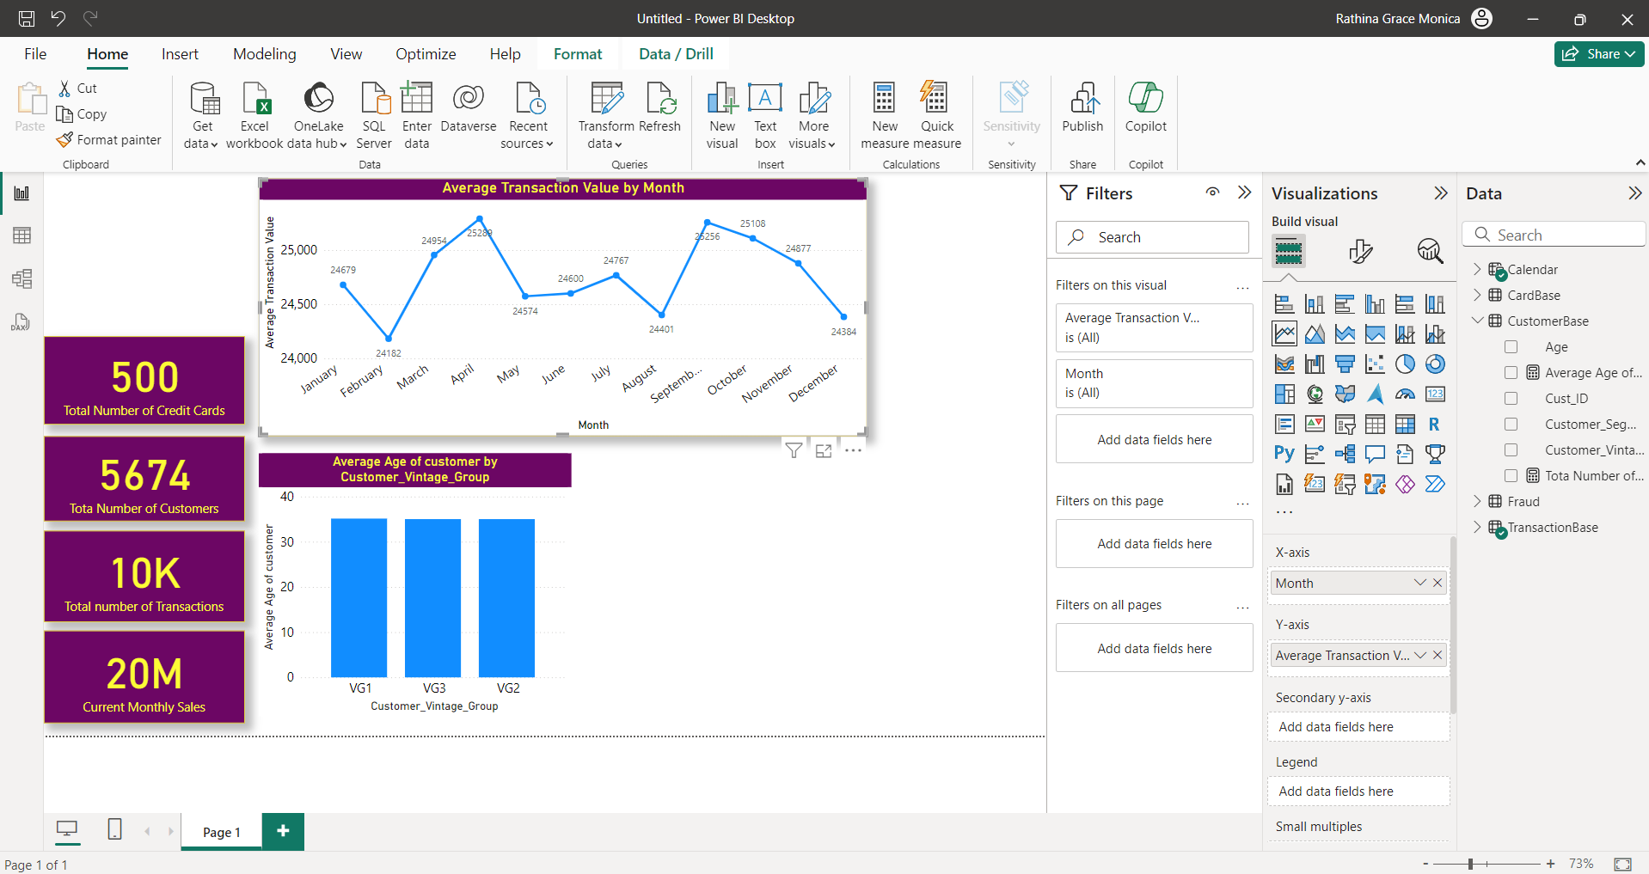

**Step 19:**

Create a new measure in the “Transactionbase” table as “Total Sales” using the following DAX function below.

Total Sale = SUM(TransactionBase[Transaction_Value])

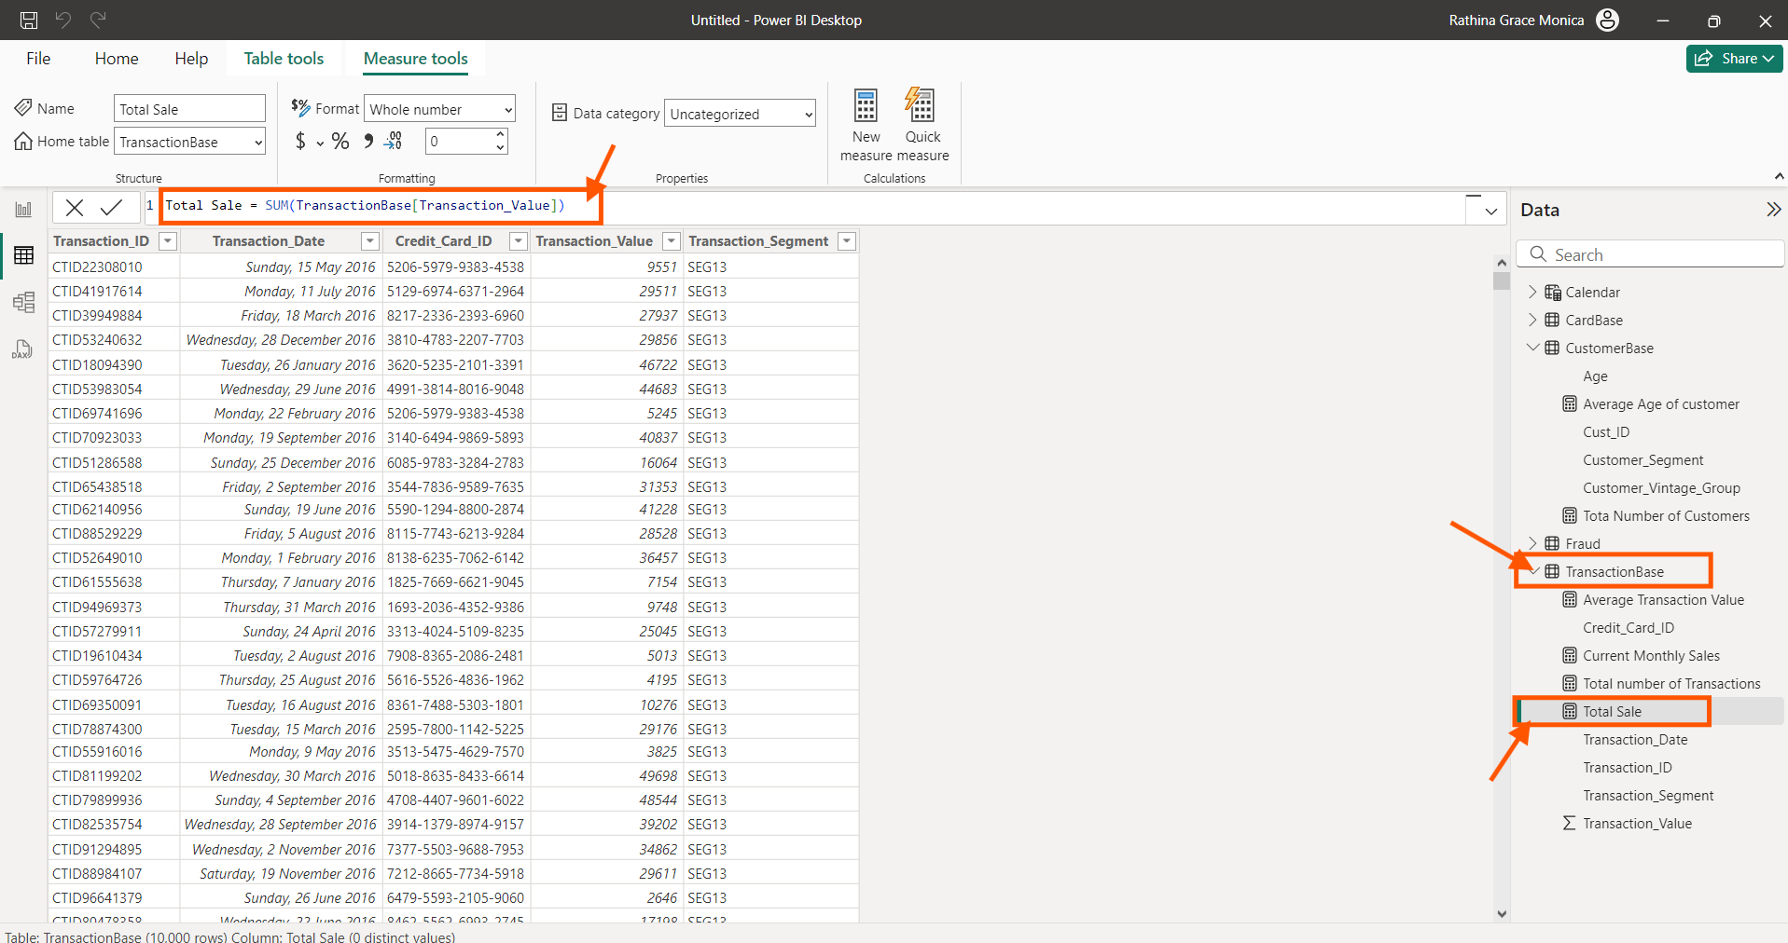

**Step 20:**

Create a new measure “Total Number of Fraudulent transactions” under the “Fraud” table using the DAX measure below.

Total number of Fraudulent transaction = DISTINCTCOUNT([Transaction_ID])

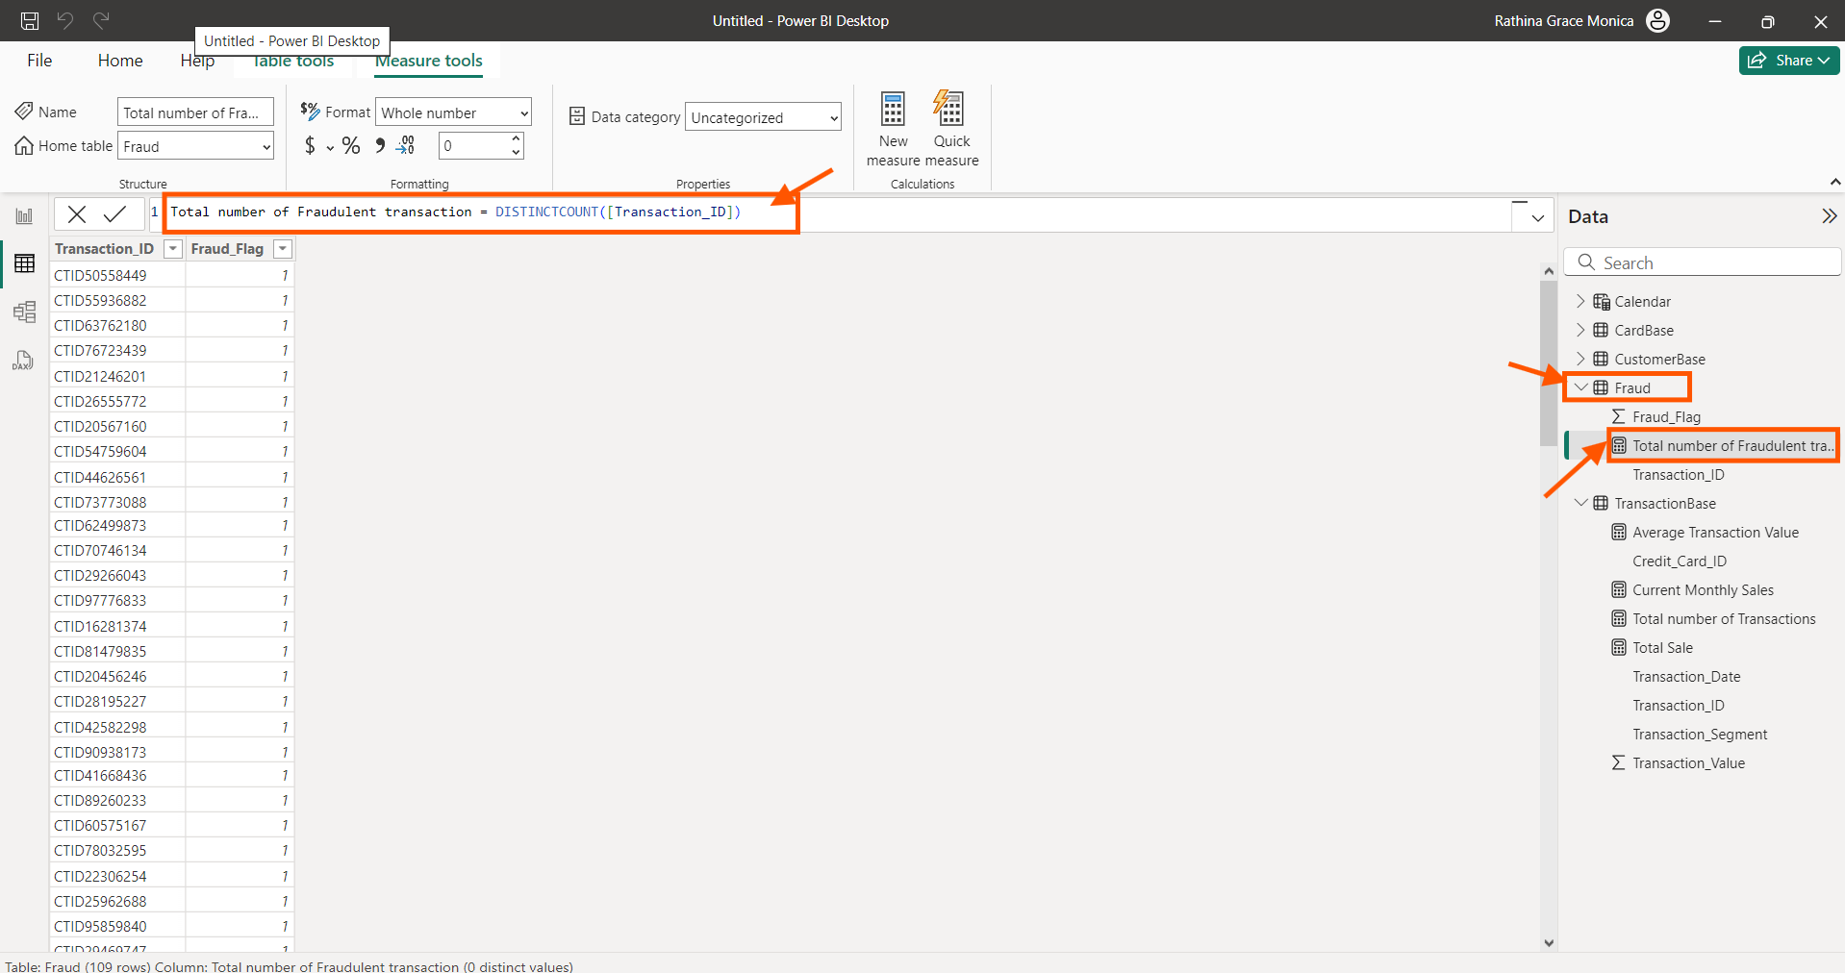

**Step 21:**

Create a new measure “Total Number of Fraudulent transactions” under the “Fraud” table using the DAX measure below.

% Fraud Transac = Divide(Fraud[Fraud transaction],TransactionBase[trans count])

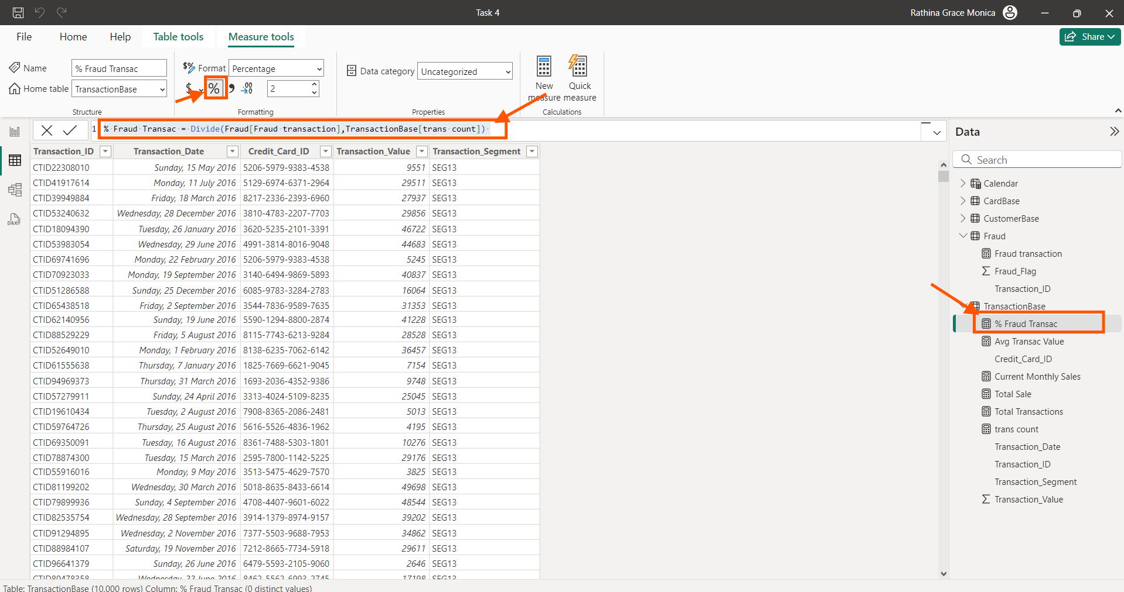

**Step 22:**

On the report View, Select “Matrix” from “Build Values”. Select “Qtr” column from “Calendar” table under rows column, Select “Total Sales”, “Total Transaction”, “Fraud Transaction”, “Average Transaction Value”, “% Fraud Transaction” along the value section.

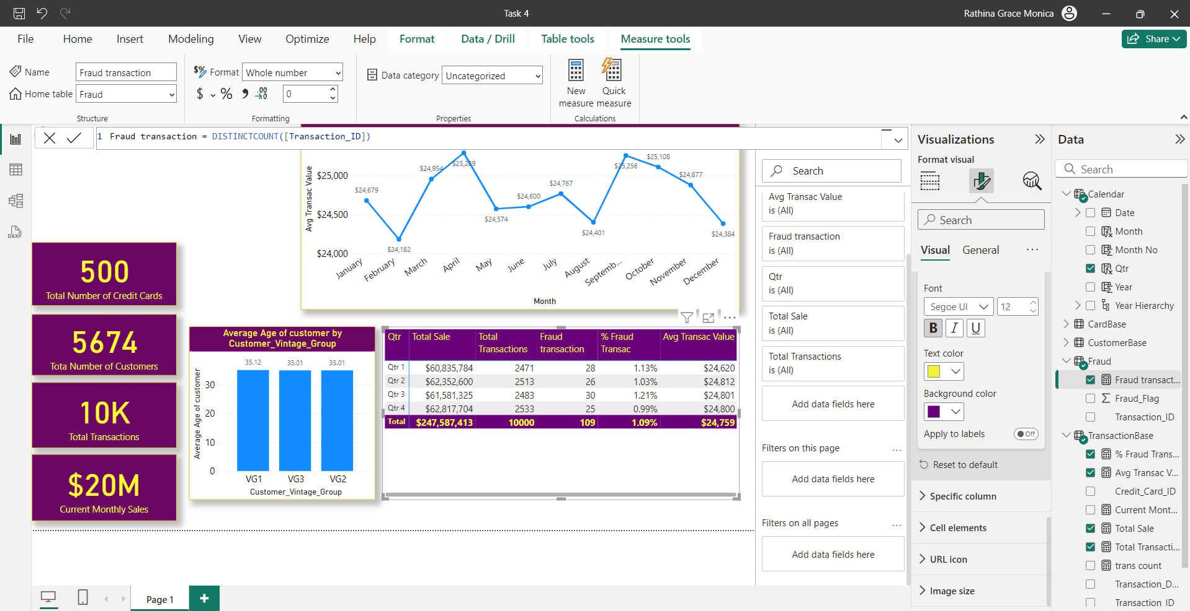

**Step 23:**

Adding a month slicer, The slicer works for all the graph and Martix. Using Edit interaction for the slicer. Choosing “None” for Line chart and “Highlight” for all the other charts. In the format option changing the slicer type to “Drop down type”. The slicer operation is highlighted for the month of July.

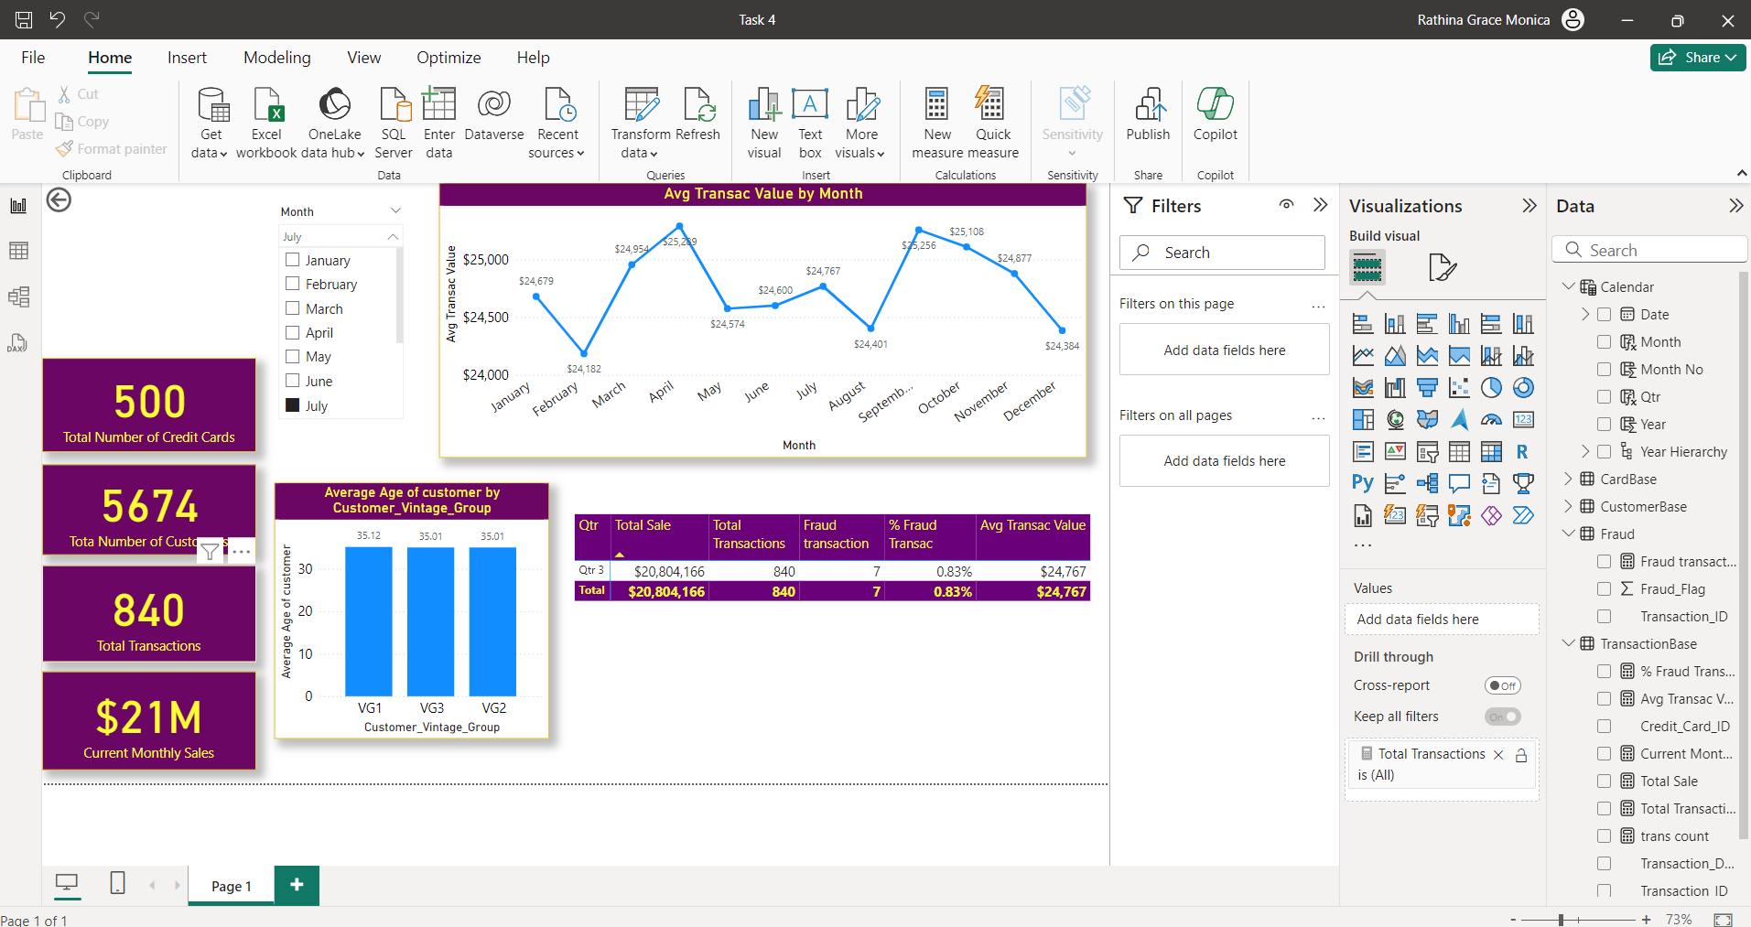

**Step 24:**

Clicking on any canvas point Add the second slicer on customer segment. It is selected with Highlight option for all the charts. So, all the charts vary for every value.

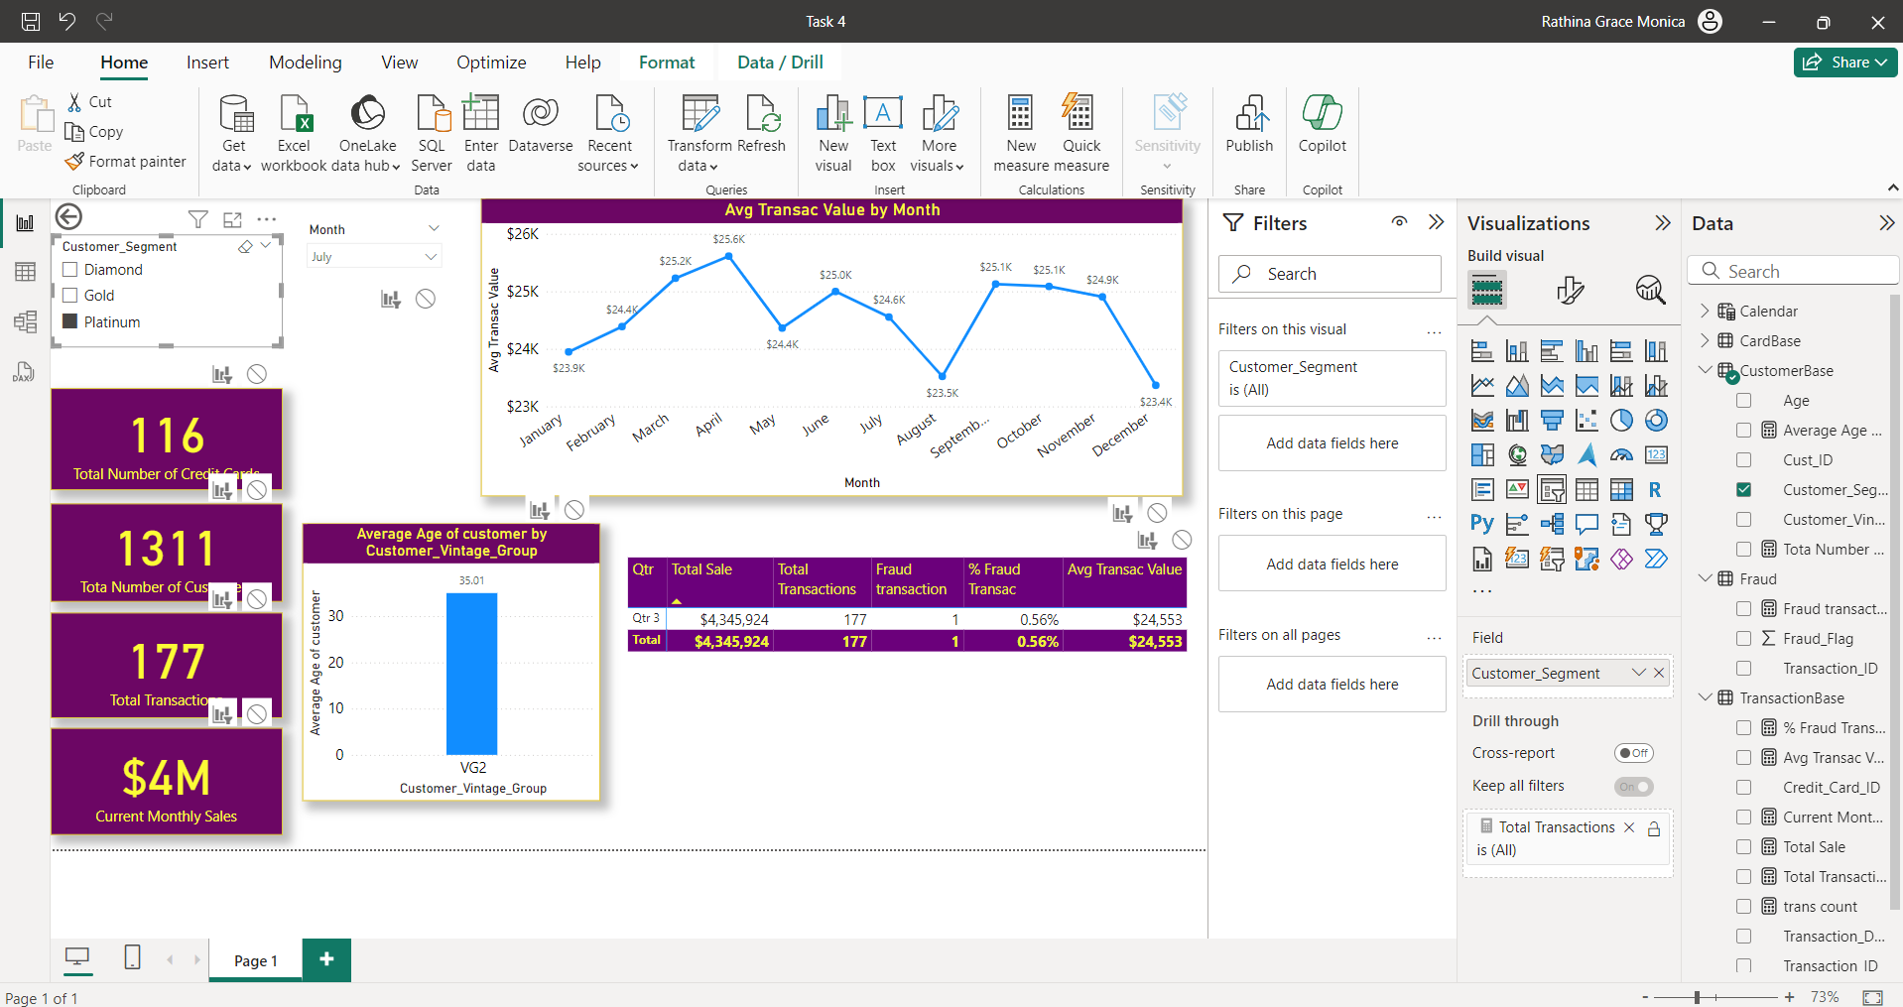

Now changing the month slicer , we find the Line graph doesn’t vary and all other graphs changes.

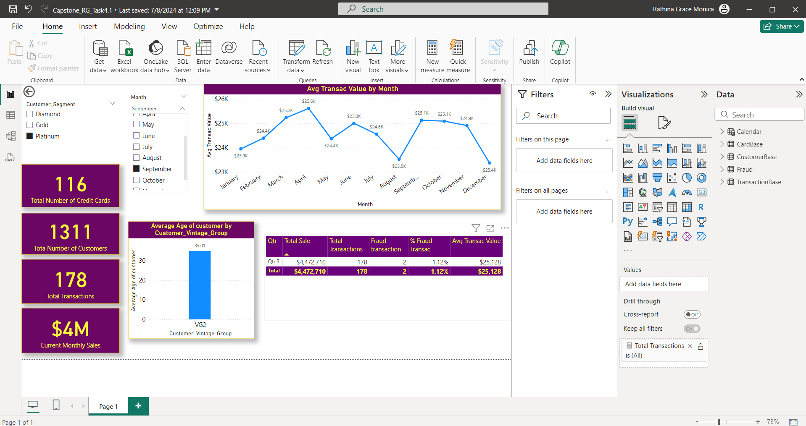

Releasing the slicers we get

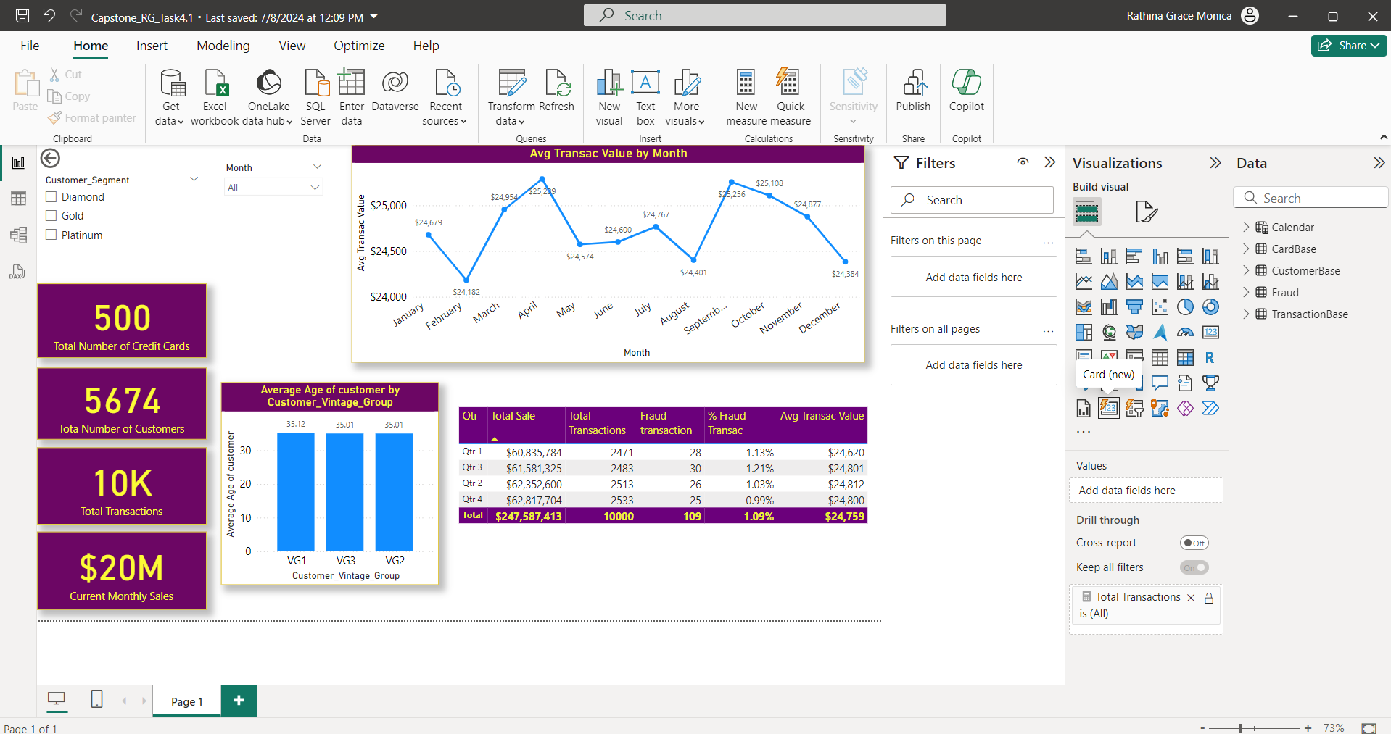

Thus, completing the given Task 4. Save the .pbix file as “Capstone_RG_Task4.1.pbix”.

**Link to the Power Bi work**

https://drive.google.com/file/d/13AeWUdiel2hlritR46ojTfbkZQHOLvYx/view?usp=sharing

**Task 5: Apply the clustering and classification technique to classify information**

**Task 5.1:**  Using the '**Task 5.1 Model Data for Clustering**' file, identify the customer segments by applying the clustering technique in Orange.

**Note:** Reviewing Module 11 – Data Mining: Introduction and Clustering will help you accomplish this task

**Estimated Time: 60 minutes**

**Tools:**  Orange

**Submission:** Save your output in .ows format with the file name [Capstone_Initial of first name + last name_Task 5.1]. Upload the Orange file together with this template filled with your answers.

**Step 1:**

Open a new Orange File. Add a “File” widget.

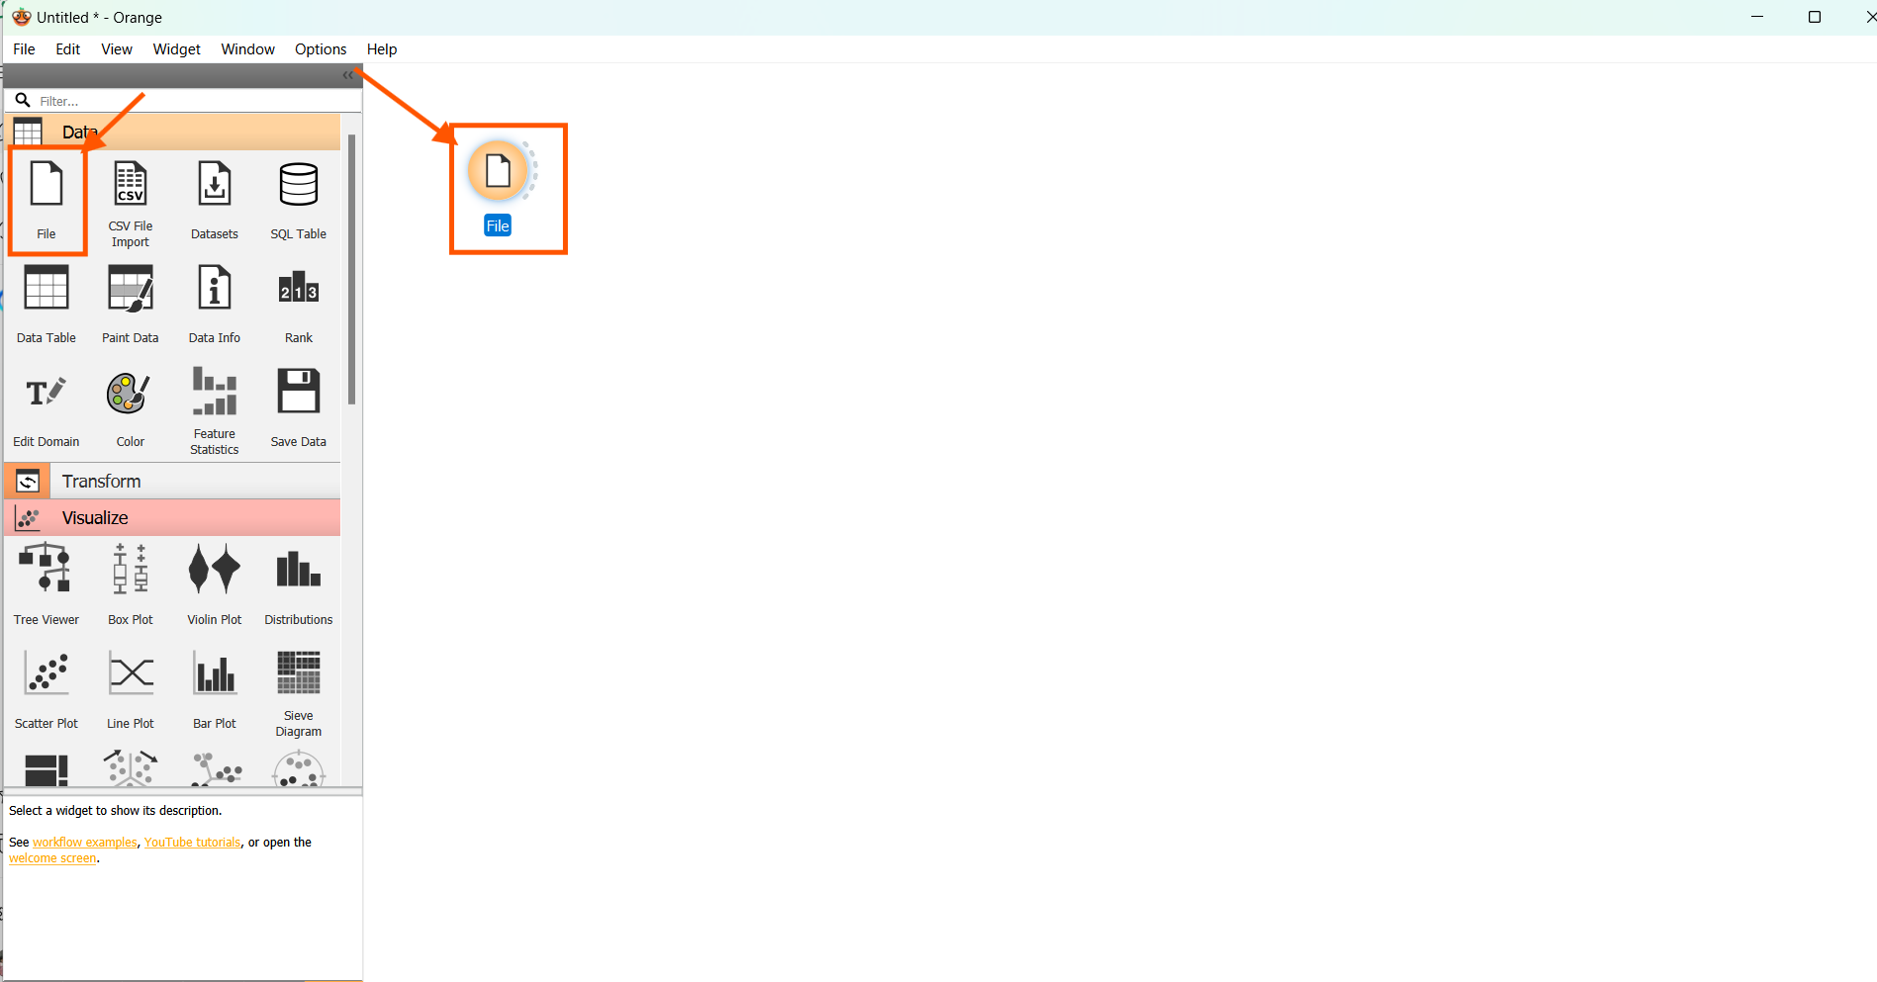

**Step 2:**

Double click the “File” widget, Navigate and open the “Task 5.1 Model data for Clustering”, Press “Open”.

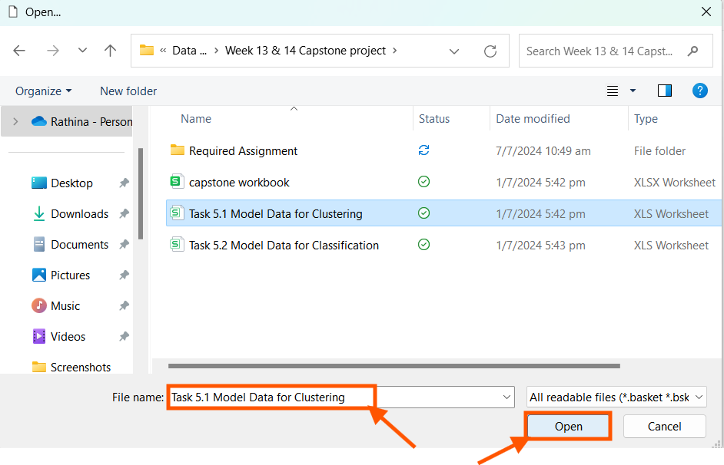

**Step 3:**

Since clustering is unsupervised learning technique, the customer column is selected under “Role” as a “Meta”. Press “Apply”.

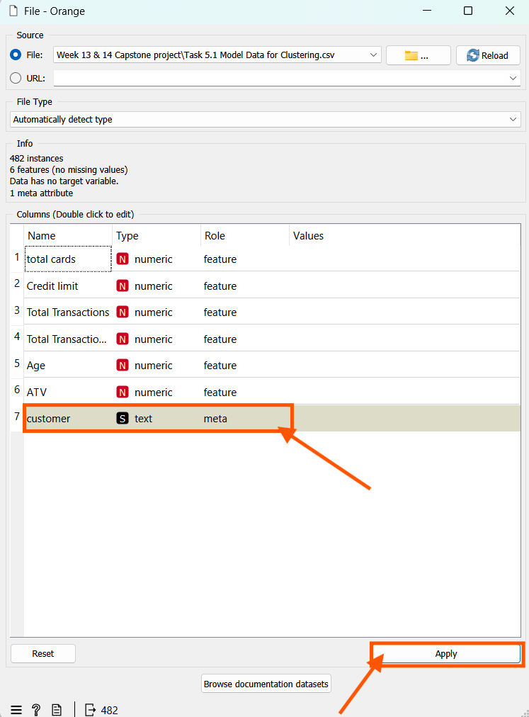

**Step 4:**

Add a “Data Table” widget to the file widget. So we can have a clear picture of what data is been loaded to the model.

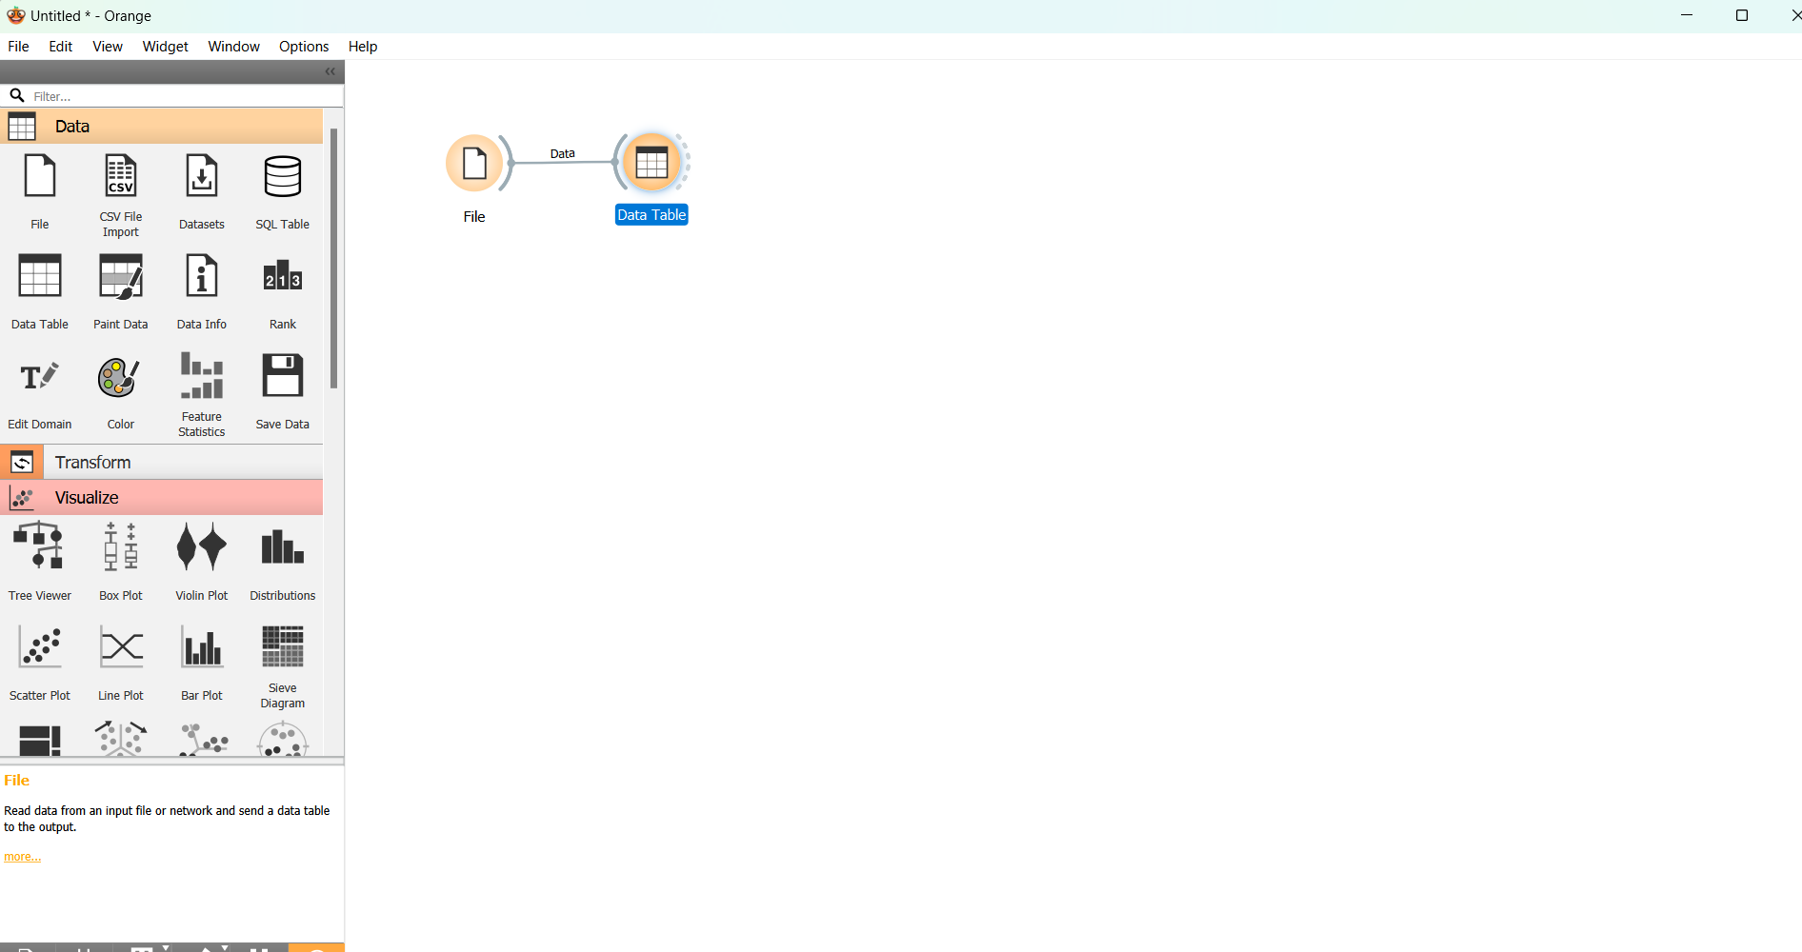

**Step 5:**

We find that there are 482 records loaded to the table with 6 featured columns and a meta column, no missing data.

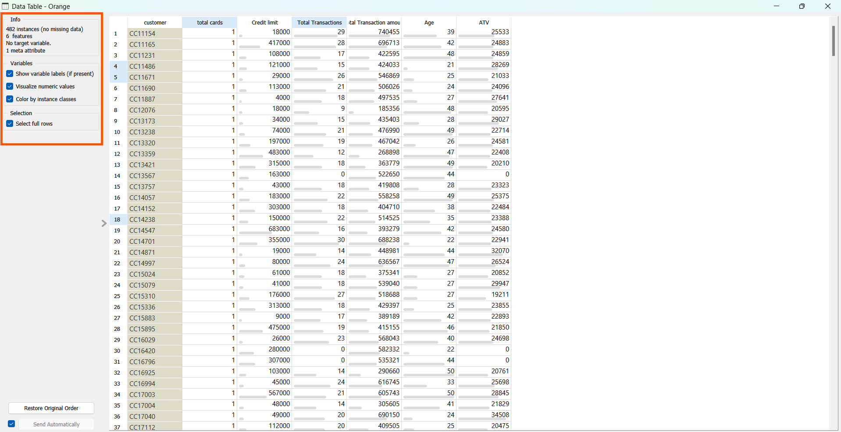

**Step 6:**

Add a Scatter Plot to view the Data.

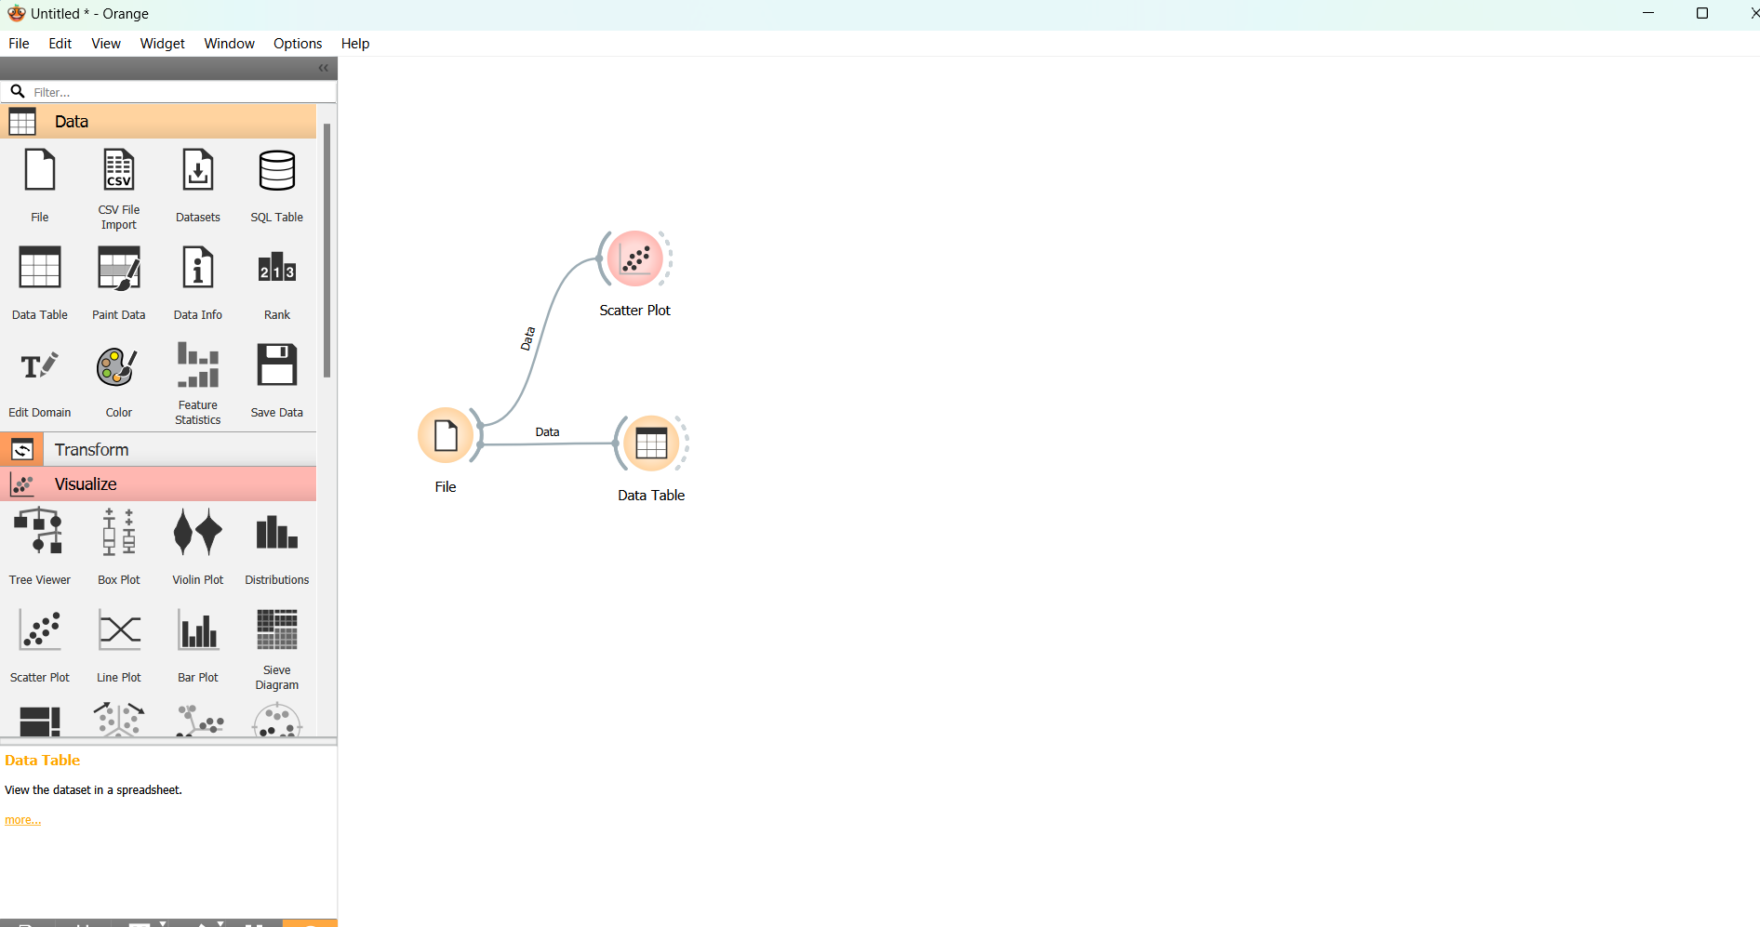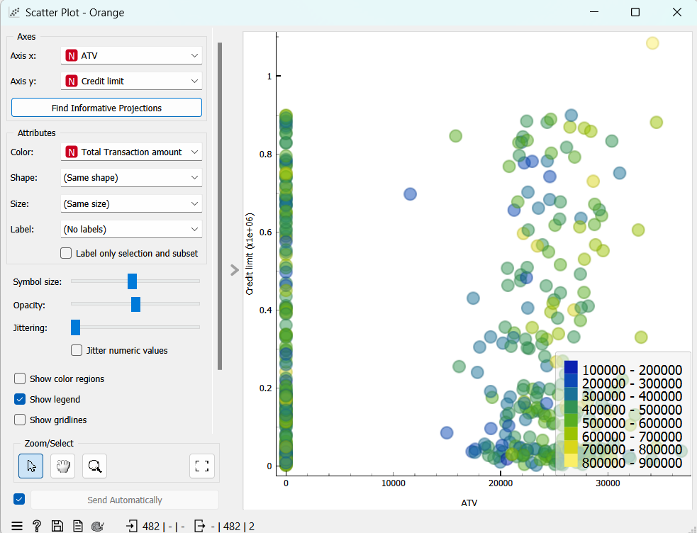

**Step 7:**

Add a Select column field to the “File” widget.

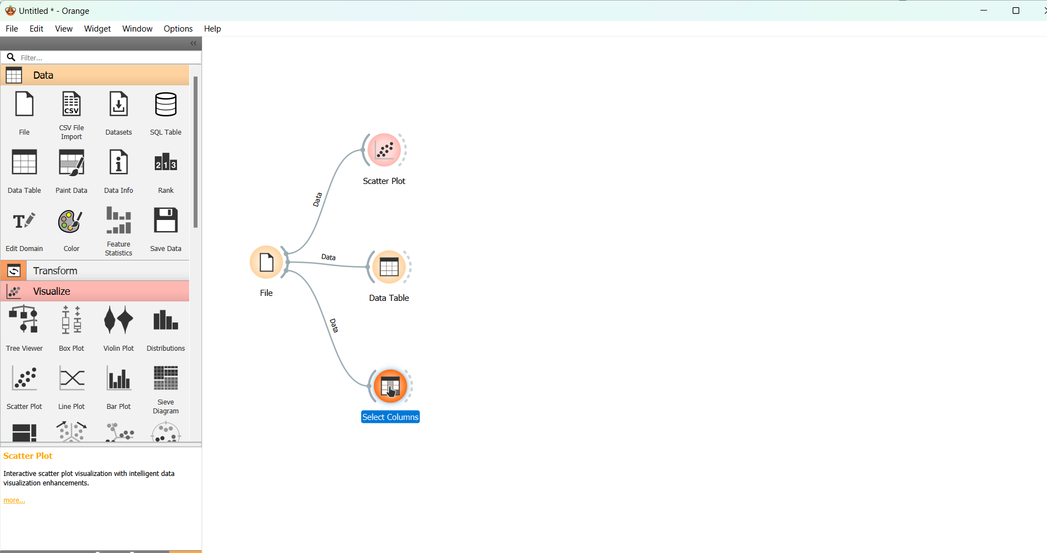

Double click the “Select Column” widget.

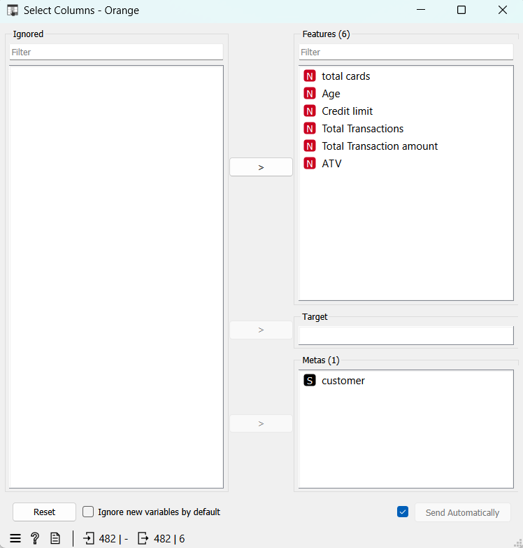

**Step 8:**

Adding a “K Mean” widget to the “Select Column” widget.

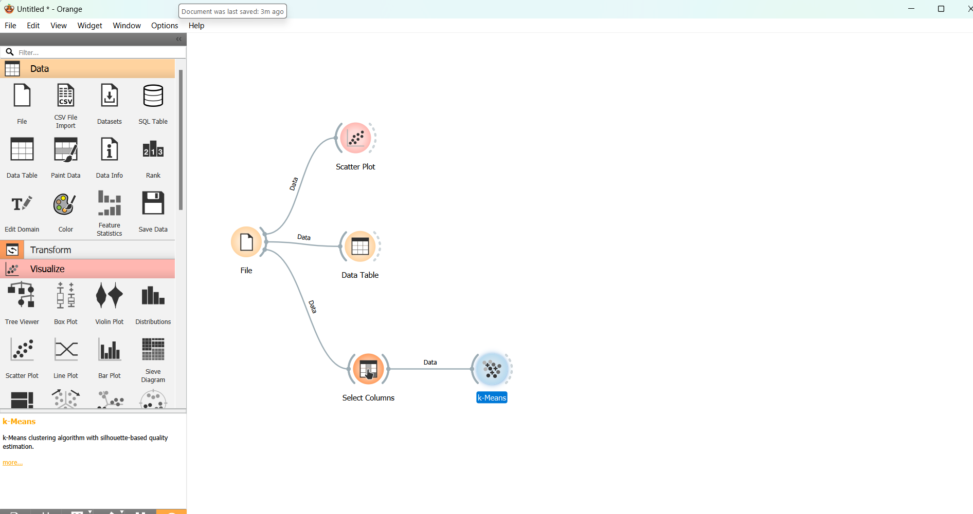

Double clicking the K-Means widget. We find that for the number of clusters 3 gets the maximum Silhouette score.

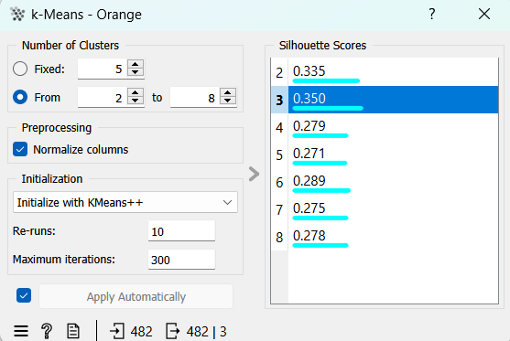

Now changing the number of clusters as “Fixed” with value = 3.

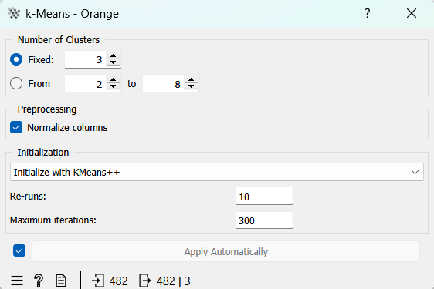

Connecting a “Scattered Plot” to check the validity of the K-means.

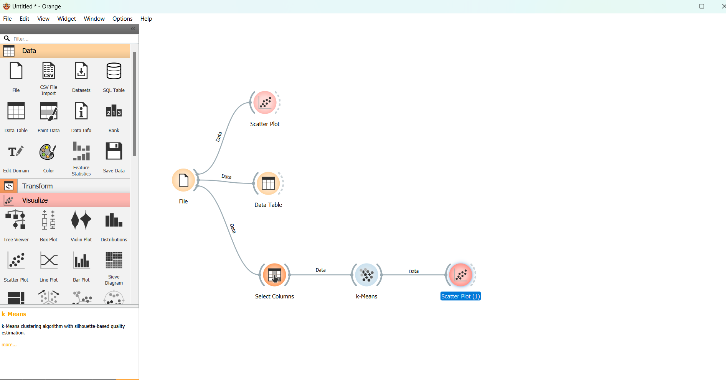

We find that many of the records with Transaction amount equal to 0 , ATV =0 but with some values for “Total Transaction Amount”. To remove those records, we use “Select Row” widget. With the condition “Transaction amount” not equal to “Zero”.

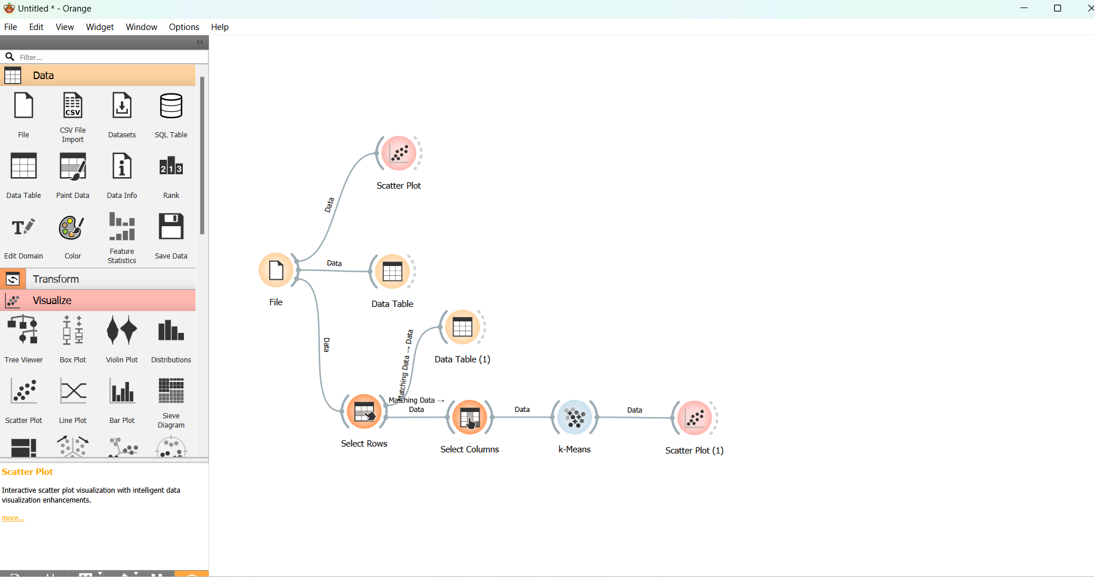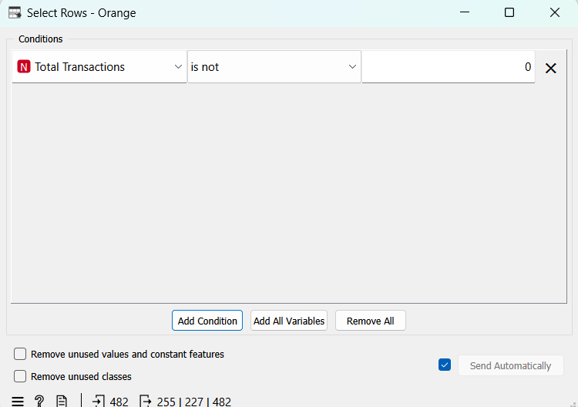

Now connecting a “Data Table” widget to “Select Rows” widget we find the clear data below.

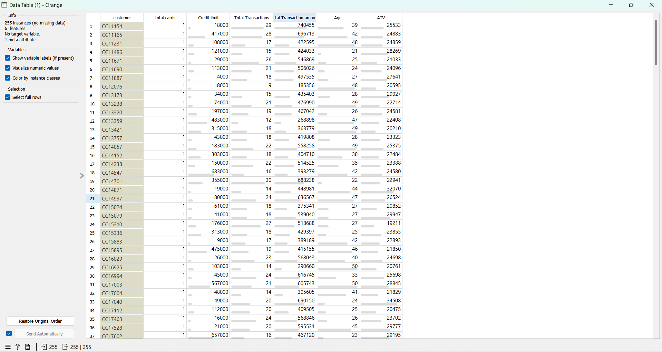

Now double clicking the K-Means Widget,

We find that there are 4 clusters with Normalisation.

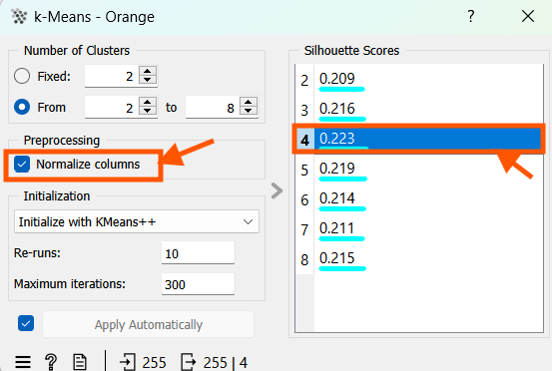

Normalisation will help us to segregate the data to more meaningful multiple data. Since we are having more attributes, lets unmark this normalisation. So, we get the K-Means less than 4 so it will be helpful for easier analysis.

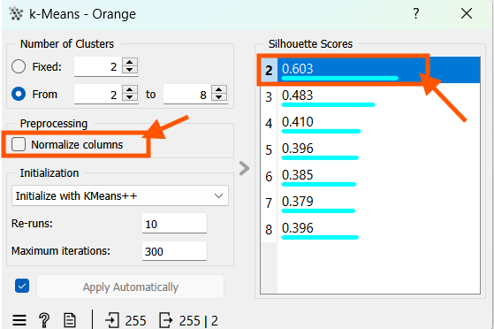

Now Connecting a “Correlation” widget to the K-Means.

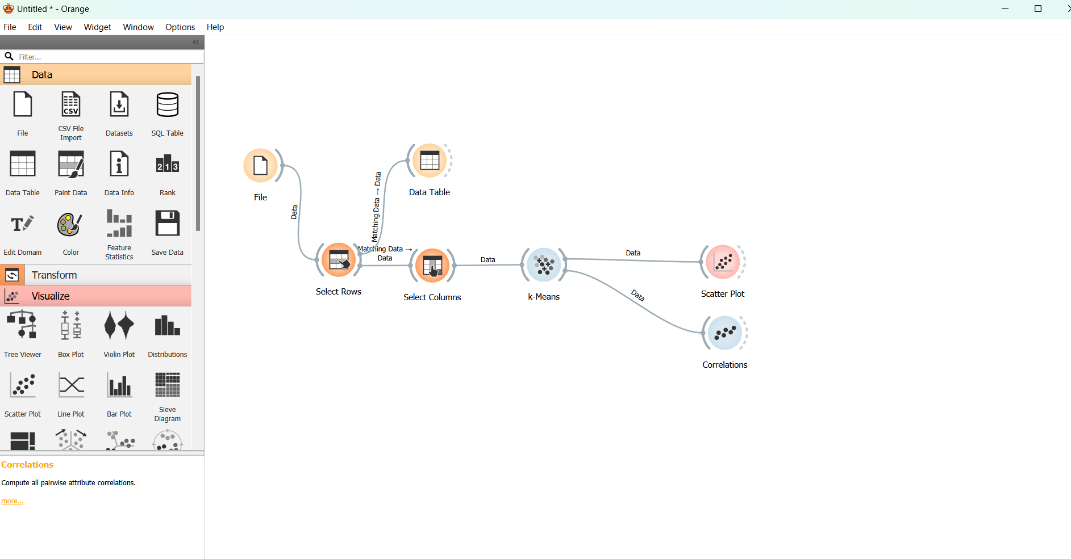

Double clicking the “Correlation” widget we get the “Pearson Correlation” matrix below.

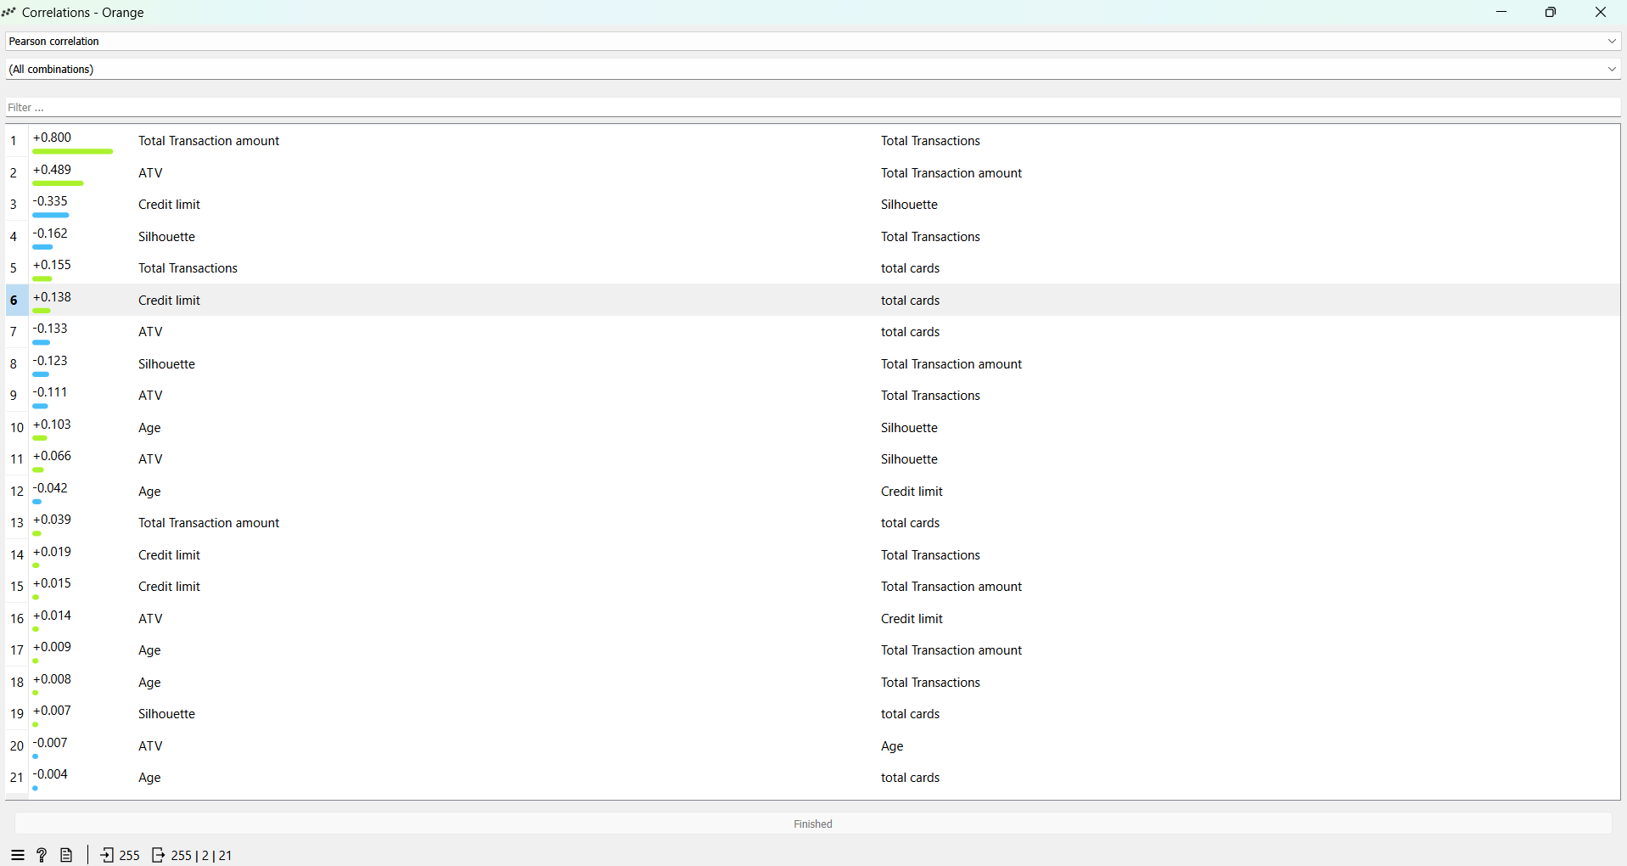

Correlation matrices help us in understanding data patterns and make informed decisions. This Pearson correlation matrix from our model helps us understand the strength and direction of the relationship between the tables in our dataset. This matrix compares every variable with every other variable visually representing these relationships through colour schemes. It helped me uncover the connections that might be missed when examining raw data.

The correlation matrices give a maximum value of +0.800 for the two relationships “Total Transaction Amount” Vs “Total Transaction”. Hence, we try to plot a “Scatter plot” between these two variables.

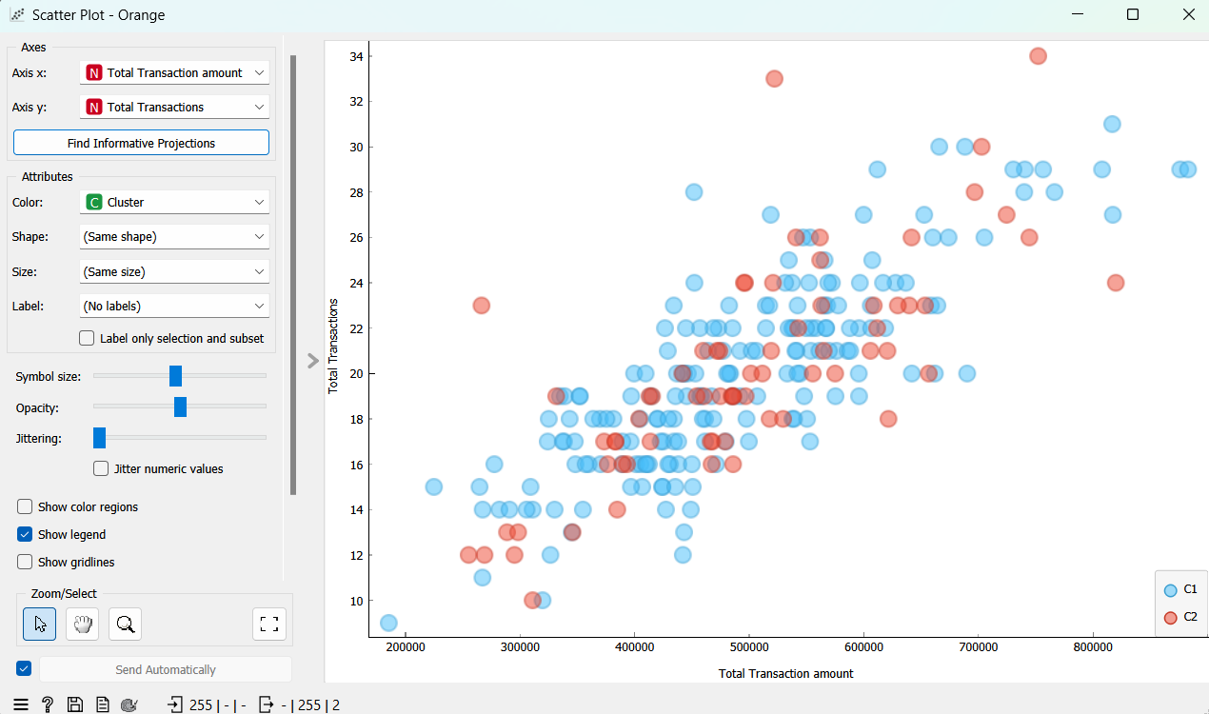

The graph appears to be linear, and we find that the Total transaction amount is directly proportional to Total transaction. More predictions are quite hard with these two variables.

The next combination with highest correlation score is “ATV” vs “Total Transaction Amount” with +0.49. so, trying a Scatter plot between those two variables.

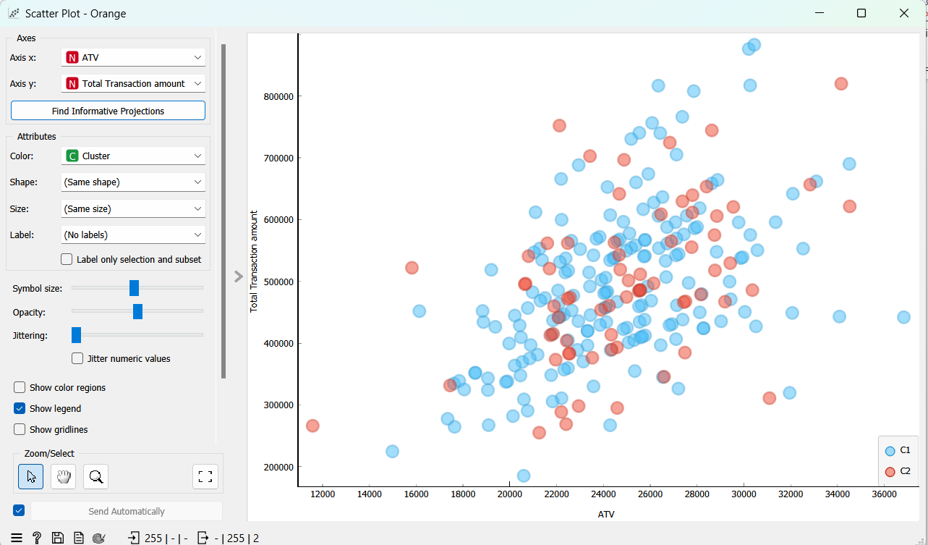

Predicting these two values are again bit tough Hence we choose the next combination “ATV” vs “Credit Limit”.

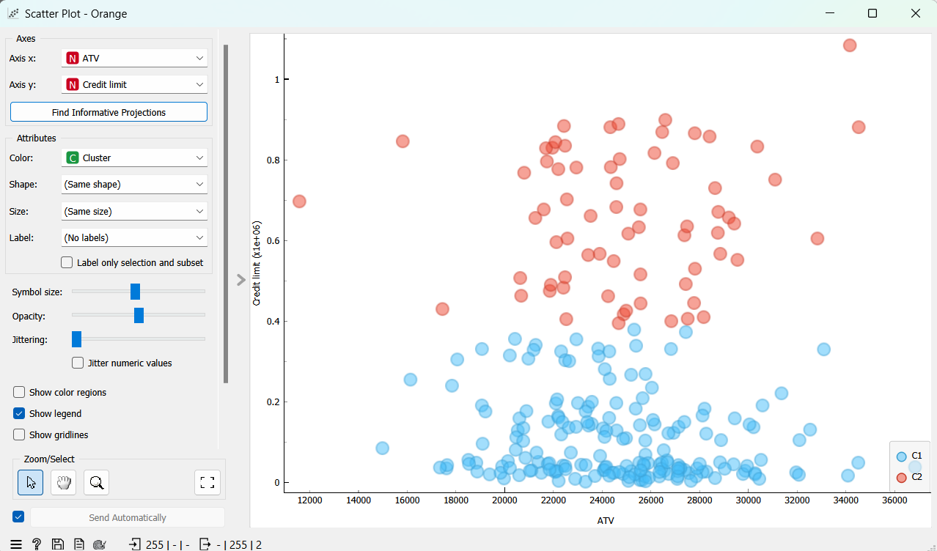

With Lower the credit limit we find that the number of transactions happened to be frequent, and so the Average transaction value (ATV) has more data points in the graph. For customers with higher credit limit only moderate number of transactions happen and their ATV is high.

The next combination is “Credit limit” vs “Total Transaction Amount”. so, trying a Scatter plot between those two variables.

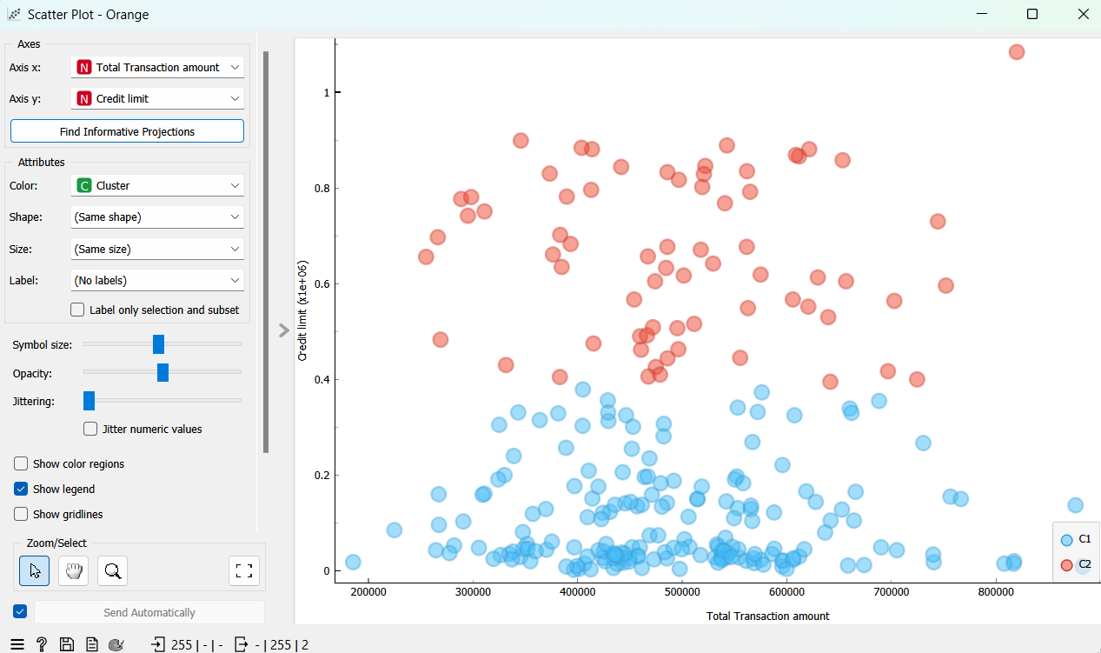

With Lower the credit limit we find that the number of Total Transaction Amount is more. Which means many transactions happened by the customers who have credit cards with lower credit limits. For customers with higher credit limit only moderate number of transactions happen and some of their Total transaction amount is high.

To study about the model further we connect a new widget “Feature Statistics”, This widget gives us a complete picture of the statistical data like how the distribution of data in every table is, mean, median, mode, dispersion, minimum value, maximum value and is there any missing values in each table.

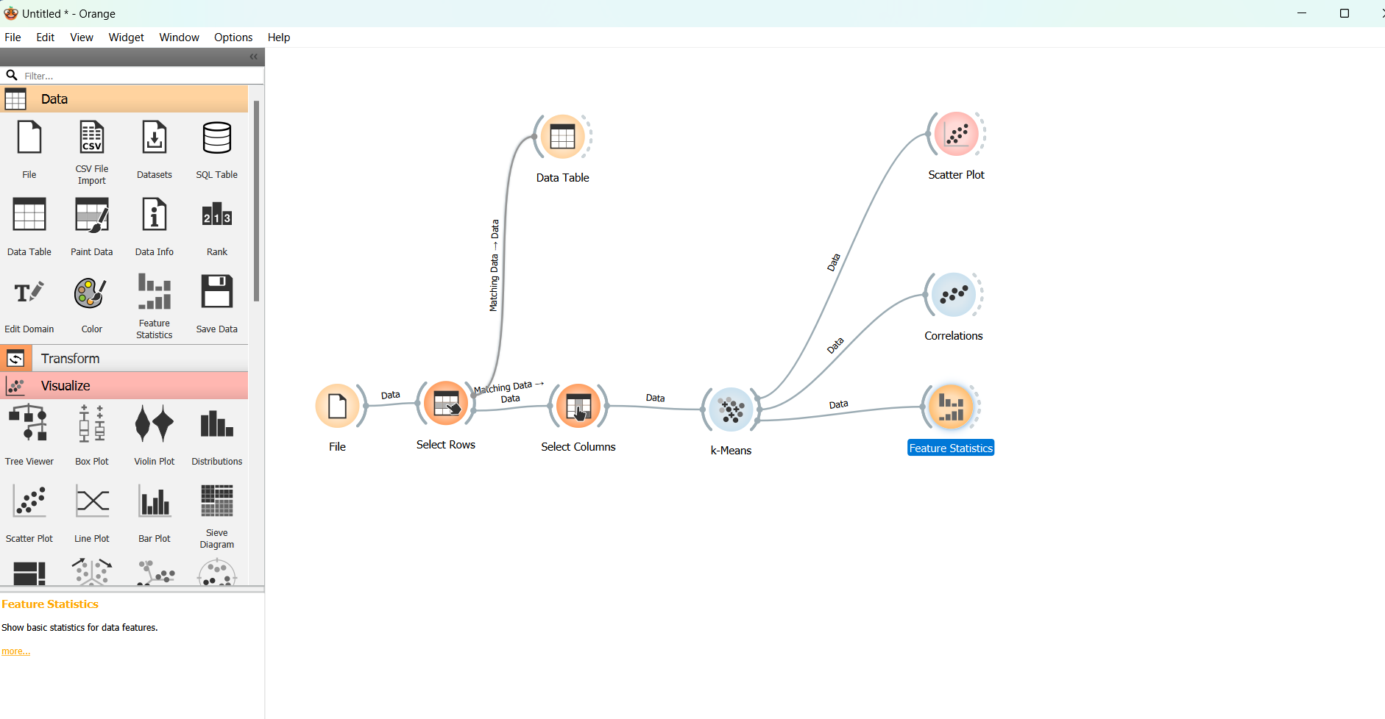

Double clicking the Feature Statistics widget, we find the the statistics measures below.

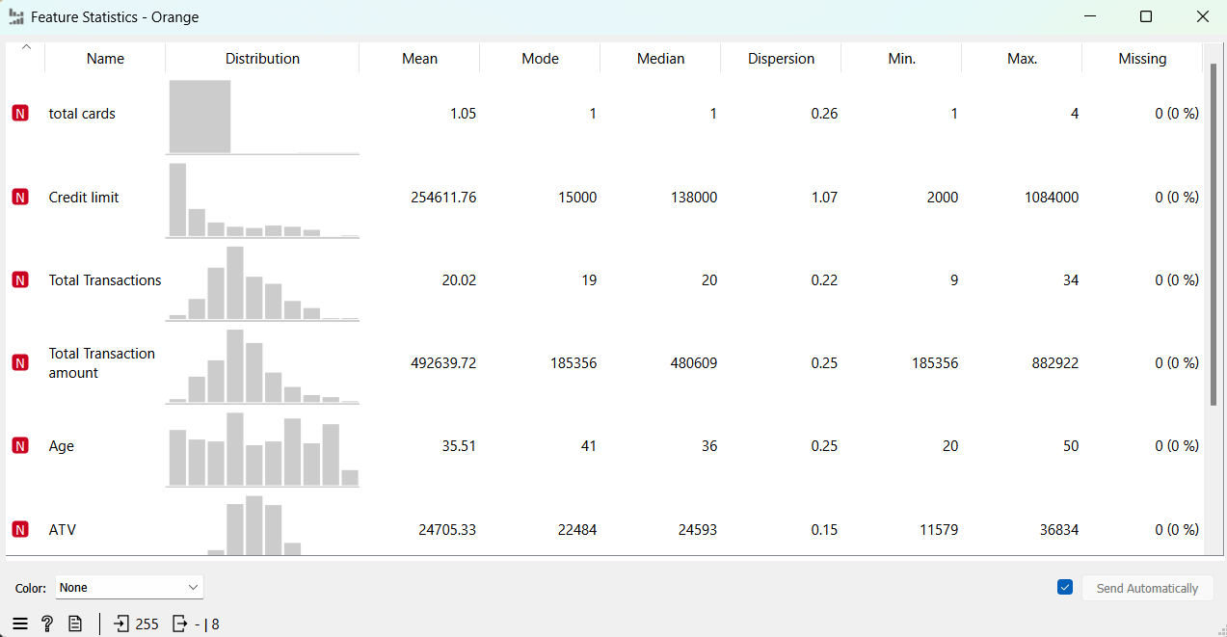

We concentrate on the statistical values of table Total transaction Amount and ATV,

Connecting a “Box plot” to the model for further analysis.

Choosing “Total Transaction Amount” variable.

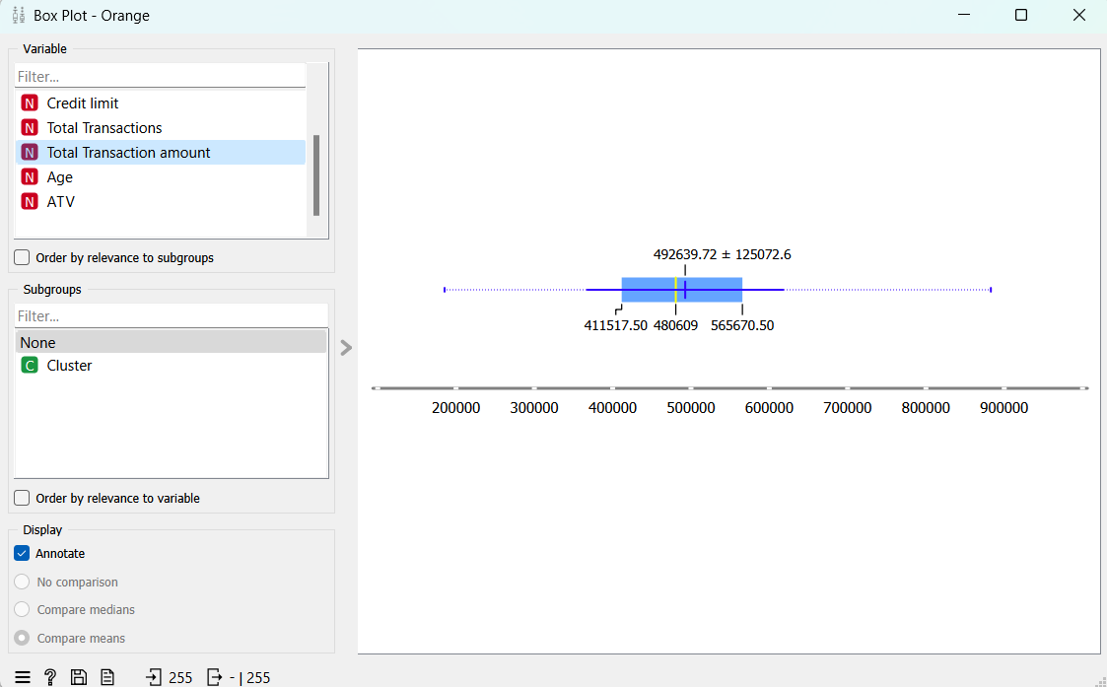

From the box plot we find the Value of Q1 as $411,517.5 and Q3 as $565,670.5, The median value Q2 as $480,609.

Calculating the value of IQR, Lowe limit and Upper Limit using the formulae.

IQR = Q3 – Q1= $154,153

Lower Limit = Q1 –(1.5*IQR) = $180,288.

Upper Limit = Q3 + (1.5*IQR) = $796,900.

The box plot is **positively skewed**, as the median value is towards left and the whisker on the right side is little longer than the whisker on the left side. This means majority of the data points are concentrated on the left side of the distribution and there are some extreme values on the right side.

From the Featured Statistics output, we find that for Total transaction amount,

Mean = $492,639.72, Median =$480,609, Mode = $185,356.

i.e, Mean > Median > Mode. Which reconfirms that the data is positively skewed. Leading us to a conclusion that most of the customers with lower credit limit performs many transactions whereas the customers with higher credit limit has moderate number of transactions and very few spend extremely high amount despite of their credit limits.

**Comparing the outliers with the boxplot.**

As we know the outliers always give the idea of unused data values which are distant from the rest of the data. More number of outliers means the predictions will be more uncertain. We can predict the plot with less or no outliers more confidently. Hence to study about the outliers.

From the features statistics output we have the following values for the Total transaction amount.

Minimum = $185,356

Maximum = $882,922

We find that in our model there is no outlier, and all the data are within the maximum and minimum range. Hence, we can have a confident prediction.

By connecting a select row and a data table and setting the condition in select row as total transaction amount is greater than $796,900 (Upper limit in the box plot)

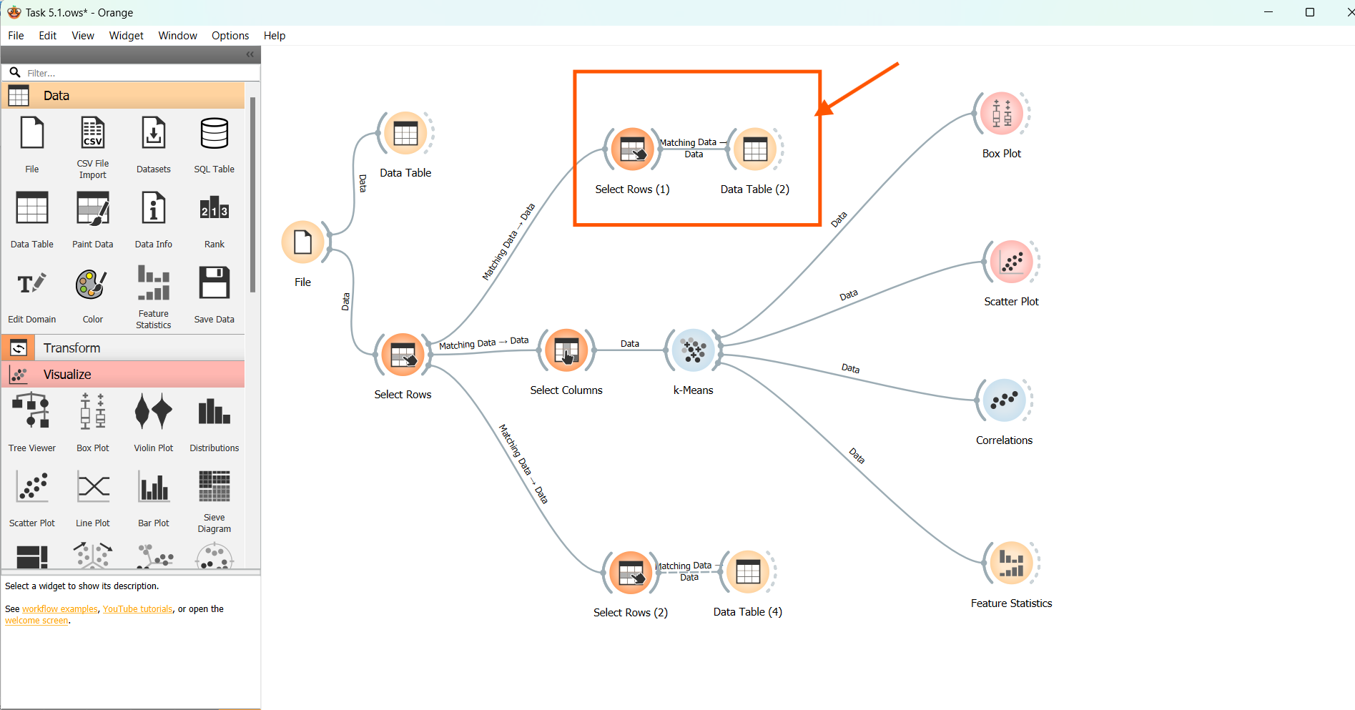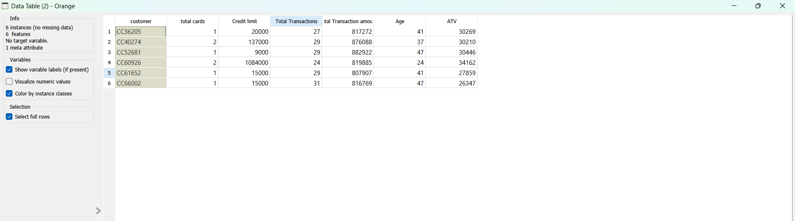

From the above output, we find only 6 customers are having a maximum spending above the upper limit value of $796,000 out of which 2 of the customers have multiple credit cards and the remaining 4 of them in the table have credit cards with pretty much lower credit limit but their number of transactions are very high compared to their credit limit, so they are the premium customers.

By connecting a select row and a data table and setting the condition in select row as total transaction amount is greater than $180,288 (Lower limit in the box plot).

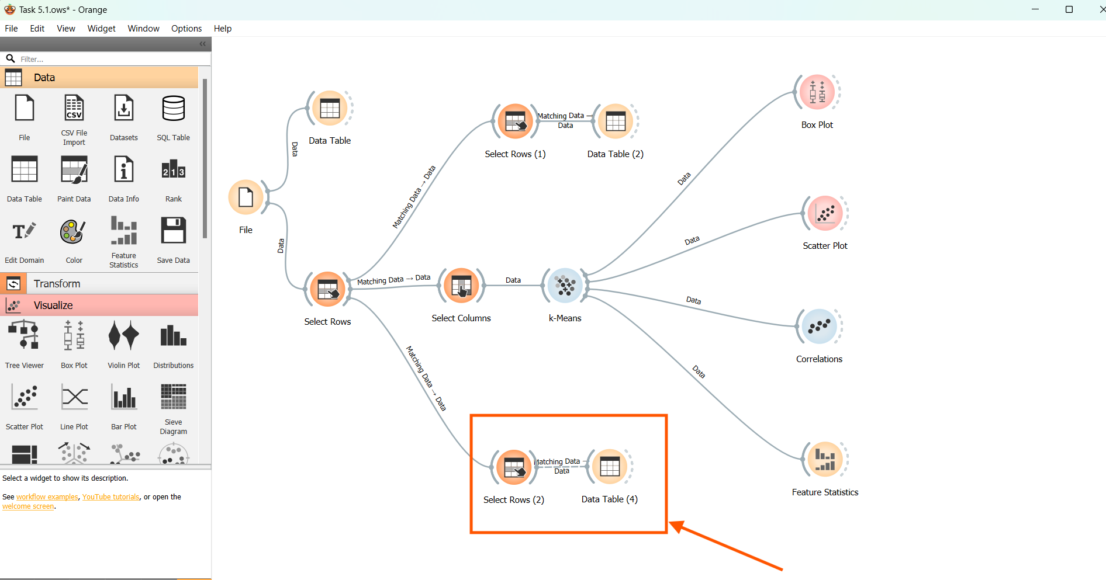

Selecting the link for the table only for matching data. Press OK

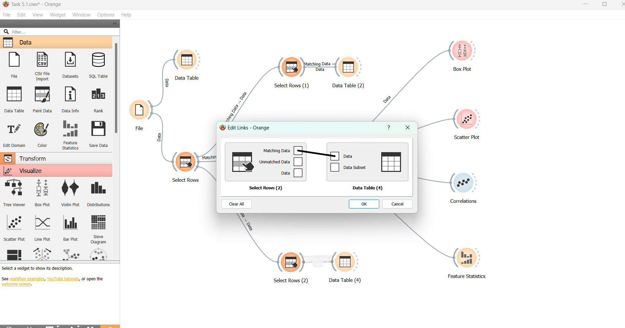

Double clicking the “Data Table”

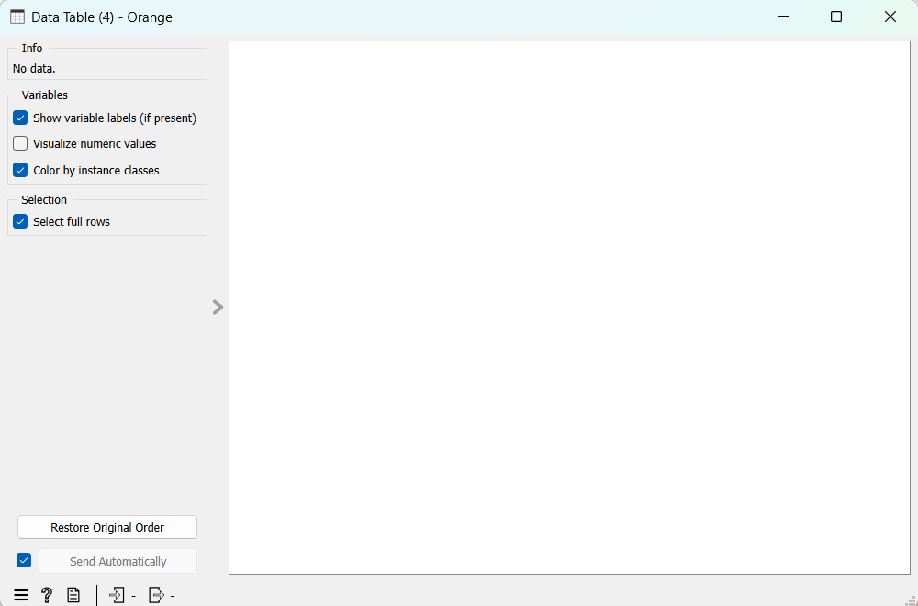

No customer is spending below the lower limit value of $180,288.

Similarly conducting an analysis on the data for ATV using Box plot.

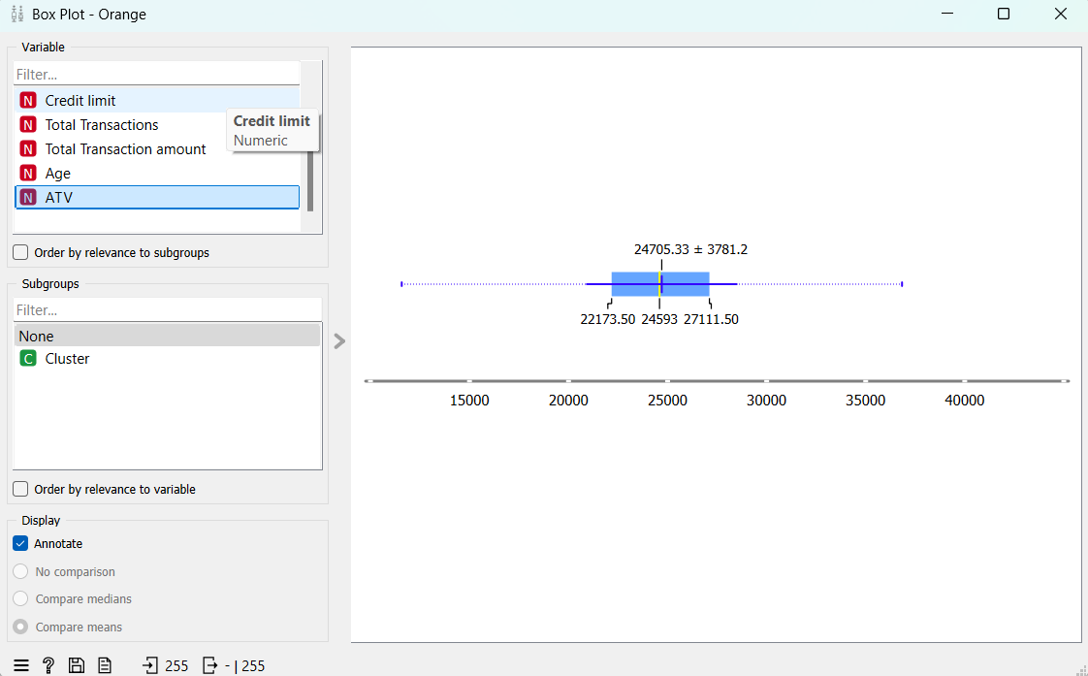

We find that the ATV is also having positive skewness.

From feature statistic output

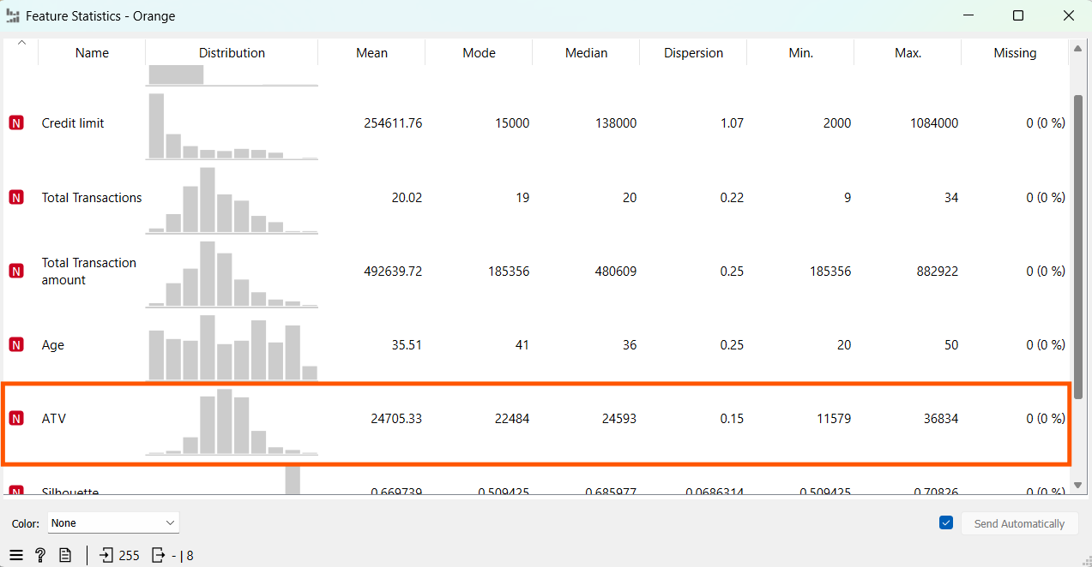

We notice that for ATV

Mean Value = $24,705.33

Mode Value = $22,484

Median Value = $24,593

Mean > Median >Mode. Which again confirms positive skewness.

Hence, we conclude a greater number of transactions happen with lower credit limit, moderate number of transactions happens with higher credit limit and very few transactions happen with extremely high values.

Saving the Orange file as Capstone_RG_Task 5.1.

Thus, Completing the Task 5.1.

**Link to the Orange file.**

https://drive.google.com/file/d/1uB1zmS8H7z-EPqywcWpEzSD7sQNnUucr/view?usp=sharing

**Task 5.2:**  Using the ‘**Task 5.2 Model Data for Classification**' file, determine the rules to identify fraudulent transactions.

**Note:** Reviewing **Module 12 – Data Mining: Introduction and Classification** will help you accomplish this task

**Estimated Time: 60 minutes**

**Tools:**  Orange

**Submission:** Save your output in .ows format with the file name [Capstone_Initial of first name + last name_Task 5.2]. Upload the Orange file together with this template filled with your answers.

**Step 1:**

Open a new Orange File. Add a “File” widget.



**Step 2:**

Double click the “File” widget, Navigate and open the “Task 5.1 Model data for Classification”, Press “Open”.

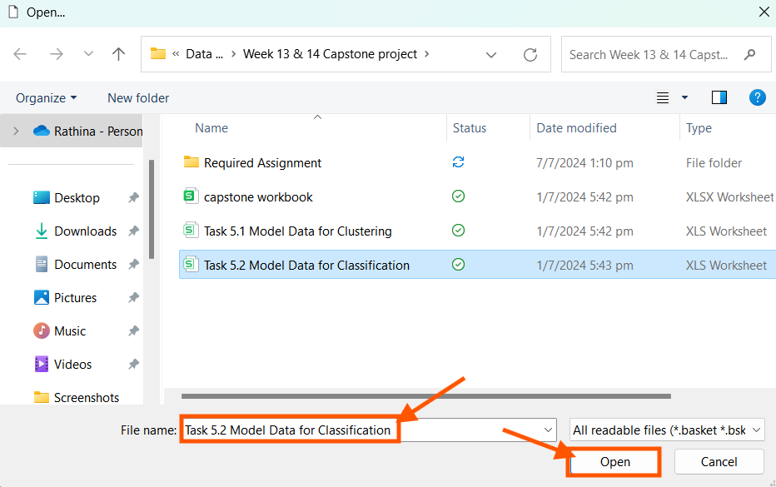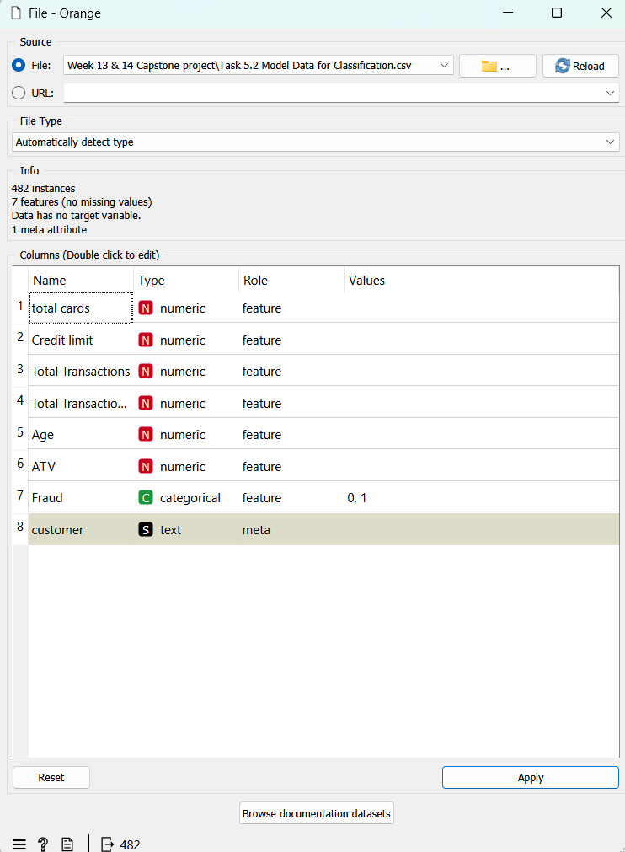

Since our Model is concentrating on Fraud Transactions, Let the “Fraud” table be set to “Target” in the Role section

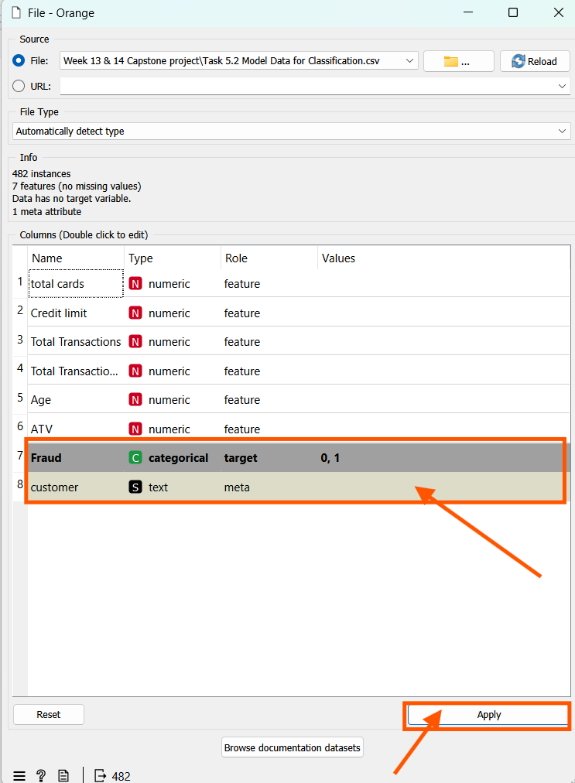

Connecting a “Data Table” widget to check whether all the data are loaded properly.

Double clicking the “Data Table” we get

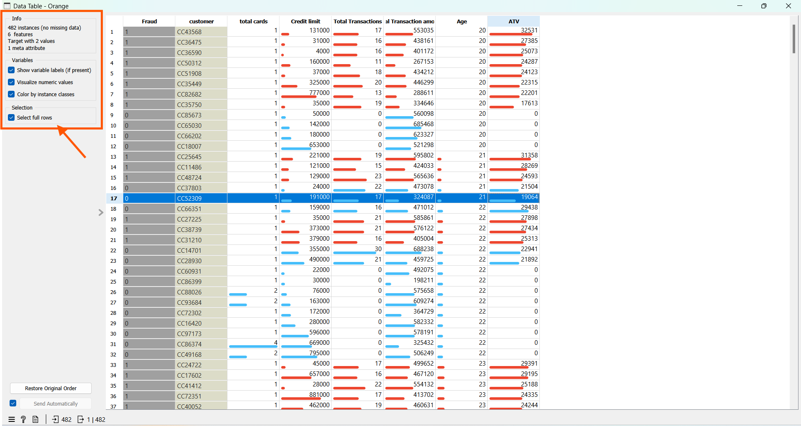

We find many data with Total Transaction and ATV to be 0. To clean the given data, we add a “Select Row” widget.

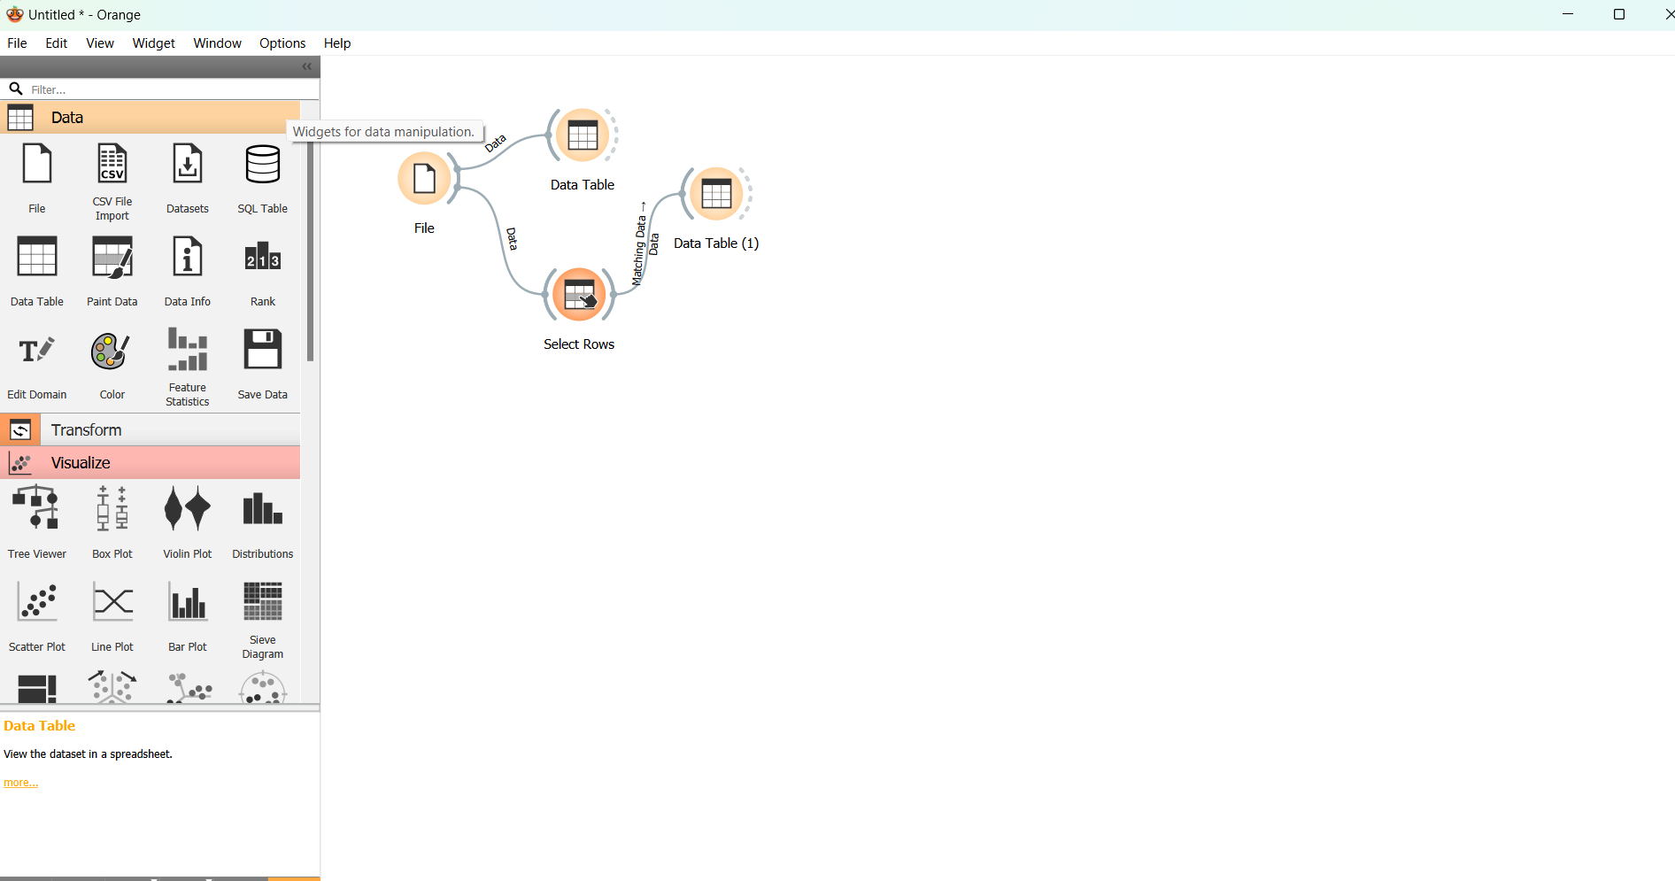

With the condition in the “Select Row” widget

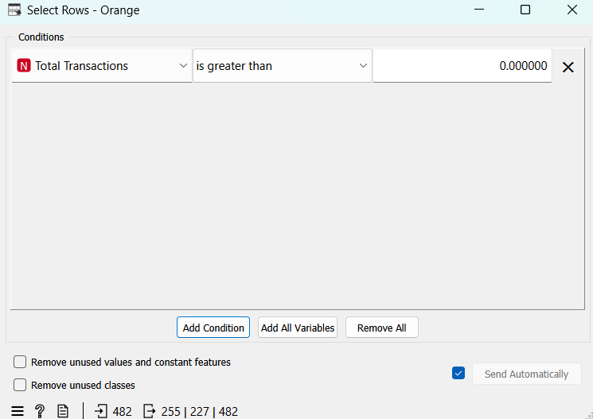

To view the cleansed data set, we connect a “Data table” to the select row widget.

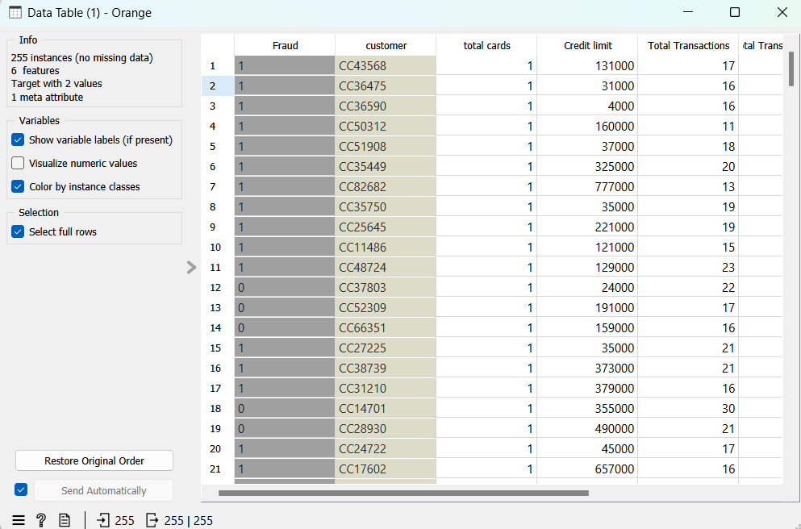

Connecting the “Select Column” widget

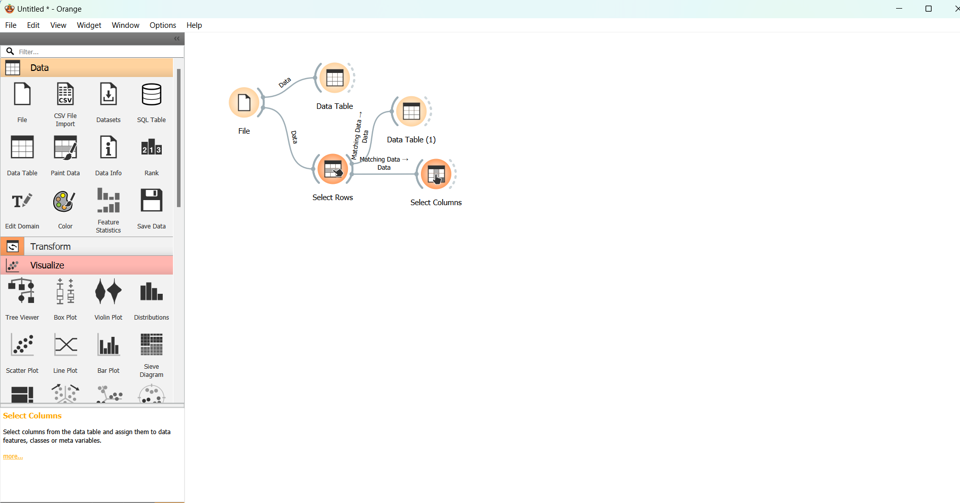

Double clicking the “Select Column” widget.

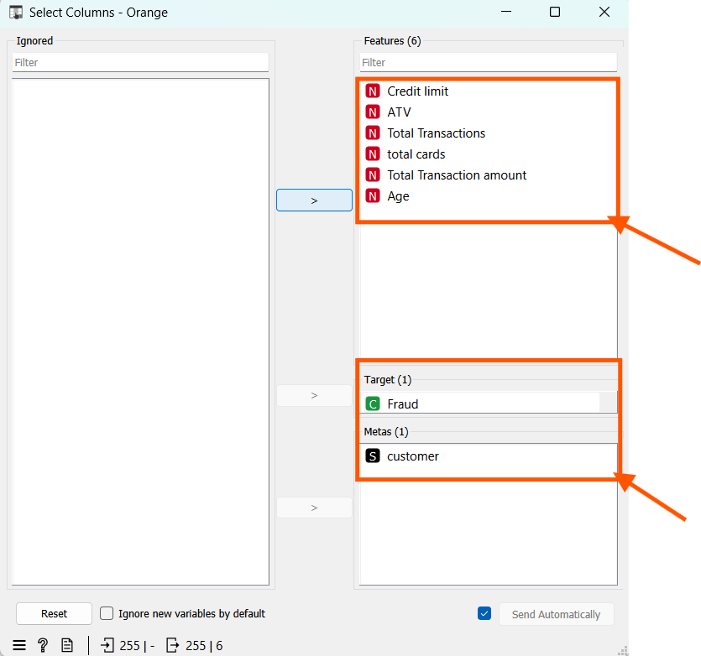

Adding a Data Sampler and double clicking it

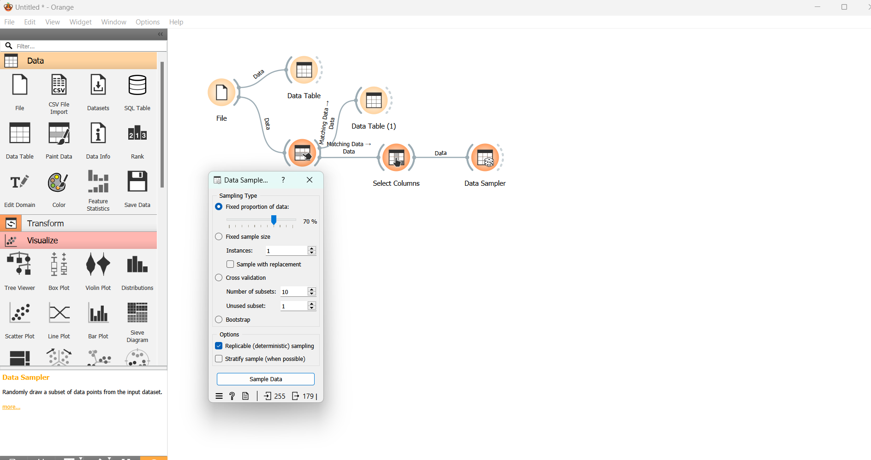

Adding a “Tree” and double clicking it, set “Limit the maximum tree depth = 3”

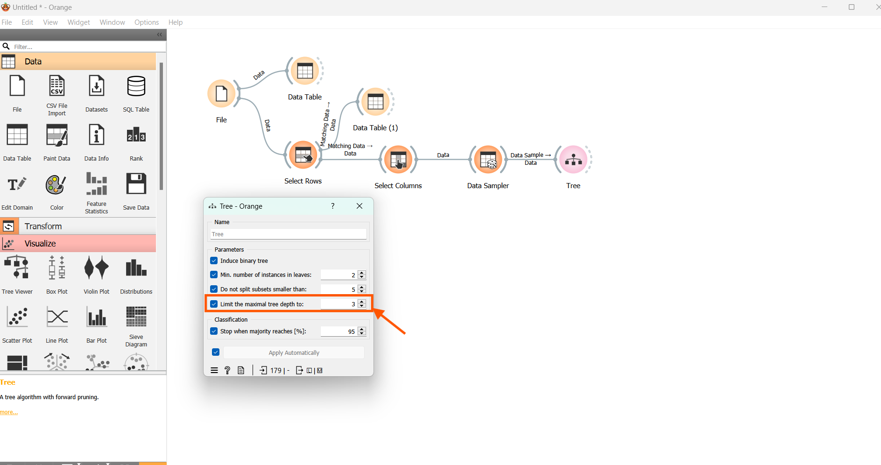

Connect a tree Viewer to view the tree, “set the target value =1”.

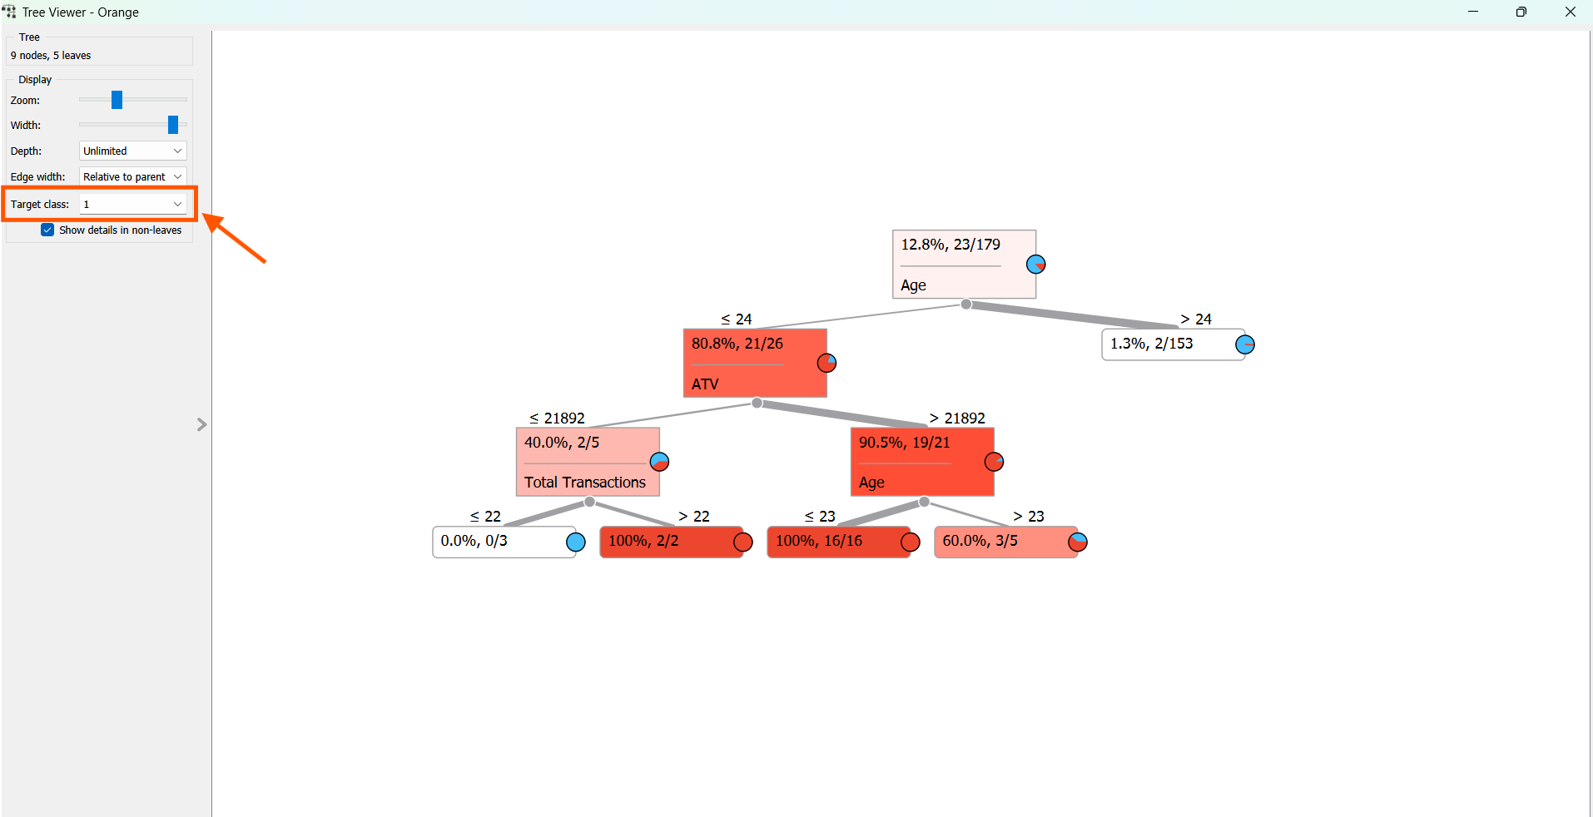

Connect a “Test and Score” between a “Data Sampler” and “Tree”. Double clicking the connection between the “Data Sampler” and “Tree” and establishing a connection between “Remaining Data” and the “Test Data”. Press “OK”

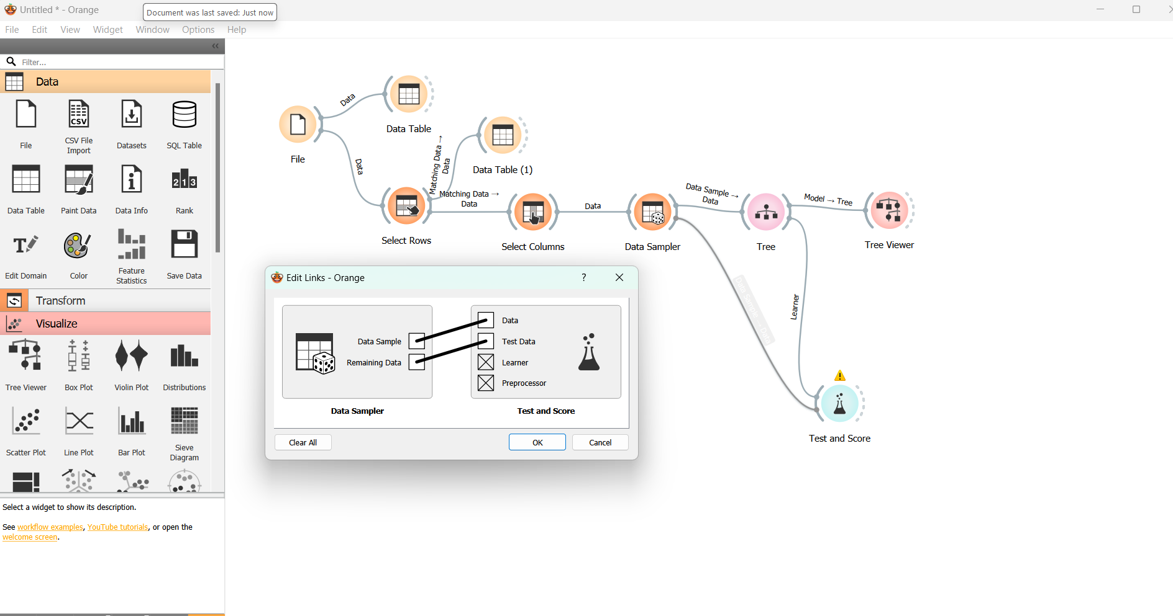

Double clicking “Test and Score”

The Classification Accuracy (CA) as 97.8% for “Test on Train data”.

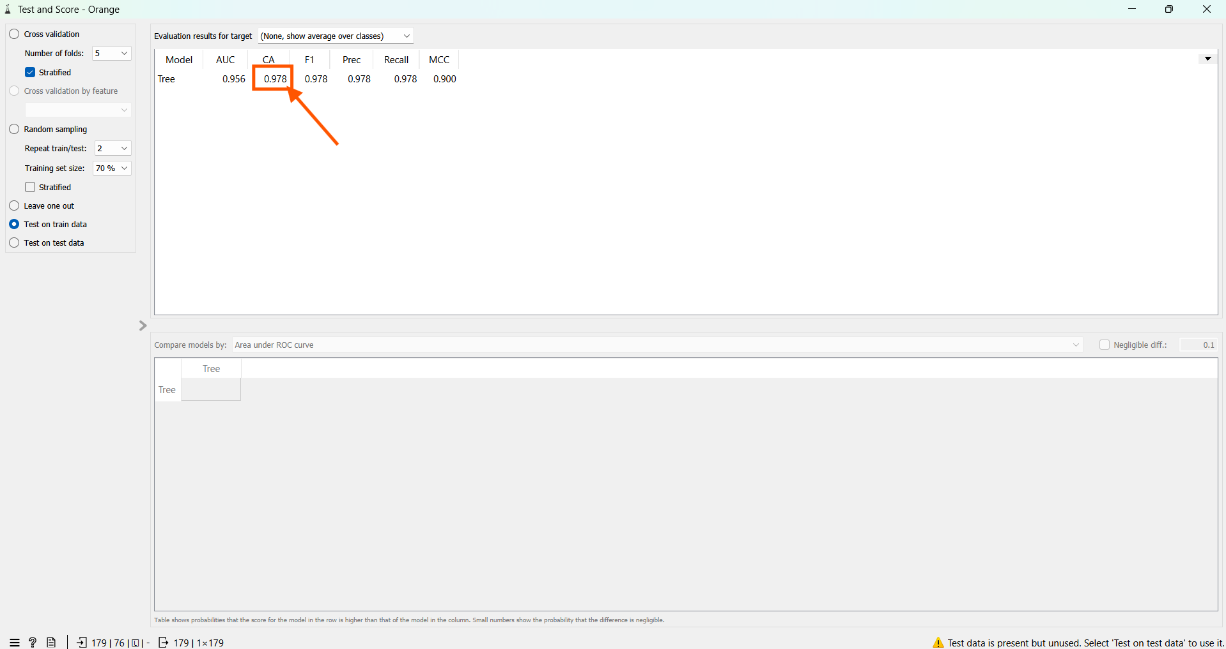

We find the classification Accuracy (CA) as 94.7% for “Test on test” data.

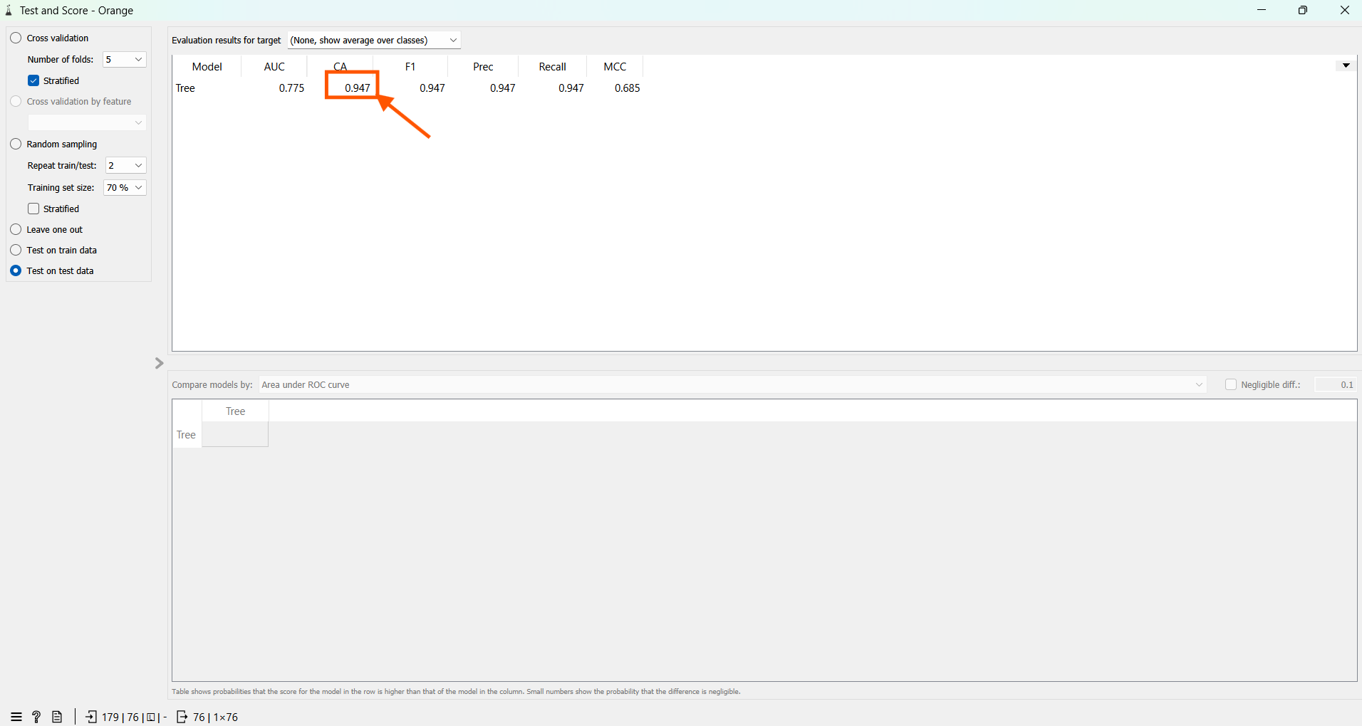

Add a “Confusion Matrix” to “Test and score”. Double clicking and checking it.

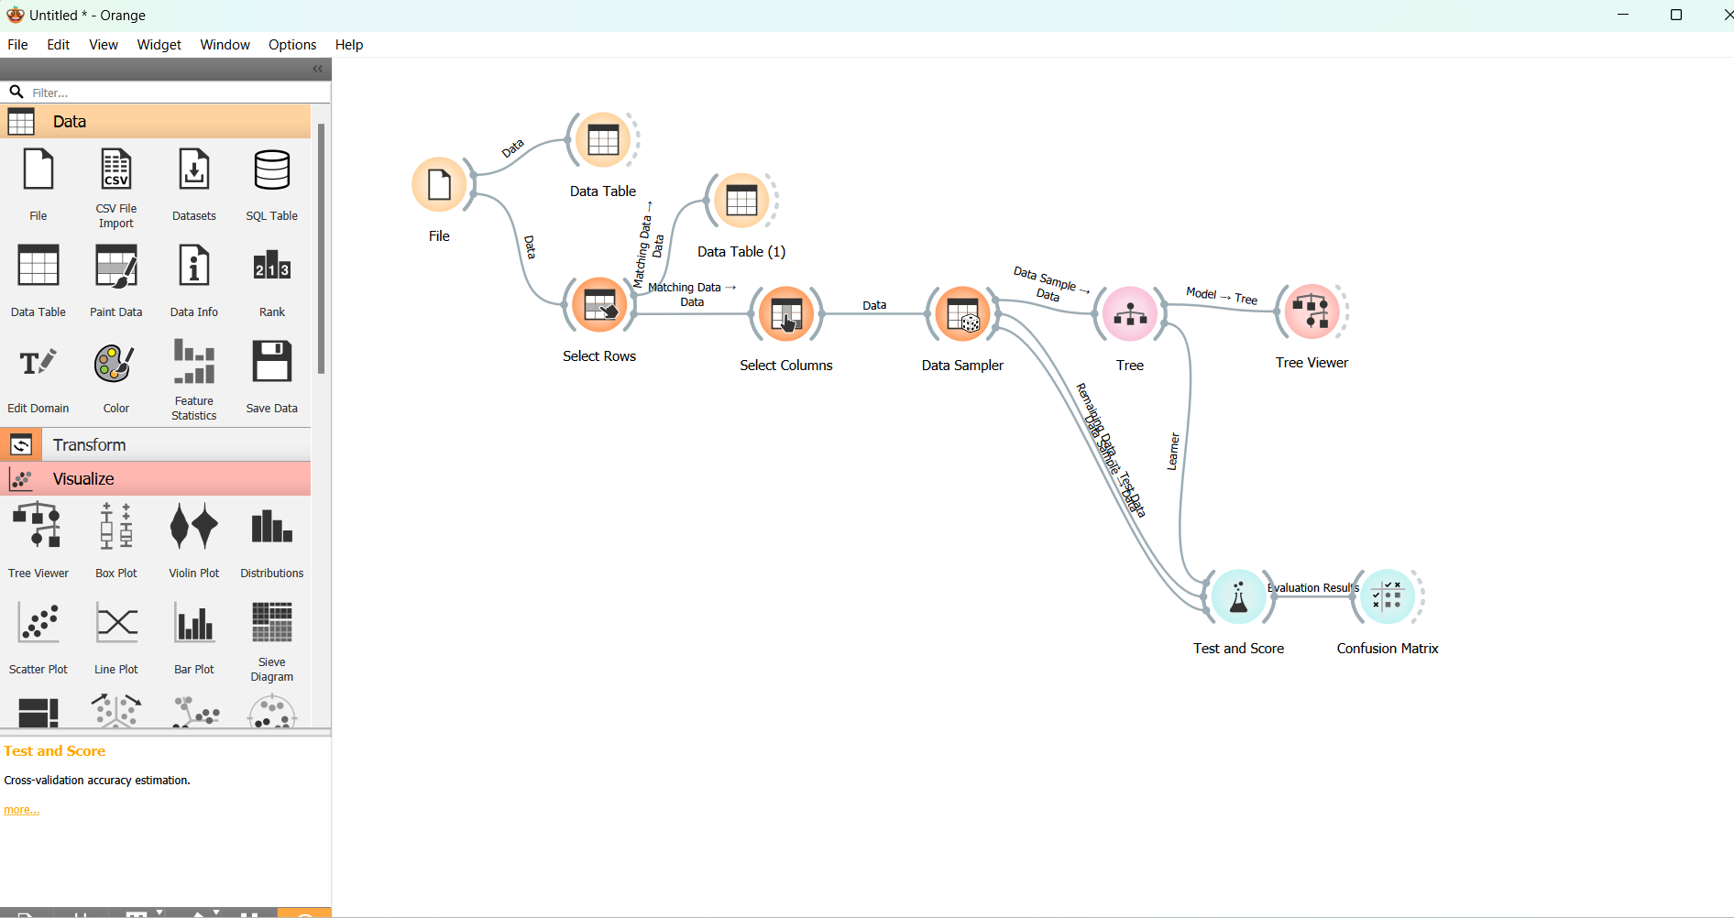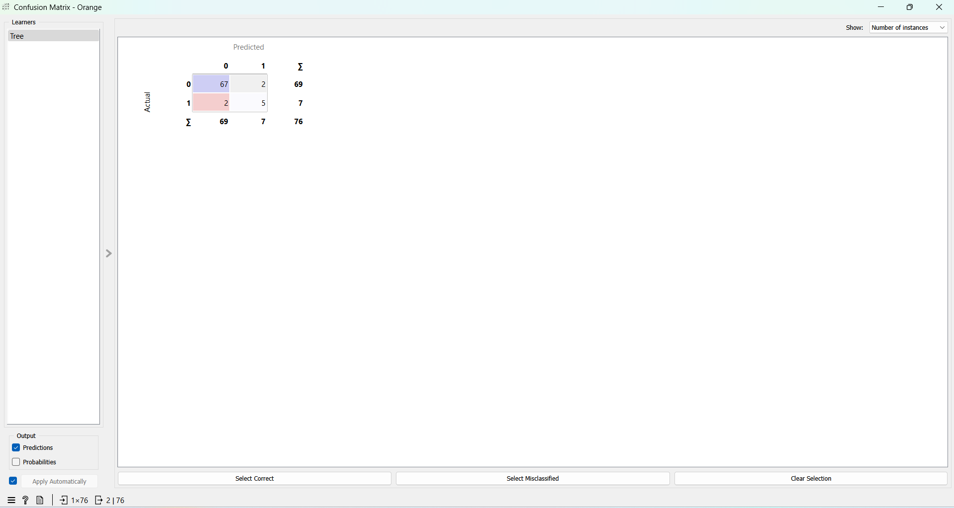

Now connecting a “Data table” to know more about the confusion matrix output.

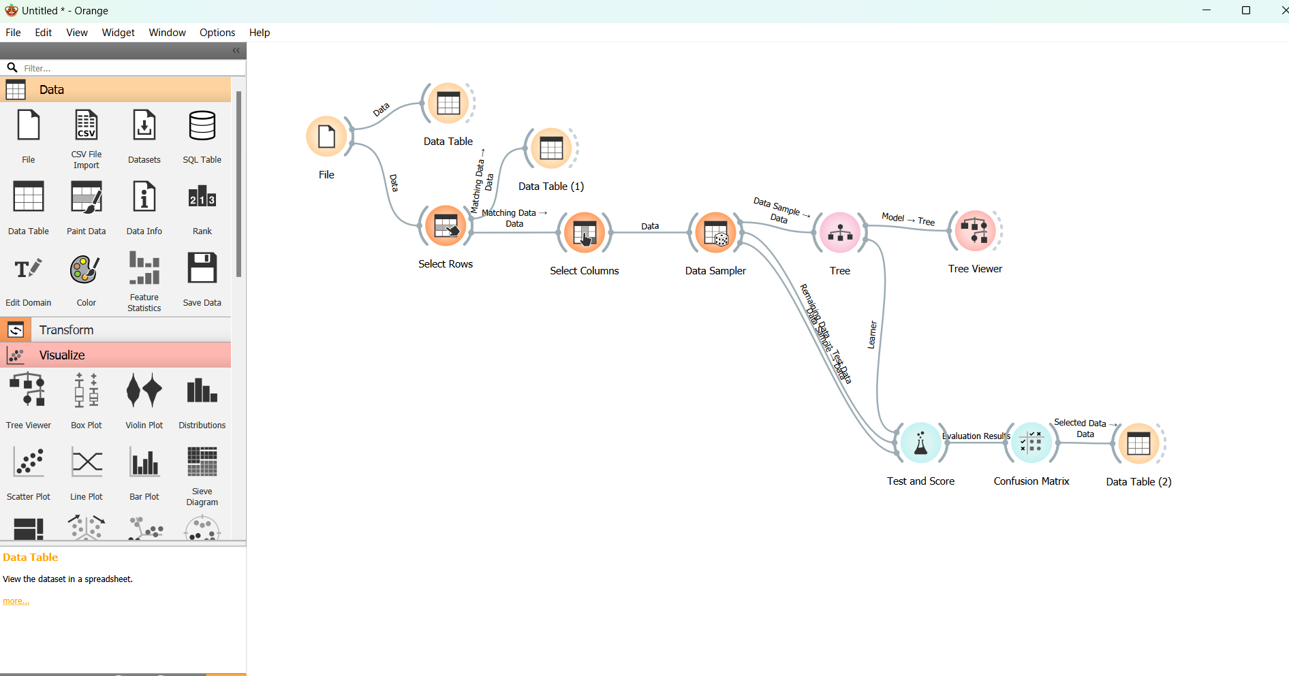

clicking the False positive value = 2. Now double clicking and viewing the data table

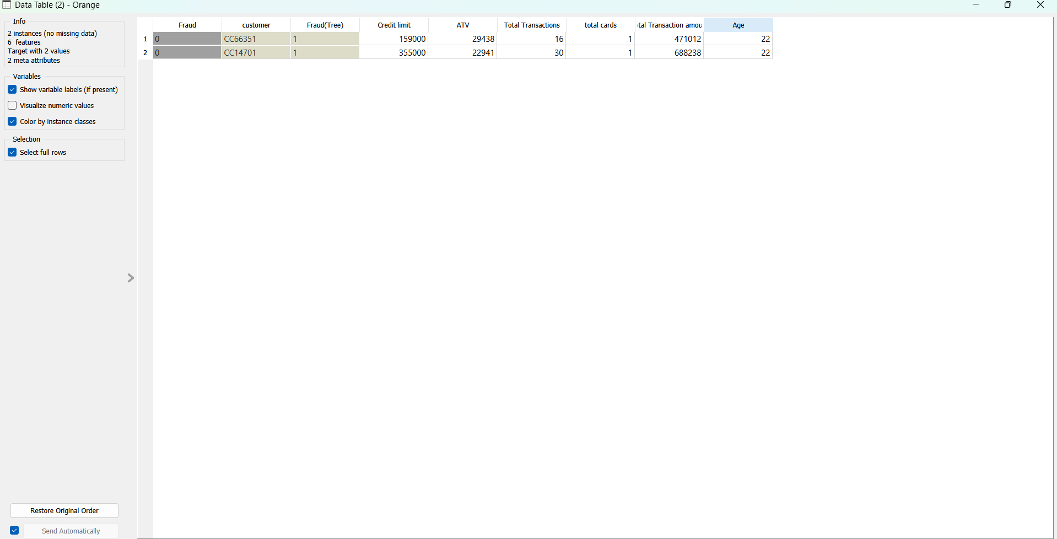

Now selecting the False Negative Value in the confusion matrix.

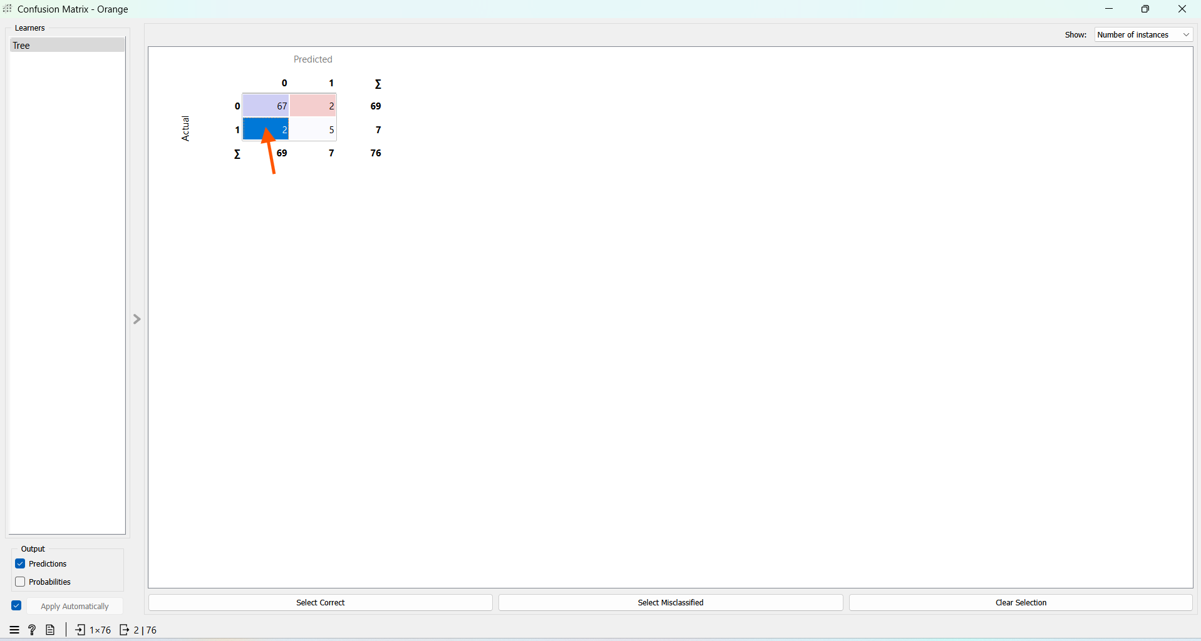

Viewing the data table

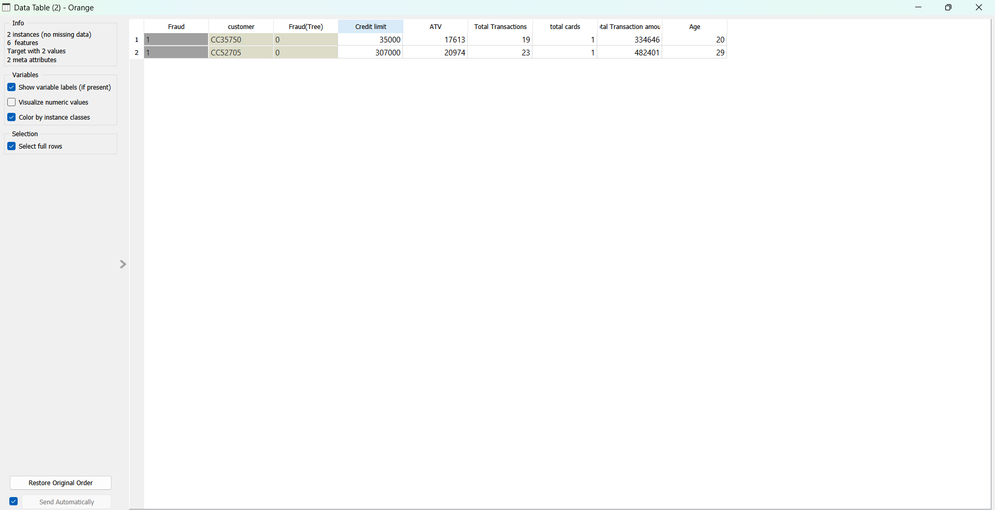

The Analyst may investigate the false negative and false positive models, take measures to improve the efficiency so that the fraud transactions are more precisely predicted.

Saving the work folder as Capstone_RG_Task 5.2

Thus, completing the given task 5.2.

**Link to Orange folder.**

https://drive.google.com/file/d/169gBvV3uvDUNdqEiO6JLryrLxeS8EtSQ/view?usp=sharing